**Math/Science Choice Board(Choose 5 out of seven activities: Project a Must!!)**

|  |  |  |
| --- | --- | --- |
| **Activity 1: Comparing Two Fractions with Different Denominators and Numerators**   | **Activity 4: Conservation(Science)**  A picture containing swimming  Description automatically generated  Objective: Make informed choices in the use and conservation of natural resources. | **Activity 5: Imagine Math**    **Work on Imagine Math**   |
| **Activity 2: Comparing Two Fractions with Different Denominators and Numerators**   | **SEL: Learn a Dance Routine**  A picture containing indoor, playing, child, girl  Description automatically generated  Create your own or find a tutorial for your favorite dance routine and practice. | **Activity 6: Reusing and Recycling**  A picture containing drawing  Description automatically generated  Objective: Make informed choices in reusing and recycling of materials such as paper, aluminum, glass, cans, and plastic. |
| **Activity 3: Classifying Two-Dimensional Figures** | **Weekly Project: Making A Family Plan**  A picture containing drawing  Description automatically generated  Objective: Create a plan for family conservation and recycling. | **Activity 7: Food Chains and Food Webs**   |

**Activity 1: Comparing Two Fractions with Different Denominators and Numerators**

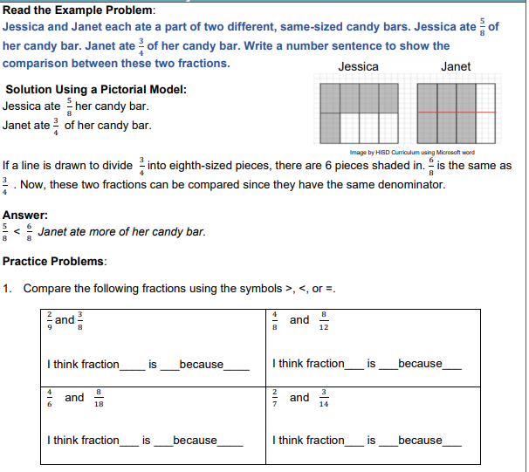

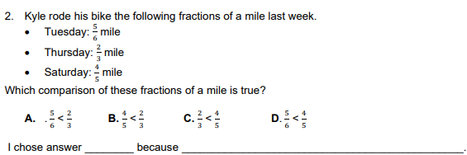

**Activity 2: Comparing Two Fractions with Different Denominators and Numerators**

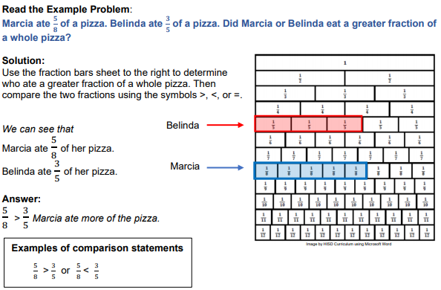

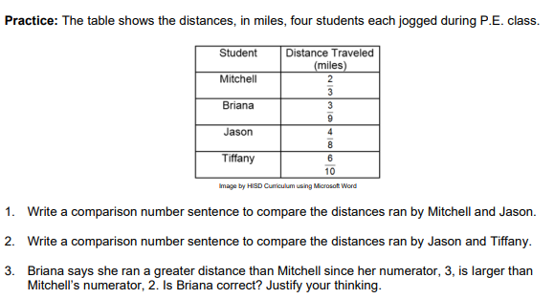

**Activity 3: Classifying Two-Dimensional Figures**

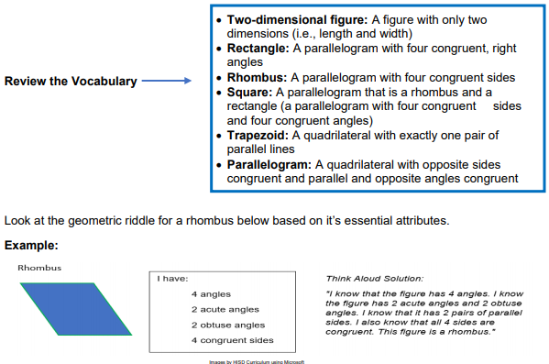

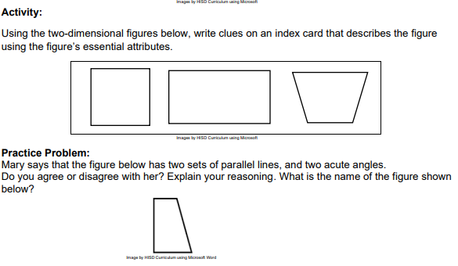

**Activity 4: Conservation (Science)**

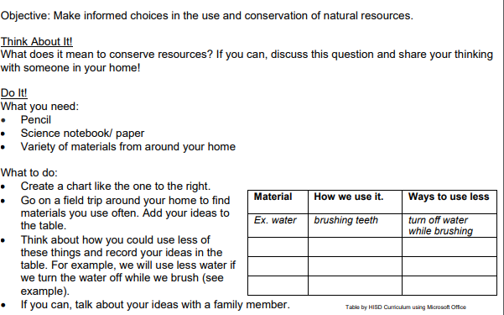

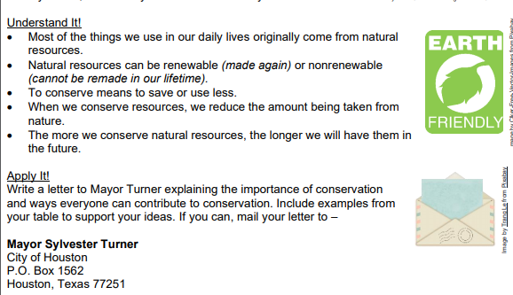

**SEL Activity: Learn a Dance Routine**

Create your own or find a tutorial for your favorite dance routine and practice.

**Activity 5: Imagine Math**

Complete at least 60 minutes a week on Imagine Math

**Activity 6: Reusing and Recycling**

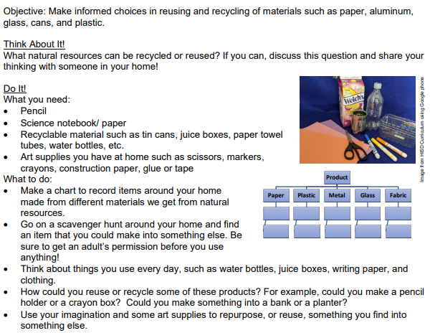

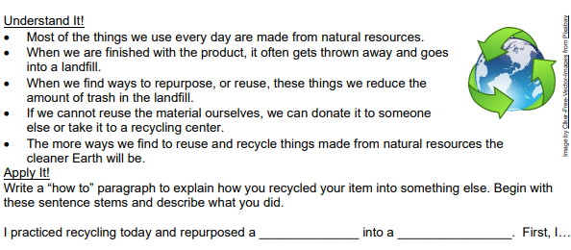

**Activity 7: Food Chains and Food Webs**

Watch the following video on YouTube: <https://www.youtube.com/watch?v=Cd1M9xD482s>

Write at least a four sentence summary about the video and food chains and food webs.

**!Weekly Project: Making a Family Plan**

