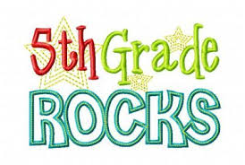

Supply List

DO NOT LABEL

|  |  |
| --- | --- |
| 2 bx | Crayola crayons 24 count |
| 2 pks | 24 pencils |
| 4 | Erasers - Magic Rub |
| 8 | LARGE Glue Sticks |
| 1 | Pair of blunt scissors |
| 3 | Boxes of facial tissue |
| 7 | Black and White Composition books (wide ruled only) |
| 1 bx | Gallon sized zip bags |
| 1 bx | Quart size plastic bags |
| 2 | Bottles of Antibacterial gel hand sanitizer |
| 5 | Plastic Folders with pockets and brads (red, blue, yellow, green, orange, 2 of each color) |
| 2 bx | Crayola Washable makers |
| 1 pk | Dry erase markers |
| 1 pk | Index Cards |
| 1 pk | Highlighters |
| 1 pk | Colored Pencils |
| 1 | Plastic Ruler (inches & centimeters) |
| 3 pk | Clorox or Lysol wipes |
| 1 | Earbuds with case |