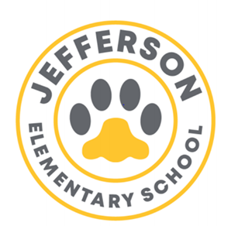**Jefferson Elementary School Year 2022 -2023**

**SDMC Agenda**

**06/01/2023** **3:30 p.m.**

**Room 6**

**SDMC Agenda**

* **Staffing/ Vacancies**:

1. Kinder
2. SLC
3. 3rd grade
4. Media Specialist
5. Office Clerk

* **Budget- As of now Budget**- Status on Big Projects- Fence, water fountain, popcorn Machine, Garden School
* **Academic Programs**- Vontoure, Imagine Math/Reading, Freckle, Waggle, Really Great Reading, Rice University, Neuhaus
* **School Culture- School Committees**; Teacher moral committee, School Event Committee,
* **Data-Test Results**

TELPAS;

STAAR Preliminary data

EOY Assessments

* **End of the Year Event**
* **Summer School.**

June 13 – July 7

Mon. thru Thurs. 7:30-2:30

Last day July 7th 7:30-11:30

* Meeting was adjourned at 4:30pm
* Parents are encouraged to visit our many platforms with information and updates: @JeffersonES2,

 @Jeffersonelementaryhisd, <https://houstonisd.org/Domain/21593>.