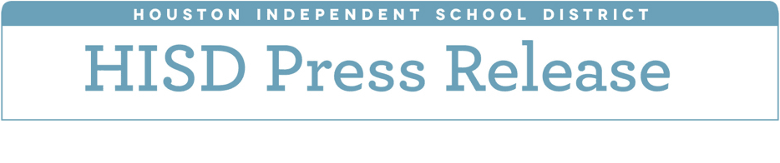

**Board of Education to hear proposal on funding model for 2018-19 school year**

*April 2, 2018* – The Board of Education on Monday will discuss proposed changes to HISD’s Resource Allocation System that address the district’s $115 million budget deficit for the 2018-19 school year. The changes include a reduction to the Per Unit Allocation (PUA), an increase in the small school subsidy, and the centralization of funding for Career and Technical Education.

**The workshop is scheduled for today at 2 p.m.**

HISD faces a $115 million budget deficit for the 2018-19 school year. To address the deficit, the district is proposing cutting $70 million from central office. Originally, the district proposed cutting $45 million from campuses, but that figure was reduced to $34 million by anticipating and assigning unspent funds from the 2018-19 budget.

“Every year, attrition leaves us with some unspent funds from our budget, which then go into our fund balance, or savings account. This provides us a cushion for emergencies and to maintain ongoing programs,” said HISD Chief Financial Officer Rene Barajas. “While we will have a smaller margin of error by utilizing these funds, we also will still have a balanced budget.”

This proposal is the result of feedback administrators received through meetings with campus leaders and the community. Schools would continue to receive funding through a Per Unit Allocation (PUA), which allocates dollars per student and allows principals to decide how those dollars are used on their campuses. Principals would still have flexibility to use the dollars allocated to their campuses at their discretion. The PUA would be reduced however, from $3,522 to $3,432 for high school and elementary school and from $3,558 to $3,468 for middle school. Funding for the Achieve 180 program, which supports underserved and underperforming schools across HISD, would continue.

HISD recognizes that under a PUA model, small schools can struggle to meet basic needs. To address those inequities, the district is proposing an increase to the small school subsidy from $7.5 million to $18.7 million. There are 83 small schools that qualify for an increased subsidy, and they include high schools that serve fewer than 1,000 students, middle schools that serve fewer than 750 students, and elementary schools that serve fewer than 500 students. In addition, funding for Career and Technical Education would be centralized.

“This proposal gets us on the right path to being able to present a budget to the Trustees that works best for our campuses for the 2018-2019 school year,” said interim superintendent Grenita Lathan. “We want to make sure that we give those that need the most, the additional support they need to be successful.”

Under this funding proposal, principals will have the discretion to hire staff that meet the unique needs of their campus and address essential services.

**The Board will hear the proposal during a workshop Monday, April 2, 2018 in the Manuel Rodríguez Jr. Board Auditorium (4400 W. 18th St., Houston, 77092).**