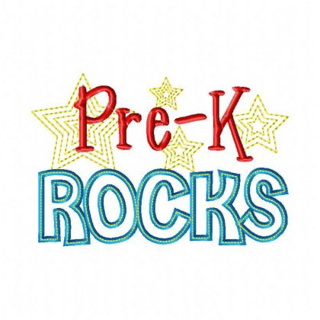

Supply List

DO NOT LABEL

|  |  |
| --- | --- |
| 8 pk | Crayola crayons 8 count, regular size |
| 1 set | Large Washable Markers |
| 1 set | Fine Point Washable Markers |
| 1 pk | Washable Watercolor Paint Set |
| 16 | Glue Sticks |
| 2 pair | Blunt Scissors |
| 3 | Boxes of facial tissue |
| 3 | Poly Portfolio Folders (red, blue, yellow) 1 of each |
| 2 bx | Gallon sized zip bags |
| 2 bx | Quart size plastic bags |
| 3 pk | Clorox or Lysol wipes |
| 2 | Bottles of hand sanitizer (8oz) |
| 1 box | #2 pencils (12 count) with erasers |
| 2 | Pencil Bags |
| 2 pk | Playdough (5 count) |
| 1 | Nap towel |
| 2 pks | Construction paper, assorted colors |
| 2 pks | Drawing paper, Manila (1 pack 8.5x11, 1 pack 12x18) |
| 1 can | Lysol Spray |