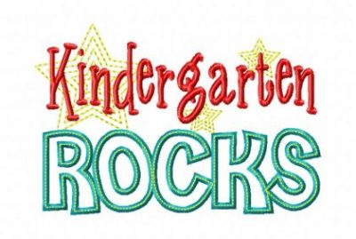

Supply List

DO NOT LABEL

|  |  |
| --- | --- |
| 2 bx | Crayola crayons 16 or 24 count |
| 2 pk | 24 pencils (Sharpened) Jumbo (Dixon) |
| 2 | Plastic Folders with pockets and brads (blue & orange) |
| 2 | Large Pink Erasers, pencil top erasers |
| 4 | Large Glue Sticks |
| 3 pk | Clorox or Lysol wipes/ Baby wipes |
| 2 | Bottles of hand sanitizer |
| 4 | Handwriting Composition Notebook 1st grade (zebra/elephant cover) |
| 1 | Handwriting Tablet ½ Storybook 40 sheet count |
| 1 | Legal sized pack of manila paper |
| 1 bx | Crayola Washable markers |
| 1 pk | Dry Erase markers |
| 1 | Tempera Paint |
| 3 bx | Facial tissue |
| 1 bx | Storage Bags Ziploc Quart size |
| 1 bx | Storage bags Ziploc Gallon size |
| 1 | Disinfectant Spray (Lysol) |
| 2 | Antibacterial Hand Sanitizer |
| 1 | Change of clothes |