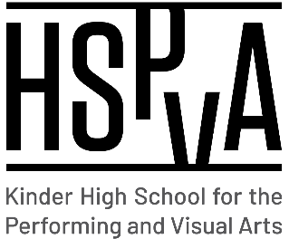

Kinder High School for the Performing and Visual Arts

Shared Decision-Making Committee (SDMC)

Thursday, September 22, 2022

**Minutes in Red**

**AGENDA**

1. Call to Order
2. Welcome
   1. Dr. Rivas welcomed the committee and thanked the former members for their service. She allowed new members to introduce themselves.
3. Approve minutes from previous SDMC meeting (June 2, 2022)
   1. Minutes were approved by committee members.
4. New Business

* SIP Review
  + SIP focused on academic progress and growth to maintain A rating for the upcoming year.
* Budget Updates
  + So far we are meeting enrollment projections and are hoping we maintain those numbers.
* Staffing Updates
  + We have a nw full time Special Education chair and we are excited about the work and support Mrs. Chandler will bring for our students.
* IAT/Interventions
* SPED/504
  + 100% in compliance thanks to Ms. Chandler and our counselors!
* HB4545 Updates:
  + On track to exceed the number of hours required for tutoring and interventions
* Performances:
  + Gearing up for All School Musical, Mamma Mia!

1. Q&A
   1. New committee members suggested that in the future membership be made up of different teachers from different department.
2. Adjourn

**Thank you for your service during the 2022-2023 school year!**