**SDMC Meeting**

**October 29, 2024**

Minutes

**Present:** J. Herrera, G. Boldman, S. Niaves, B. Shargey, C. Tapia, J. Stewart. B. Adcox, J. Silva, H. Smith, M. Hayes, M. Frost, Parent M. Zamora, Business Partner Dr. Moreno.

**Absent:** M. Maharaj, Parent: R. Mendez

**SDMC Overview**

Overview and responsibility of the committee were shared with the group.

District guidelines about the responsibilities and requirements were discussed.

**Enrollment (Snapshot – 10.24.24)**

9th. 284 students

10th. 235 students

11th. 233 students

12th. 177 students

Total enrollment for the year is **929** students. That is 29 more students then what we were allocated on the 24/25 school budget.

**Action Plan 2024/25**

**6 Indicators of Success**

* By January 2025, 70% of 9th. grade emergent bilingual students will earn a semester average of 70 or higher by the end of the fall semester.
* By January 2025, 100% of all 9th. grade emergent students will earn approaches or higher on the Interim English 1 EOC.
* By June 2025, 100% of students will be at Approaches level in Biology.
* By June 2025, 95% of students will be at Meets level in Biology.
* By the end of 2024-25 school year, each special education teacher will receive at least one classroom observation per week and feedback will align in part to the previous weeks' coaching action steps.
* By March 2025, by building leadership team, 80% of teachers will receive a "4" or higher on the use of scaffolding.

**Course Sequence Proposal 25/26 school year**

Discussion about updating the course sequence selection for students.

Concern that there is a small group of students that have struggle in both math and science during their high school careers here at DeBakey.

One possible solution is to have student take AP Science as the 5th science course and making AP Pre-Calculus the fifth math course.

This will also allow student to complete the **32 credits** for DeBakey High school.

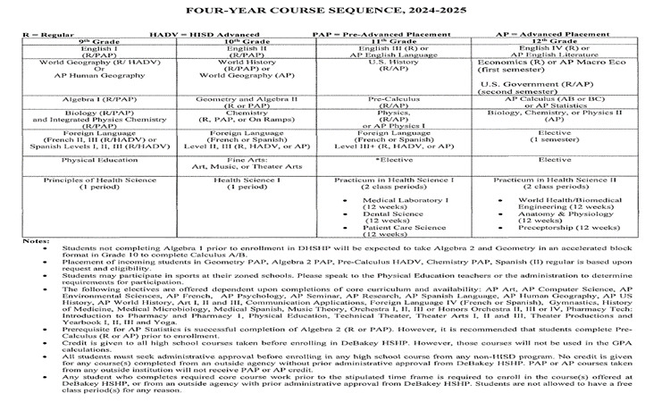

SDMC Concerns

SDMC ITEMS 10.29.24

Discipline Consequences for Level 1 Infractions

* Clear language that has little room for loose interpretation from student, parent, teacher, or admin
* Consistent language across all forms of communication
  + For instance, handbook vs emails
* Time between infractions and consequences (Where is specific wording requiring a non-neighborhood school can enforce after/before school policies?)
  + Getting emails weeks later about infractions students were written up for
  + Need a system to see how many referrals have been submitted for each student
  + With detention only on Friday (Is Saturday legally enforceable?), taking weeks for students to see consequences for actions (no real correlation between infraction and punishment)

Study Hall/Tutorial/Hall Duties

* Understanding is that spots will flip every “X” weeks, but this can be issue with student learning
  + Teachers have difficulty getting windows for students to review/correct work, especially AP - this will be a bigger issue the closer to the exam
  + Is there a way to volunteer for hall duties as opposed to being “selected” to serve? Can we trade teachers spots
* Teachers that serve hall duty are having their students moved to the next teacher
  + [Redacted] has 30-35 kids on some days that show up on student roster
  + Is there a way to rebalance these rosters as some teachers only have 8-9 students
  + Combining study hall and midday tutorials is inefficient. For example, Adcox has 4 students assigned for midday tutoring but an additional 21 students for study hall at that same time

Transparency

* Last minute decisions not shared to whole staff
  + Due to inflexibility with C-Day schedule, this is more important to address loss of time between A and B days
  + Recently: Spirit Week/Fall Fest dates and AIM Acknowledgements
* Infractions shown in a spreadsheet for staff to view
  + Back to referrals above, but would help with tracing cheating in classes
  + Helps with tracking date of infraction, date of punishment, and date of service
* SDMC meetings posted on Canvas - used to be there, not anymore

Spot Checks and Feedback/MRS (this is tricky since we can’t ‘disagree’ with the district expectations, but we could mitigate/mediate how/when/why/how well they are implemented at the local level)

* Disagreement with how well they help
  + Professionalism vs. micromanagement
  + Allows for limited growth and creativity from the teacher
  + Communicates distrust from top down