**SDMC Minutes for March 4 2021**

|  |  |  |
| --- | --- | --- |
| **Present** | **Title** | **Attendance** |
| **Lizbeth Cavazos** | **Teacher** | **X** |
| **Lesley Coneo** | **Teacher** |  |
| **Deborah Salinas** | **Parent** |  |
| **Vilma Guzman** | **Teacher** |  |
| **Torrye Hooper** | **SSO** |  |
| **Truc Luong** | **Teacher Specialist** | **X** |
| **Crystal Gonzalez** | **Parent** |  |
| **Claudia Perez** | **Teacher** | **X** |
| **Paola Casteneada** | **Teacher** |  |
| **Nimmi Thomas** | **School Principal** | **X** |
| **Keisha Twitchell** | **Teacher** | **X** |
| **Tuyet Vo** | **School administrator** | **X** |
| **Carla White** | **Title 1 Coordinator** | **X** |
|  |  |  |
| **Nancy lopez** | **Teacher** |  |
| **Edith Maldonado** | **School Based Employee** | **X** |

**SDMC Minutes Marh 2021**

**NORMS**

Mute Mics

Best intent for all

Use raise hand feature

Minimize background noises

-Mission/Vision and Core Values

-Shared pics of students engaged in online learning

-SDMC Members

**Agenda**

* Celebrations- 2 min
* Spark Park
* Tutorials
* Academic Boot Camp
* Data
* MyOn
* Budget

**Celebrations:**

* Prodigy: Park Place is in a nation wide competition
* MyOn: There is a school-wide competition among grades to increase independent reading at Park Palce
* Imagine Learning/Math: High fidelity of usage of this intervention program
* 100 Days Celebrations: Every grade level had some kind of clelebration to commemorate this day at Park Place

**Tutorials: Virtual Saturdays**

* Expectations
  + Lesson Plans
  + Attendance from TEAMS
  + Permission Slips

**Academic Boot Camp:**

Park Place will be conducting the ABC virtually during spring break and invites will be sent home to Tier 2/3 students

**Demographics:**

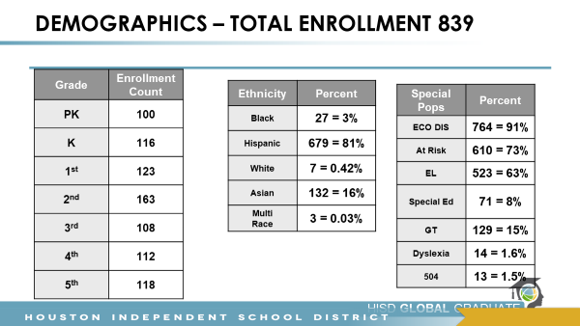

The current demographics and enrolment was discussed especialy the special populations

**Attendance:**

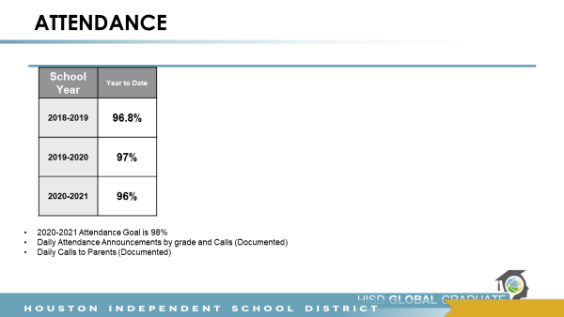

Current Attendance and goals were discussed and the suppot of our wrap around specialsit in doing home visits were made known to our SDMC

**Budget:**

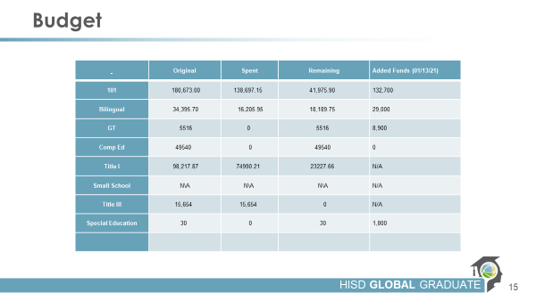

Park Place budgt was discussd as to what was our starting point and where we are currently and the plans to make purchases in terms of instructional resources from Mentoring Minds. Our writing PD from Abydos was also dicscussed. The SDMC had no questions

**Dilemma:**

The final discusión ws presenting the problem that we are facing as a campus with regard to not having a strong RTI/IAT at Park Palce. The problema was presented and th members expressed that Principal Thomas should reach out to the teachrs t osee if there was anybody interested to Work as an IAT Support one per grade level to meet the needs of the campus.

**Action Plan**

HB3 Training

All teachers will have ESL and GT certification

AT BATS

FEED BACK

INTERVENTION

Tier 2 and 3 intervention

**Shared Picture Highlights**

Prodigy

MyOn

Spark Park

**Meeting Adjourned: 4:30 PM**