**ELA Choice Board #4**

***Directions:* Students please complete the activities from ELA/Social Studies board in the order that you prefer. Submit evidence of completion by May 8, 2020 on Google Class.**

|  |  |  |
| --- | --- | --- |
| **#1 Text Evidence**  **Student will read a fiction story and determine the theme and use text evidence to support understanding.**  **Students will answer 2 questions on Theme and Inference graphic organizer**  **Resource:** [**www.storyonline.com**](http://www.storyonline.com)  **Read any Fiction Book from there website.** | **#2. Fiction Text**  **Students will read a fiction story and determine the major’s character feelings, relationship, and conflict.** | **#3.**  **Problem/Solution Text Structure**  **Choose your own book at home or a story from Think Up Reading to identify the problem solution text structure.**  **As you read, ask yourself:**  **What is the main problem the author presents?**  **What steps does the author present to solve the problem?** |
| **#4. Social Studies Celebrations Texas**  **Texas is the second-largest state in the United States and is No. 2 in population (number of people living in an area).**  **Texas is home to many people from around the world. They brought their customs, food, and languages when they immigrated to Texas. Many groups hold special festivals to share their culture.**  **LOOK at the image. Write about what the image is saying to you** | **#5 Free Space**  **FREE FUN SPACE**  Education Back To School Clipart Clipartix_clipartix | **#6. Imagine Reading**  **The student will engage with Imagine Learning platform for 45 minutes every day.** |
| **#7. Writing**  **LOOK at the picture below. READ the information in the box below.**  **THINK about different things you do to stay healthy. It could be exercising daily, eating healthy foods, or any other way you keep your body healthy.**  **WRITE about how you keep your body healthy. Explain what makes this practice important.**  **Be sure to ― • clearly state your central idea • include details to support your central idea • organize your writing • choose your words carefully • use correct spelling, capitalization, punctuation, grammar and sentences**  **•** | **#8. Social Studies**  **Juneteenth African Americans in Texas have a very special celebration each year on June 19th. This marks the day in 1865 that people who were slaves found out the Civil War ended. The Emancipation Proclamation signed by President Abraham Lincoln freed the slaves, but it took two years before the slaves found out they were free.**    **Fold a paper in three sections. Write 3 facts you learned about Juneteenth and draw a picture for each fact**.  **Resources: Texas Weekly Week 27**  **Login in using Clever** | |
| **#9. Using Facts to Find the Central Idea**  **Choose an informational text to read and use facts to determine the central idea.**  **• Use the tip to the right to know how to find the central idea.**  **• As you read, think about: Which facts have something in common to support the central idea? o How could I use the ideas in the facts to create the central idea?** |  | |

***Use these Strategies to help you Solve the Problems for ELA Above***

***Problem #1***

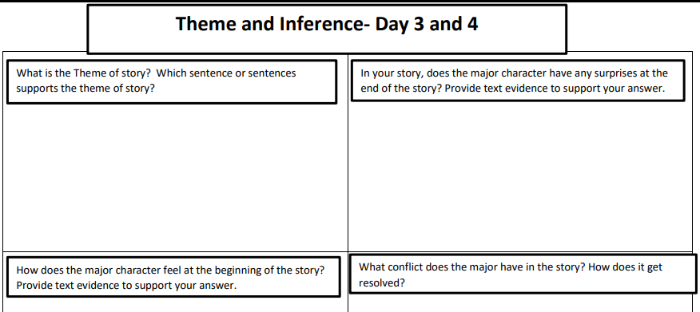**Problem #3**

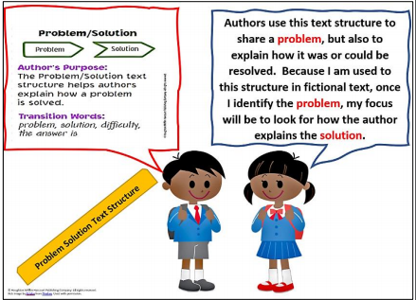

**Problem #8**

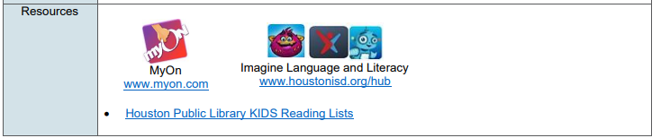

**Problem # 4**



Name \_\_\_\_\_\_\_\_\_\_\_\_\_\_\_\_\_\_\_\_\_\_\_\_\_ **MATH Choice Board**

***Directions:* Students please complete the activities from MATH board in the order that you prefer. Submit evidence of completion by May 8, 2020 on Google Class.**

|  |  |  |
| --- | --- | --- |
| **#1 Multiplicationa and Division**  **Tripp counted a total of 48 blueberries in one carton. Tripp and 5 friends want to share the blueberries equally.**  **Draw and Write an equation which shows how many blueberries each boy will receive?** | **#2 Multiplicationa and Division**  **Jason, Grey, Hugh, Randall, Ben, and Vince divide 42 pieces of gum equally among themselves. Then they each give 1 piece of gum to Carter.**  **How many pieces of gum does each of the 7 boys get?** | **#3 Word Problem**  **A tailor purchased 850 buttons. Two hundred fifteen of these buttons were white and**  **375 of these buttons were black. The rest of the buttons were blue.**  **How many of the buttons that the tailor purchased were blue?** |
| **#4 Word Problem**  **Show your work:**  **Mrs. Lewis bought 200 yards of ribbon. She used 60 yards to decorate blouses. She used some of the ribbon to decorate dresses. Now she has 58 yards of ribbon.**  **How many yards of ribbon did Mrs. Lewis use to decorate the dresses?** | **#5 FREE FUN SPACE**    **Any Activity you want Ms. Joseph to See** **on Class Dojo** | **#6 Imagine Math**  **Do Imagine Math for at least 45 minutes.** |
| **#7 Multiplication Practice**  **Practice writing your multiplication chart using your 6, 7, 8, 9 times table** | **#8 Multiplication and Division**  **Coach Trevino separates 48 students in his P.E. class into 6 equal teams. He sketches a strip diagram to model the teams. First work the problem out and then Draw a strip diagram to best represents Coach Trevino’s sketch.**  **Example of Strip Diagram** | |
| **#8 Review Exploring Forms of Energy**  **To access this interactive lesson, visit https://tinyurl.com/HISDGrade3Day04**  **Objective: Explore the forms of energy found at home.**  **Think About It!**  **What forms of energy do we encounter every day? If you can, discuss this question and share your**  **thinking with someone in your home.**  **Do It!**  **What you need:**  **• Gather a variety of objects that move to function, such as a toy car, yo-yo, windup toy, and**  **paper fan.**  **What to do:**  **• Explore the objects and record your observations about what each object is and what you need**  **to do in order to make it work.**  **• Record your thinking on a table.** | | |

## **Project: Due May 8, 2020 *Activity: A Bad Case of Stripes:***

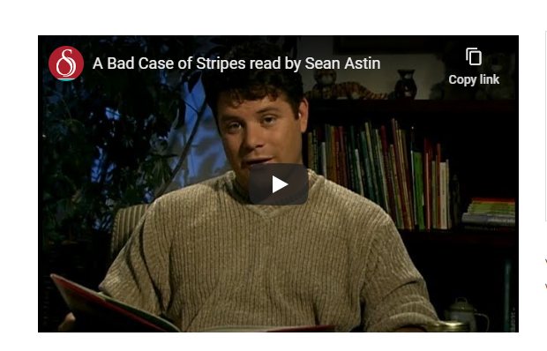

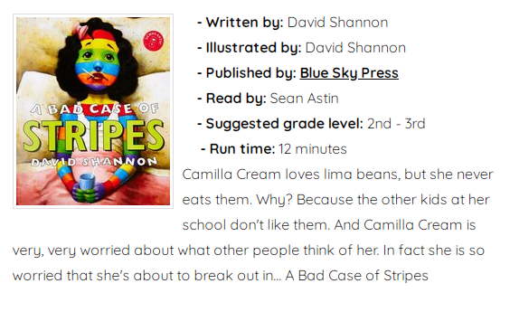

**Activity:** Camilla’s classmates call her names and make fun of her. Pretend you are a student in her class. Write a persuasive paragraph to the other students to convince them not to tease her.

RESOURCE: www.storyonline.com