HOUSTON INDEPENDENT SCHOOL DISTRICT

**TITLE I, PART A, PARENT AND FAMILY ENGAGEMENT PROGRAM**

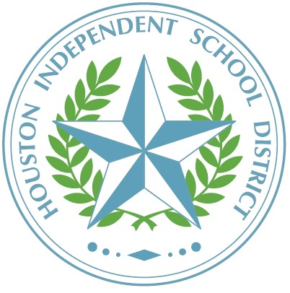

Charles H. Milby High School

1601 Broadway St.

Houston, Texas 77012

October 2023

TO: Parents of Students Attending Milby High School

# SUBJECT: 2023–2024 TITLE I STATUS NOTIFICATION

This is to inform you that the school that your child attends is a schoolwide Title I, Part A campus, and as a parent, you have the right to be involved in the planning, review, and improvement of the Title I program.

Title I, Part A, is a federally funded program that provides resources and opportunities to improve the academic achievement of economically disadvantaged students. Title I ensures that all children have a fair, equal, and significant opportunity to obtain a high-quality education based on the Texas Essential Knowledge and Skills (TEKS) and reach, at a minimum, proficiency on the State of Texas Assessments of Academic Readiness (STAAR).

Under the Every Student Succeeds Act (ESSA), Title I funds enable schools to employ and train highly qualified teachers and paraprofessionals, purchase instructional materials, update technology in the classroom, and sponsor parental involvement activities. To increase student academic achievement, Title I funds supplement various academic programs offered at your campus.

If you have any questions regarding this information or in the planning, review, and improvement of the Title I program, please contact Rewa Booher at 713-928-7401 or rbooher@houstonids.org.

Sincerely,

Ruth I. Pena, Principal

Rev. 10/04/2023