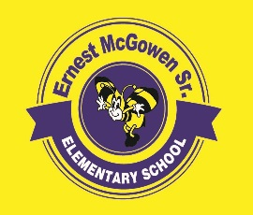**McGowen Elementary School**

April 29, 2022

**SDMC Meeting Agenda**

1. Budget Update
2. Calendar
   1. Teacher Appreciation Week
   2. STAAR Testing Week
   3. Award Ceremonies
   4. Summer School
3. Mock STAAR Performance
4. Campus Changes for 2022-2023
   1. Position Additions
   2. Enrollment Goals
5. Committee Questions/Comments/Suggestions
6. Closing