**MCLIMS Pre-Kindergarten Homework**

**Assigned: Friday Dec. 7 Due: Thursday, Dec. 13**

We have been working on making lists in class. Enjoy making a list at home together! The first step is to help your child decide what they want their list to be about. Write a title and underline it. Then, populate your list with images and a word for each. Remember to modify the expectations for writing to fit your child specifically. This can be an exercise in oral language and brainstorming (with your child doing the illustrating and you doing most of the writing), shared writing between the two of you, or your child writing independently (stretching words to sound them out) with your support. Enjoy!

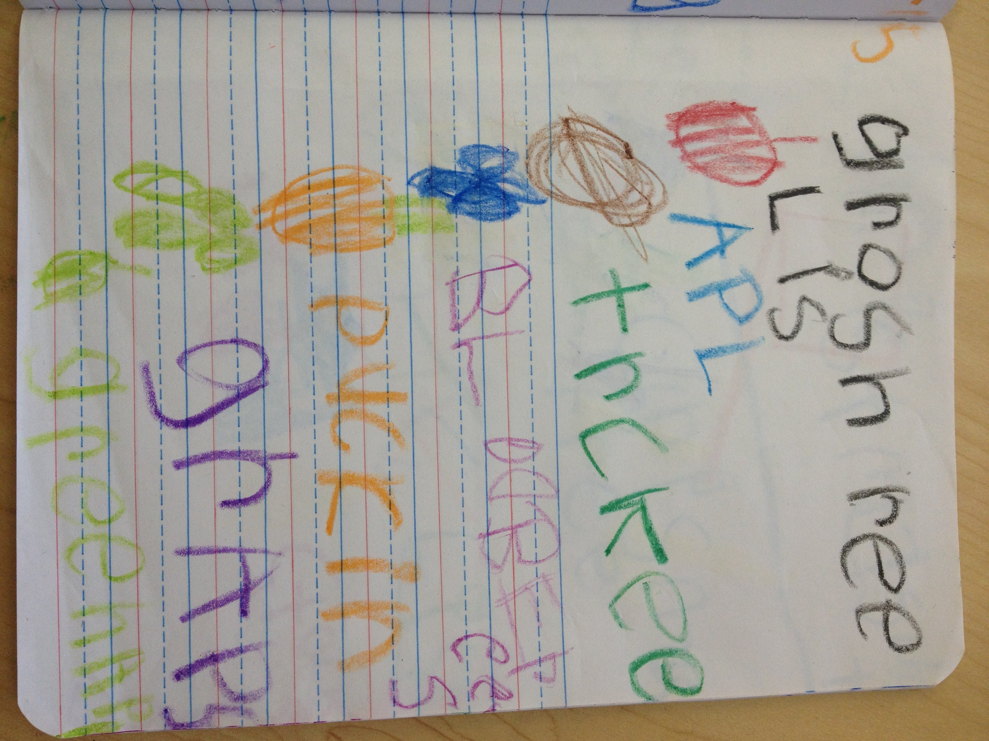

**A list of list ideas!**

* Grocery list
* Wish list
* Things to do over winter break
* Winter clothes
* Holiday decorations in your home
* Gifts to give others
* Favorite toys

A grocery list from Reva’s journal. Good job, Reva!

**Bonus activities:**

* **Use your index (“pointer”) finger to read your list to 3 different people! This supports 1 to 1 correspondence between written and spoken words.**