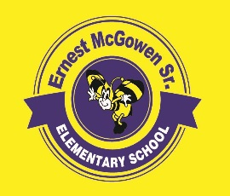**McGowen Elementary School**

June 2, 2022

**SDMC Meeting Agenda**

1. Budget Update
2. Calendar
   1. Close of School
   2. 2022-23 Campus Needs Assessment
   3. Summer School
   4. Safety Concerns
3. STAAR Performance – Preliminary Result
4. Campus Personnel Changes for 2022-2023
   1. Position Additions
   2. Enrollment Goals
5. Committee Questions/Comments/Suggestions
6. Closing