[](http://www.houstonisd.org/HISDmedia)**More HISD students than ever before taking AP exams and earning college credit**

*Aug. 21, 2015 —* Houston Independent School District students are earning significantly more college credit through Advanced Placement exams now than they have in the past six years, according to 2014-2015 data released by the College Board.

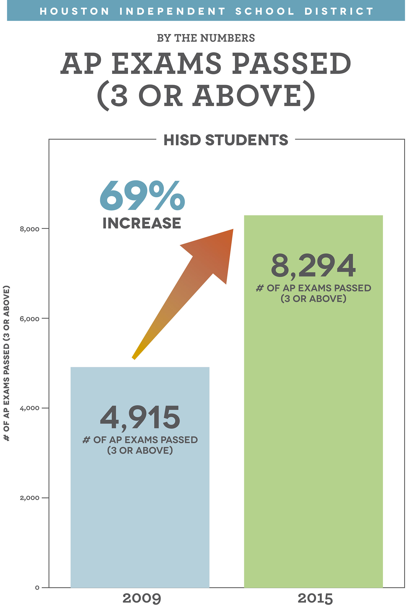This year, 8,294 exams given to HISD high school students were scored high enough to qualify — a 3 or higher on a 5-point scale — for college credit through the program. That’s a 69 percent increase from 2009, when just 4,915 of the exams given received scores of 3 or higher on that same 5-point scale.

More students than ever before are taking Advanced Placement exams. Last year, HISD high school students took 25,147 exams — more than double the 11,594 that were taken in 2009. That a 117 percent increase.

An additional 522 middle school students took AP exams — Spanish, Chinese and World History — during the past school year. Of those students, 87 percent scored high enough to earn college credit.

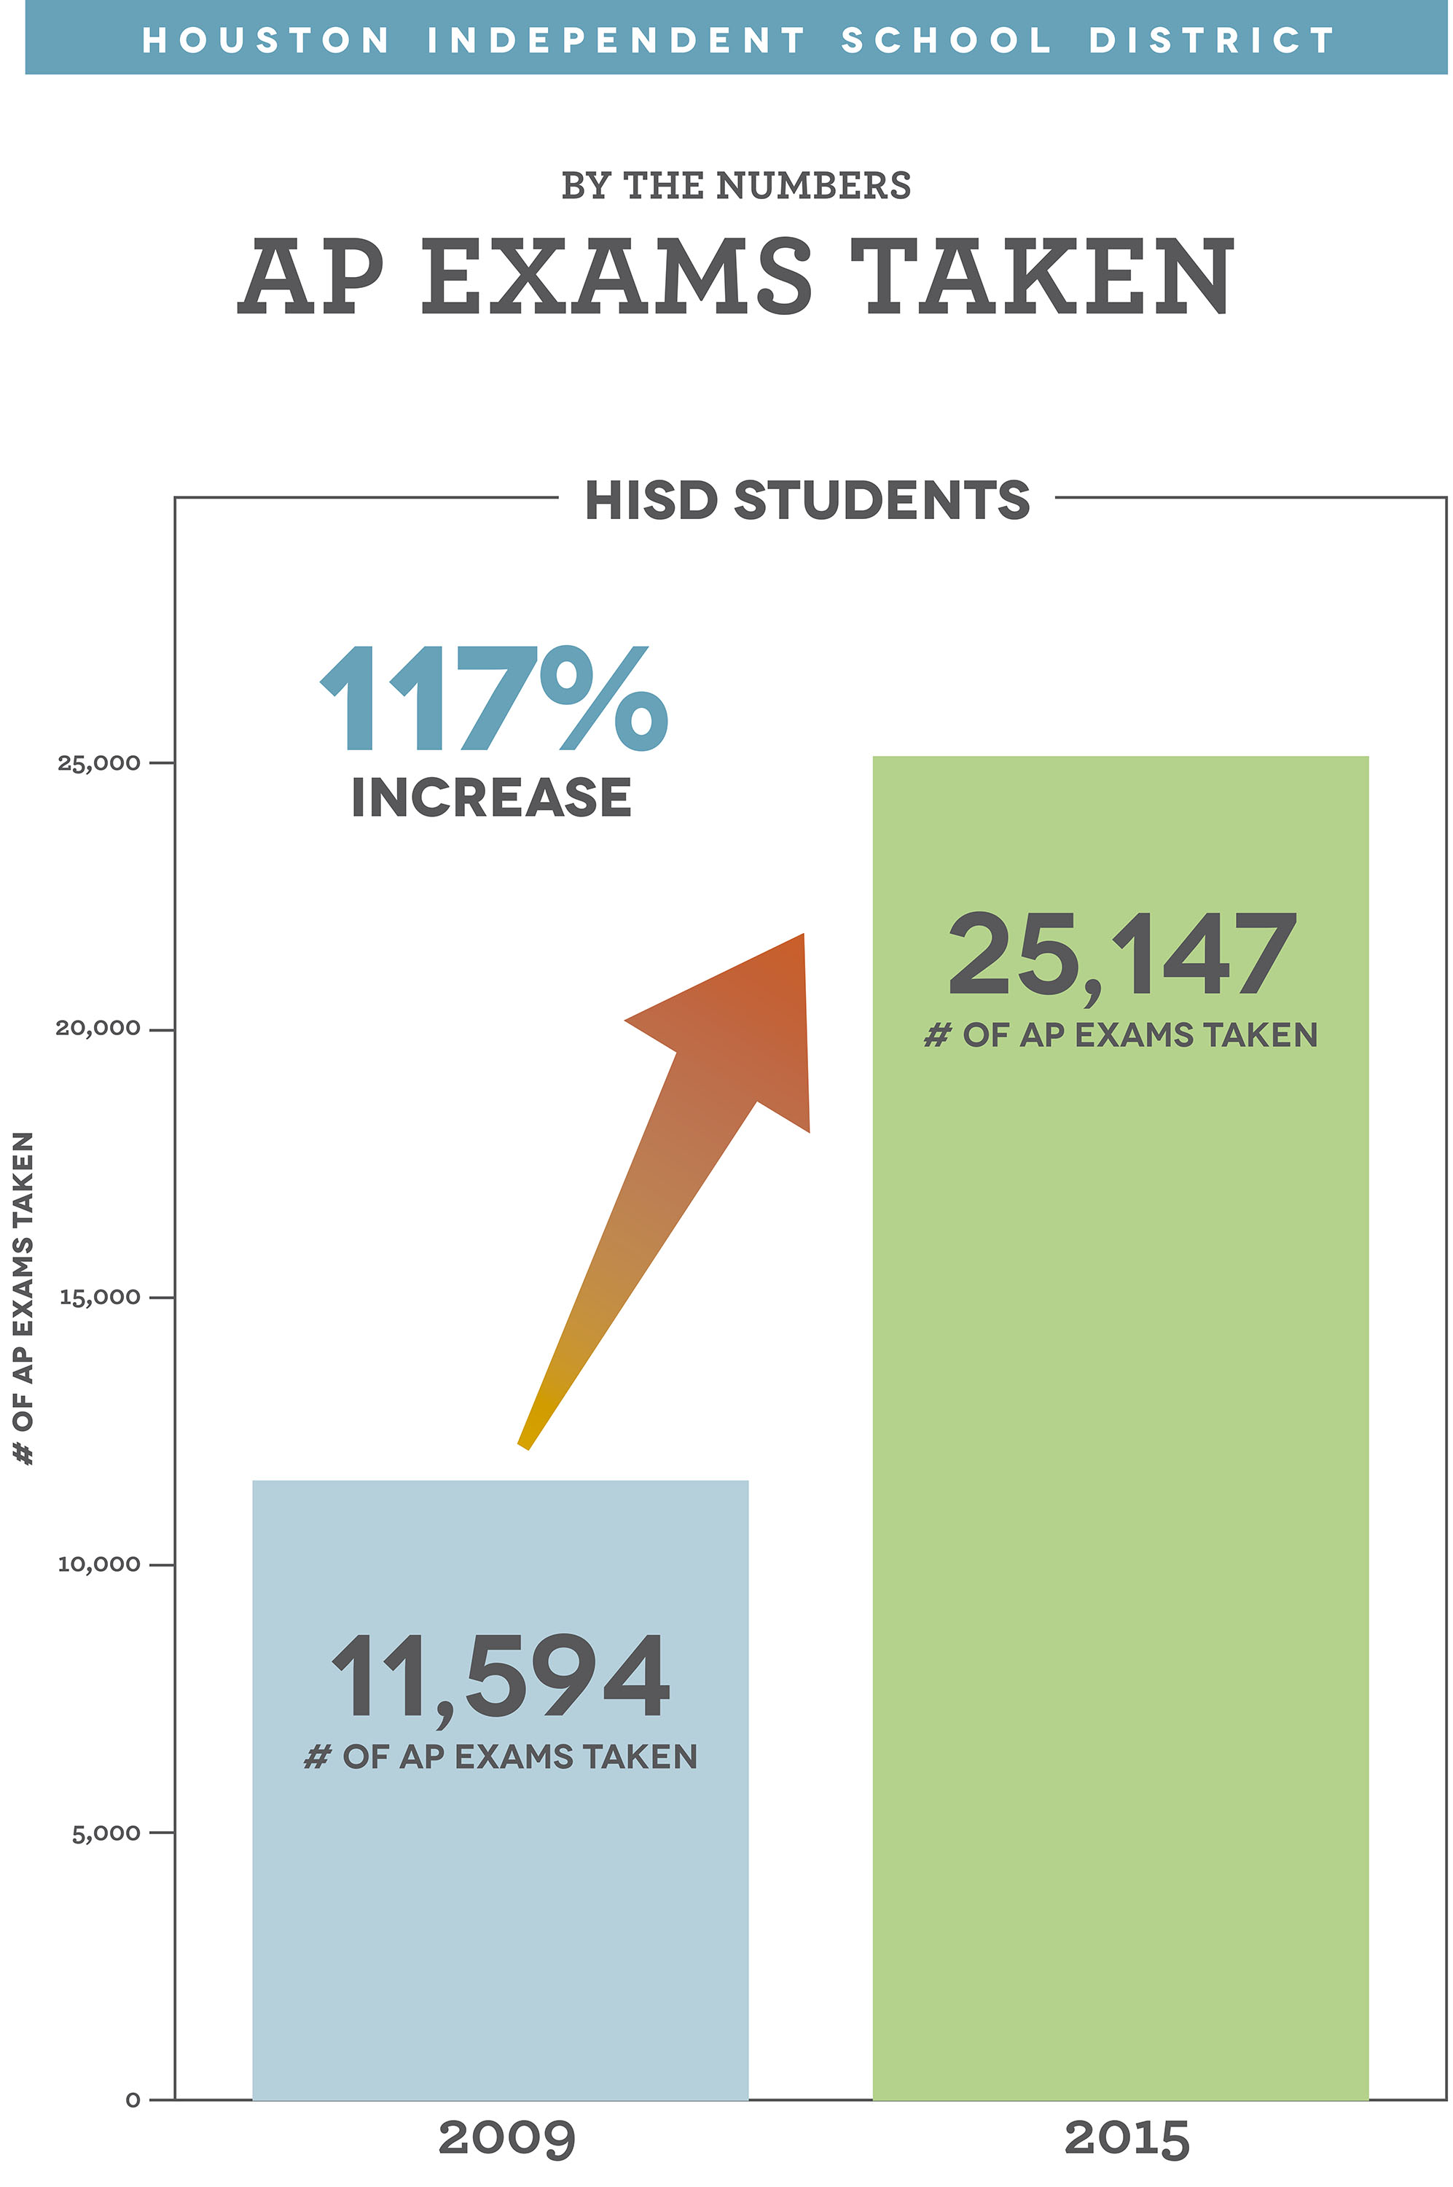“This is such a great accomplishment not just for our Advanced Placement students, but also for the AP teachers who are working every day to make sure their students are successful,” HISD Superintendent Terry Grier said. “These dedicated and hardworking students will have a tremendous leg up when they graduate.”

The district had an all-time high of 13,954 high school students taking 25,147 AP exams last year. That’s a nine percent increase from the 2013-2014 school year.

The numbers are also up when looking at the number of exams qualifying for college credit. Almost 500 more exams were scored high enough to qualify for college credit when comparing 2014-2015 school year over the 2013-2014 school year. That’s a more than six percent increase.

Dr. Grier long has been a proponent of the Advanced Placement program, which provides students with the opportunity to take college-level courses and earn college credit while still in high school. The program, which Grier has expanded every year, is a key component of the district’s efforts to continue strengthening academic rigor in classrooms across the district and make sure all students graduate college and career ready.

AP offers a total of 36 exams in seven subjects, and HISD administered all 36 of the exams during the 2014-2015 school year. HISD covers the fees for all exams to ensure all students have an equal opportunity to earn college credit.

In addition to making the tests more accessible to all students, HISD also places a strong emphasis on individual success. Last year, the district began studying Advanced Placement potential data, which is provided by the College Board and uses PSAT scores to determine how likely various students are to score a 3 or higher on different AP exams.

Using the research, district and campus administrators were able to identify and more closely match students with subjects in which they were predicted to do well. The move was designed to ensure students have the opportunity to take the Advanced Placement courses in which they were predicted to do well.

District officials also used that same data to identify the strongest AP teachers. These teachers were then called upon to revamp the AP curriculum and train their counterparts.

