**ELA/Writing Choice Board**

***Directions:* Students please complete the activities from the ELA board in the order that you prefer. Submit evidence of completion by April 24, 2020 in Google Class.**

|  |  |  |
| --- | --- | --- |
| **#1. Unfamiliar Words Part 1**  1. Student will read the literary passage from **Frank Pearl in The Awful Waffle Kerfuffle STAAR (2019**)  2. Student will record 5 unfamiliar words and complete the graphic organizer: | **#2. Analyze Plot and Make Inferences/ Frank Pearl in The Awful Waffle Kerfuffle STAAR (2019**) **Part 2**  3. Student will respond to the text in complete sentences. The rising action in the story happens when \_\_\_\_\_\_\_\_\_\_\_\_\_\_\_. The climax of the story happens when \_\_\_\_\_\_\_\_\_\_\_. After that, the fallen action is when \_\_\_\_\_\_\_\_\_\_\_\_\_\_\_\_\_\_\_\_\_\_\_\_\_. The resolution of the story is \_\_\_\_\_\_\_\_\_\_\_\_\_\_\_\_\_\_\_\_\_\_\_\_\_. | **#3.**  **Point of View**  1. Student will read the literary passage from **Frank Pearl in The Awful Waffle Kerfuffle (2019**) or use www.myon.com  2. Student will respond to the text in complete sentences. The difference between first-person and third-person point of view is \_\_\_\_\_\_\_\_\_\_\_\_. This story is written in \_\_\_\_\_\_\_\_\_ person point of view. My evidence is \_\_\_\_\_\_\_\_\_\_\_\_. I infer the narrator feels \_\_\_\_\_\_\_\_\_\_\_. My evidence is \_\_\_\_\_\_\_\_\_\_\_\_\_. |
| **#4.**  **Point of View**  The student will write two short paragraphs narrating the same event but: One using a first-person point of view and the second one using a third-person point of view. | **FREE FUN SPACE**  Education Back To School Clipart Clipartix_clipartix | **#5. Imagine Reading**  The student will engage with Imagine Learning platform for 3**0 minutes every day.** |
| **#6.**  **Poetry and Figurative Language**  1. Student will read the **Poem Pants (2016).**  3. Student will answer guiding questions in complete sentences. An example of a simile in this poem is \_\_\_\_\_\_\_\_\_\_\_\_\_\_\_\_\_\_\_\_\_. It’s a simile because \_\_\_\_\_\_\_\_\_. An example of a metaphor in this poem is \_\_\_\_\_\_\_\_\_\_\_\_\_. It’s a metaphor because \_\_\_\_\_\_\_\_\_. An example of figurative language in this poem is \_\_\_\_\_\_\_\_\_\_\_. Is figurative language because it means \_\_\_\_\_\_\_\_\_\_.  **5. The student will create a poem using figurative language** | **#7. Theme and Inferences**  1. Student will read the **Poem Pants (2016).**    2. Student will record 5 unfamiliar words and complete the graphic organizer previously used.  3. **Student will answer guiding questions in complete sentences.**  The theme of this poem is \_\_\_\_\_\_\_\_\_\_\_. My evidence is \_\_\_\_\_\_\_\_\_\_\_\_\_\_\_\_. | **#8.**  LOOK at the picture below.    THINK about a time when you felt very happy. It could be a birthday party, a time you went somewhere special, or an important event in your life.  **WRITE about a time when you felt very happy.** Be sure to ― • write about a personal experience • organize your writing • develop your ideas in detail • choose your words carefully • use correct spelling, capitalization, punctuation, grammar and sentences |

**ELA: A variety of books can be found below:**

• <https://www.learninga-z.com/>

• [www.myon.com](http://www.myon.com)

**Choice Board #4 Example of Point of View Box**

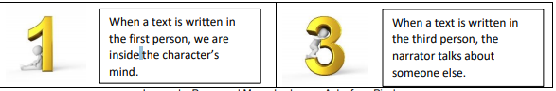

**Choice Board #7. Theme and Inferences**

**Explanation of Theme**

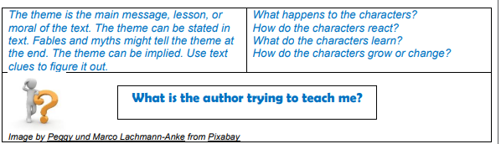

**MATH Choice Board**

***Directions:* Students please complete all the activities from the MATH board in the order that you prefer. Submit evidence of completion by April 24, 2020 in Google Class.**

|  |  |  |
| --- | --- | --- |
| **1. Write the following sentence frame.**  **There were 114 flowers in the garden. Mary picked 78 of the flowers.**  **How many flowers are in the garden now?**  **Write the following sentence frame.**  **There are \_\_\_\_\_\_\_\_ flowers in the garden now.**  **Draw a representation of**  **the problem**  **Example: Number line, Picture** | **2.** **A store clerk had a box with 50 oranges. He threw away 8 of these oranges because they had gone bad. He placed the remaining oranges in two baskets. He placed the same number of oranges in each basket.**  **How many oranges did the store clerk place in each basket?**  **Use a strip diagram and GET strategy, and draw their own representation and equation.** | 3.  **Write three math problems that includes multiplication and division. Send me a picture of the problems you wrote.**  **Example: 6x7 total divided by 12** |
| **4. Comparing and Ordering Whole Numbers**  **Cut number cards for sorting. Place cards in a pile face down. Select five cards from the pile. Use the place value chart to compare and order the numbers. Order the cards from least to greatest and record. Order from greatest to least and record.**  **Explain your thinking using these sentence stems: • \_\_\_\_\_\_\_\_\_\_\_\_ is greater than \_\_\_\_\_\_\_\_\_ because \_\_\_\_\_\_\_\_\_\_\_\_\_\_\_\_\_\_\_\_\_\_\_. • \_\_\_\_\_\_\_\_\_\_\_\_ is less than \_\_\_\_\_\_\_\_\_ because \_\_\_\_\_\_\_\_\_\_\_\_\_\_\_\_\_\_\_\_\_\_\_\_\_. Repeat using different number cards.** | **5. FREE FUN SPACE**    **Any Activity you want your teacher to See** **on Class Dojo**  **Ms. Joseph** | **6. Science**  **Pick Two groups to Investigate and compare how animals and plants undergo a series of orderly changes in their diverse life cycles such as tomato plants, frogs, and lady beetles.**  **Key Concept:**  **\*life cycles \* growth \* characteristics** |
| **7.** **Addition and Subtraction**  **Alma bought her mom a special birthday present that cost $674. Alma contributed $305 to buy the present. Her sister Paula gave her some money to buy the present. Her dad gave her the last $234 she needed to buy the present.**  **How much money did Paula give Alma?** | **8. Solve Two-Step Addition** **and Subtraction Word Problems**  **Review your work from the day before #7 activity. Explain in writing how you used strip diagrams to help you solve math stories. Use strip diagrams to represent the math stories in the Math Stories #2 resource. Solve the math story and then explain the strategy you used to solve the math story.** | **9. Do Imagine Math for at least 30 minutes.** |

***Math Resources***

***Choice Box #4***

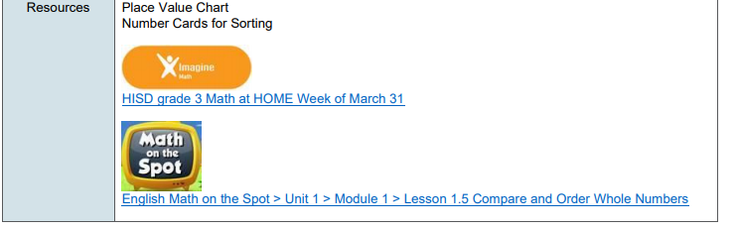

**Example for *Choice Box #6* 1. Read the first time and picture what the math story is about. 2. Read the second time and focus on the question and what you need to find out. 3. Read the third time and determine what important information is needed to answer the question.**

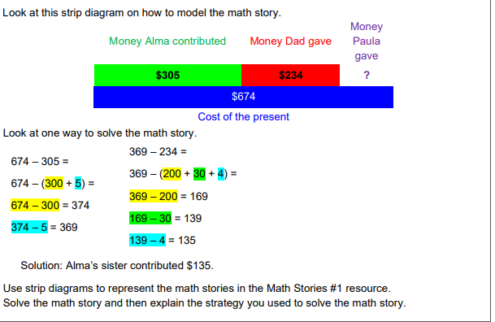

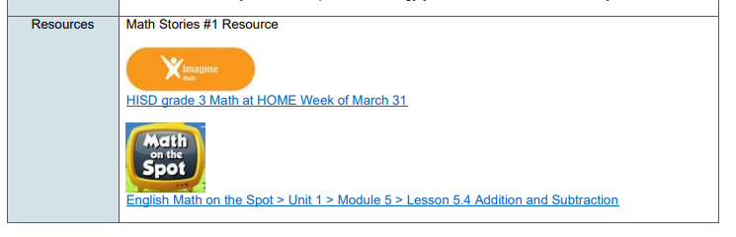

**Project: Due April 24, 2020**

**Activity 2.)  Watch the Story Catching the Moon on** [**www.storyonline.com**](http://www.storyonline.com) **then complete the activity at the bottom.**

