**Two Problems Week 25**

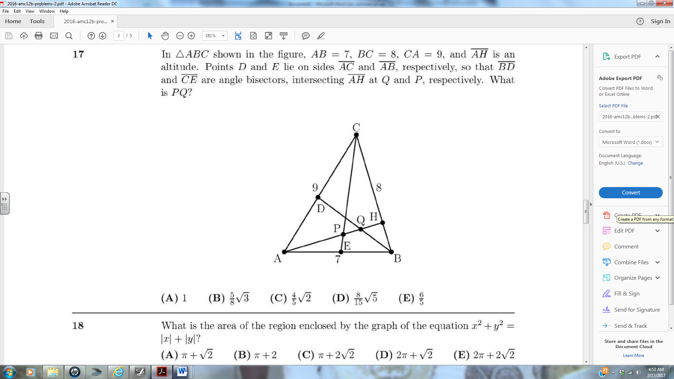 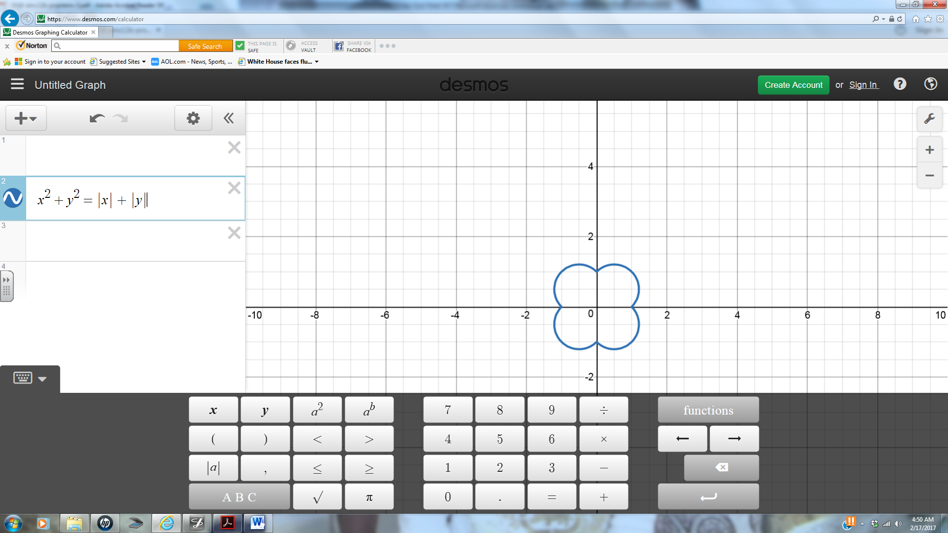

The graph of x2+y2 = is drowned above on the right.