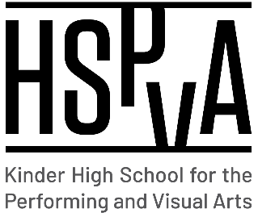

Kinder High School for the Performing and Visual Arts

Shared Decision-Making Committee (SDMC)

Wednesday, December 14, 2022

Minutes in red.

**AGENDA**

1. Call to Order
   * Dr. Rivas called the meeting to order at 11:40 am.
2. Welcome
   * Dr. Rivas welcomed the committee and shared excitement about almost completing the first semester. She mentioned the regrouping teachers had to do in order to make up for the two days lost due tp the water crisis in Houston right after the Thanksgiving break.
3. New Business

* Staffing Updates
  + We have hired a new AP Language teacher, Mr. Falomo to start soon and Mr. Martin Longoria will fill in as interim mariachi director. Students and staff are excited to welcome them!
* Academic Programming for 2022-2023
  + Based on current number, reopening an AP physics class looks possible for the upcoming school year. Also possibly adding an AP Spanish Lit class looks possible. We are excited to offer more AP selections on campus.

1. Budget
   * Admin has been monitoring the budget closely and will have the district budget meeting at the end of December. We are happy to report that we met enrollment projections and will receive a little extra funding that will be used for intervention tutorials.
2. IAT
   * HB4545
   * IAT, tutoring and HB4545 are going extremely well. We are projected to far exceed the number of hours required by the state to ensure all students are receiving the supports necessary for them to be successful academically.
3. Attendance & NGs
   * The attendance committee is scheduled to meet at the end of December to review the students with excessive absences to create a plan of action to regain credit. New rule requires all NGs to be resolved quickly.
4. Safety & Security

* Safety and security committee is meeting regularly to ensure we are in compliance with all drills and that our communication is up to date. We have one more fire drill to conduct this semester.

**Thank you for your service during the 2022-2023 school year!**