**Math/Science Choice Board(Choose 5 out of seven activities: Project a Must!!)**

|  |  |  |
| --- | --- | --- |
| **Activity 1: Stem and Leaf Plot with Whole Numbers** | **Activity 4: Food Webs (Science)**    Objective: Connect food chains to make models of food webs. | **Activity 5: Imagine Math**    **Work on Imagine Math** |
| **Activity 2: Connecting Multiple Graphs**  So far, we have studied frequency tables, dot plots, and stem-and-leaf plots. Write on a piece of paper what they have in common. Then, read the scenario below and create the graphs requested. | **SEL: Create an obstacle course**  A close up of some grass  Description automatically generated  Use items around your house (pillows, pool noodles, baskets, etc) to create a fun obstacle course. | **Activity 6: Inherited Traits**    Objective: Identify inherited traits in plants. |
| **Activity 3: Problem Solving using Stem-and leaf Plots with Decimals** | **Weekly Project: Inherited Traits Booklet**   | **Activity 7: Sit-Ups with Math Facts**   |

**Activity One: Stem and Leaf Plot with Whole Numbers**

A stem-and-leaf plot is another type of graph that we can use to organize our data. This one looks a little different. It has two main parts: the stem and the leaf. It also organizes our data using place value. The stem represents the digit(s) in the greater place value and is normally written vertically from least to greatest. The leaf represents the digit(s) in the lesser place value and is written horizontally from least to greatest.

Look at the following stem-and-leaf plot for the following birthdates: 1, 2, 2, 4, 7, 9, 10, 10, 10, 13, 15, 16, 21, 22, 23, 23, 23, 28, 29, 30, 31

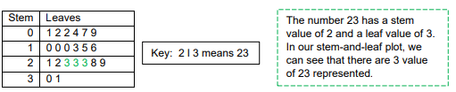

Practice: During the 2019 NFL football season, the Houston Texans scored the following numbers of points in each game: 26, 30, 0, 10, 28, 13, 27, 10, 53, 31, 23, 27, 26, 7, 20, 28, 24, 24, 23, 14, 22, 31 Complete the stem-and-leaf plot below to represent this data. Make sure you write the numbers in order from least to greatest first.

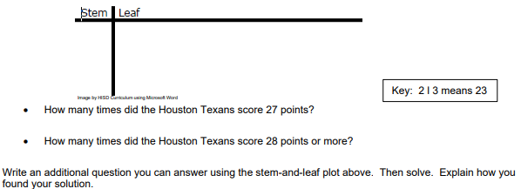

**Activity 2: Connecting Multiple Graphs**

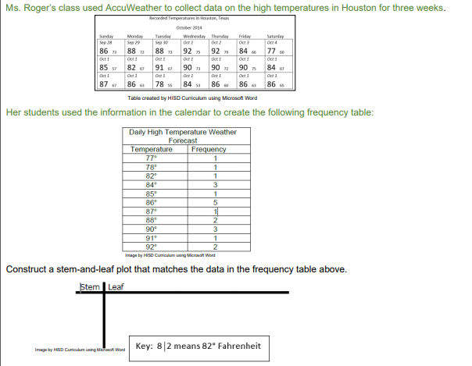

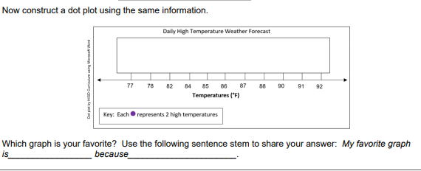

**Activity 3: Problem Solving using Stem-and leaf Plots with Decimals**

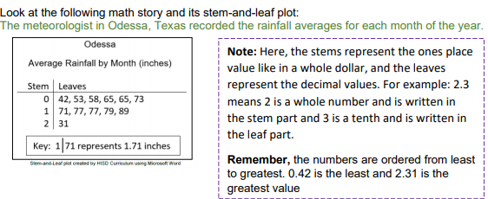

Now, answer the following questions on your paper:

• For how many months did Odessa have an average rainfall total of 0.65 inches? How do you know?

• What is the difference between the lowest rainfall total and the highest rainfall total? Create a question that can be answered by the data represented in the stem-and-leaf plot. Solve and record your solution. Use these sentence stems to help you formulate your question:

• How many months had rainfall over _________?

• How many months had rainfall less than ________?

• How many months had rainfall greater than _________ but less than _____________?

**Activity 4: Food Webs**

**Think about it About It!**

What energy source drives a food web? If you can, discuss this question and share your thinking with someone in your home.

**Do It!**

**What you need:**

• Pencil

• Science Notebook / Paper

• Colored pencils / Markers

**What to do**:

• Look at the picture of the Savannah food web below. Identify/record all the producers and consumers in your journal or a sheet of paper.

• Create food chains from the list of producers and consumers.

• Create a new food web from your food chains. (You do not have to use all the animals listed.)

• Present your new food web and explain the flow of energy to someone in your home.

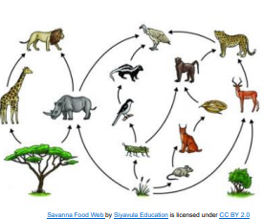

**Understand It!**

Food webs are composed of both producers and consumers that are interdependent. Organisms obtain their primary source of energy from the Sun, and then that energy is transferred from one organism to another. The arrows show the direction the energy flows from one organism to another. Present your new food web and explain the flow of energy to someone in your home.

**Apply It!**

Journal Entry: Compare your food web to the original food web. What are some similarities and differences about the flow of energy?

**SEL Activity:**

Use items around your house (pillows, pool noodles, baskets, etc) to create a fun obstacle course.

**Activity 5: Imagine Math**

Complete at least 30 minutes a for two days on Imagine Math

**Activity 6: Inherited Traits**

**Think About It!**

Who do you look like? Which trait did you get from your mother? Which trait did you get from your father? (Think about eye color, hair color, height…etc.) If you can, discuss your thinking with someone in your home.

**Do It!**

**What your need**:

• Pencil

• Science Notebook / Paper

• Colored pencils / Markers

**What to do:**

• You are going on a scavenger hunt. Inspect the plants around your house to identify the plants and their offspring. (You should look for small shoots or small plants next to larger plants)

• Create a table (like chart shown) or on a sheet of paper and record the inherited traits the plants have in common. Understand It! Inherited traits are characteristics that are passed down from parent to offspring. All organisms pass down traits to their offspring, including plants.

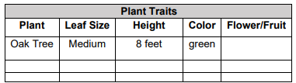

**Activity 7: Sit-Ups**

Do 12 Sit-ups.

Pick a number and do your multiplication facts.

For example:

1x1=1

1x2= 2, So I would do my 1 facts all the way to 12

**DO NOT USE 1 FACTS!!**

**Have someone record/video you doing your jumping jacks, and upload your video.**

**Weekly Project:**

You are to do research on yourself and your family members Then you are to create a book with the following:

Cover Page: On the cover page- Your name (ie. Miss Brigham); Title (ie: My Family); and a Picture (ie: of Yourself or your family)

Page 1: A picture of yourself; Under the picture, a description of yourself: Example: I am 5 feet tall. I have brown hair and brown eyes. I look like my mom/dad.

Page 2: A picture of your mom, dad, grandmom, or granddad. You can choose either one of the choices that I gave you. Then under the picture, you will describe that family member just like you described yourself.

Page 3: Choose your brother or sister, and if you are only child, choose another family member to draw a picture of and describe.