**[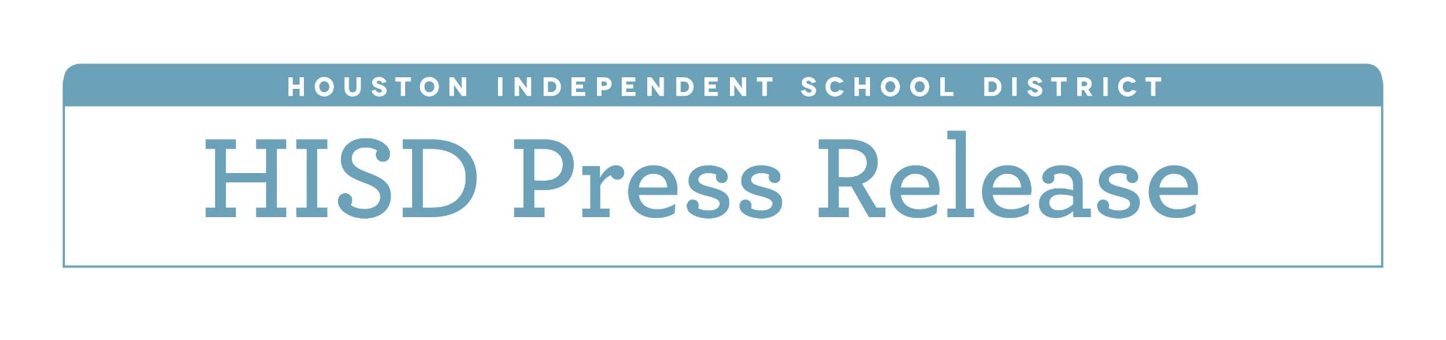](http://www.houstonisd.org/HISDmedia)**

**HISD facing $107 million budget shortfall under current public school funding structure**

*As district prepares to send tax dollars back to the state, it faces shortfall for 2016-2017 school year*

*Feb. 4, 2016* — Under Texas’ current funding structure, the Houston Independent School District will be required to send millions of dollars back to the state, resulting in a projected $107 million budget shortfall for the 2016-2017 school year.

Under Chapter 41 of the Texas Education Code, the state school finance system requires districts designated as property-wealthy to send tax dollars back to the state — a process known as “recapture” and commonly referred to as Robin Hood. The money is then re-distributed to districts deemed to be property-poor, as well as to the state’s general fund for use in non-education purposes.

Though nearly 80 percent of HISD students come from low-income families, the district is considered property-wealthy under the state’s current funding formula because of rising property values throughout the city.

Deputy Superintendent and Chief Financial Officer Ken Huewitt told trustees that the state-mandated “recapture” payment would cause a budget shortfall that could result in significant reductions at both the campus and district level. However, Huewitt stressed to trustees that teaching and learning would remain the district’s top priority. As the 2016-2017 budget is built, he said, the focus will be on students and classrooms.

District and campus administrators have been instructed to review their respective budgets and determine where potential cuts could be made. Potential departmental reductions must be submitted by the end of next week. The amount each department has been asked to identify for potential reduction is directly proportional to their share of the district budget.

Additionally, district administrators are reviewing all central office-based contracts to determine what, if any, can be cut. Also up for consideration is the ASPIRE teacher bonus program, which provides financial rewards to educators whose students are making the strongest gains. The program would award bonuses for the current year but then be eliminated for the 2016-2017 school year, which would save the district about $10 million.

Huewitt stressed to trustees on Thursday that department and campus reductions would only be considered if there was still a shortfall after reductions had been made in central office contracts and the ASPIRE teacher bonus program.

The 2016-2017 budget update was presented on Thursday during an HISD Board of Education workshop. Another budget workshop is expected to be scheduled in early March.

