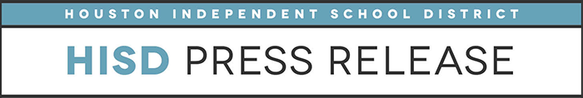

**Slime kits, action figures top the list in Longfellow ES annual toy survey**

*Nov. 16, 2018* – Houston Independent School District students at Longfellow Elementary announced today that action figures and slime kits are two of the hottest toys this holiday season, according to their annual toy survey.

“Today we are showing some different toys that your child might want,” said fifth-grader Kaylyn Newcomb. “We want to give you a little bit of inspiration so you don’t have to draw things out and ask them what they want.”

For the ninth consecutive year, Longfellow students surveyed their classmates to determine what gifts kids would like to receive for the holidays. The goal of the survey is to help give parents and relatives an idea of what to buy before they do their holiday shopping.

Tablets and phones were popular among second-grade girls, which surprised many of the surveyors. Other top toys are Legos, Squishies and Nerf Guns.

The students worked in teams for more than two months to survey classmates and spent a week compiling their findings.

“We are really proud of the students. They were really logical about it this year,” said program organizer and fourth-grade teacher Jennifer Howell. “They took tablets out to survey the kids, tabulated all of it and then put it into the PowerPoint [presentation].”

In addition to presenting their findings, the students showcased samples of the top toys that were provided to the school by Target. After the announcement, the fifth-graders who led the survey were allowed to choose a toy for themselves. The remaining toys were later given to needy Longfellow students.

Below are the results of this year’s survey, by gender, for all grade levels.

**Girls**

1. Slime Kit
2. LOL Dolls
3. Squishies
4. Hatchimals
5. Dolls (Barbie/Monster High)

**Boys**

1. Action Figures
2. Toy cars
3. Nerf guns
4. Toy train

Legos