Activity 1: Comprehension Cootie Catcher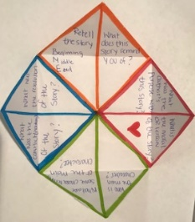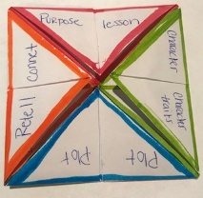 | Activity 2: Self Portrait  Draw a cartoon like picture of yourself. Around you put some of best characteristics.  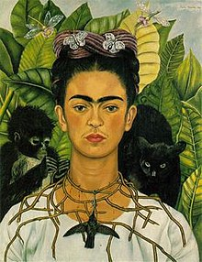***Minimum of 10 adjectives. | Activity 3: Comic Strip Plot Retell  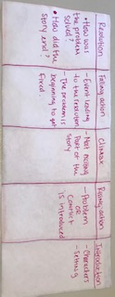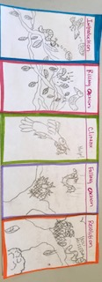
Activity 4: Create your own story.  Look around your house or outside find three (3) objects that you find interesting and create a story using those objects.  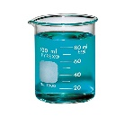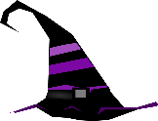  This Photo by Unknown Author is licensed under CC BY-SA | Activity 5: Read and Record  Pick a good book. Find a phone/computer or tablet to record yourself either audio only or video as well. Read and record yourself while you read.   | Activity 6: Informational Text Dive  Choose a non-fiction book (informational text) on a separate sheet of paper answer these questions.  ***If no other book is available use article provided.  ***Questions in the back
Activity 7: Book Club  Choose a book and discuss it with a friend. Screenshot your conversation and send it to me.  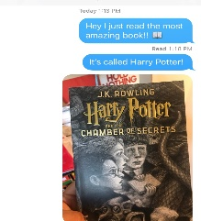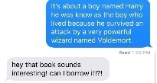 | Activity 8: Documentary  Choose a documentary to watch and answer the following questions  - Oceans  - Terra  - Dancing with the Birds  - Untamed Romania  .  | Activity 9: Accordion Vocabulary  Students will choose 5 words of the vocabulary list and create vocabulary accordion.  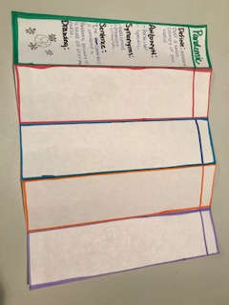
Project: State Float
Instructions: Students will choose one of the fifty states in the United states to learn more about it. Once the student has done research on his selected state. The student will create a model of a parade float for the selected state.
Requirements: Float must include;
- State name
- State flag
Your state name
- At least three state symbols (google search: _____________ state symbols)
- Outline state’s shape (trace a picture of your state)
Your state name
- Date of statehood (google search ______________statehood date)
- A representation of a leisure activity (something people do for fun) that is popular in your state.
*** Take a short video showing off your project explaning all these different components of your float. Upload/ text this video to Class Dojo for a test grade. Rubric is attached to the State Float Project packet.
ELA/Social Studies Choice Board
Activity 1:  Materials: sheet of paper, scissors, colors, fiction book  Instructions:  Students will use a sheet of paper to create a cootie catcher with comprehension questions to answer after they are done reading a fiction story.  ***Take a short video of you answering one of the questions on the cootie catcher this will be taken as grade. | Activity 2:  Materials: Sheet of paper, pencil, colors.  Instruction: Student will use a sheet a paper to draw a cartoon like self-portrait. Once done the student will use adjectives to describe some of their characteristics. There need to be a minimum of 10 characteristics around the self-portrait. | Activity 3:  Materials: Sheet of paper, pencil, colors, scissors, fiction book  Instructions: Students are to create a comic strip of a fiction story they read. The comic strip will tell the plot of the story in pictures.  Plot includes:  Introduction- characters, setting  Rising action- the problem begins  Climax- part with the most action.  Falling action- the problem begins to get resolved.  Resolution- what was the solution of the problem.  Each part in your comic strip must represent one part of the plot, therefore you will have five (5) sections.  ***This will be taken as grade. Upload/text a picture to Class Dojo or myself.
Activity 4:  Materials: three objects around the house, pencil, paper.  Instructions: students will write a story that include the three objects that they found in their house.  Requirements:  -story must include the three chosen items.  -Student must write at least half a page. | Activity 5:  Materials: phone/table/computer and a book.  Instructions: while you read record yourself  ***This will be taken as grade. Upload/text a picture to Class Dojo or myself. | Activity 6:  Materials: sheet of paper, pencil, article or nonfiction text of your choice.  Instructions: Students are to answer the following questions using complete sentences.  Questions:  - What questions do you still have on the topic?  - How does the author show that he/she is an expert on the topic?  - Write three questions that you can answer about your topic after reading.
Activity 7:  Materials: phone, book, parent permission to text friend.  Instructions: student is to read a book. Once they have finished text your friend and tell them about your book with great detail. Screenshot your conversation and send it to me for Dojo Points! | Activity 8:  Materials: pencil, paper, Netflix  Instructions: Watch a documentary answer the following questions.  Questions:  - What questions do you still have on the topic?  - How does the author show that he/she is an expert on the topic?  - Write three questions that you can answer about your topic after reading. | Activity 9:  Materials: Paper, pencil, colors, vocabulary list  Instructions: take the piece of paper and fold it accordion style to make five equal parts. Put the vocabulary word at the top of the section. (look at example) Find a synonym, antonyms, write a sentence using the word and draw a picture to represent the word.  ***This will be taken as grade. Upload/text a picture to Class Dojo or myself.
Instructions

