1. Reading  Retelling Glove  • Choose a fiction book to read.  • You will retell the story using elements from the text.  • You may trace your hand on paper and leave enough space on each finger to include details about the main character, setting, conflict, resolution and lesson learned.  • Use the sample below to know where to write the details about each element on your retelling glove.  • Use the space below to retell your text in complete sentences.  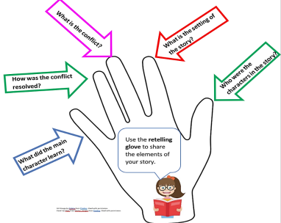  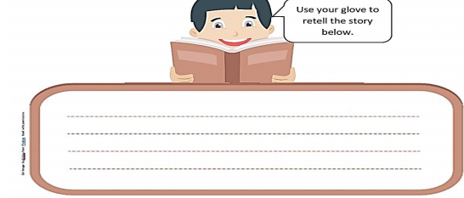 | 2. Math  Two- and Three- Dimensional Figures  Sort the polygons according to a self-selected attribute. Remember to use formal geometric vocabulary (e.g., vertices and sides) to describe the sort. Sort the polygons according to the attribute you selected and label each circle.  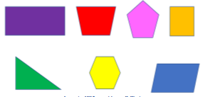  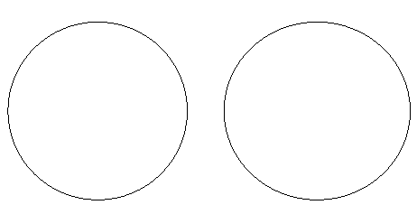 | 3. Science  Basic Needs of Animals  Identify the basic needs of animals  What do animals need to survive? Discuss the question and share your thinking with someone in your home.  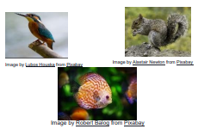  Choose one of the animals.  Write about the basic needs of the animal and explain why these needs are important.  A __________ needs _________ because _________.  My animal is a ___________. It eats ____________. Its  shelter is ______________. It drinks ___________. It  breathes _______________. A _______________  needs _________________  because________________.  Resources: sheet of paper, Pencil, Colored pencils.
4. Reading  Persuasive Letter  THINK about something that you feel your school needs.  WRITE a short letter to your principal telling her what you think the school needs.  Be sure to —  •include all the parts of a letter: the date, the greeting, body, closing, and the signature.  •talk about why you think it is needed, who would benefit from  having it, and how it will make the school better  •write complete sentences  •look over your work for capitalization, grammar, spelling and  punctuation errors.  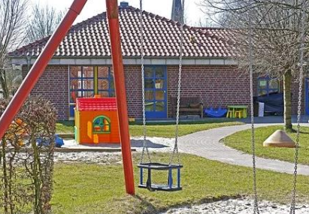   | 5. Math  Length  Look at this number line  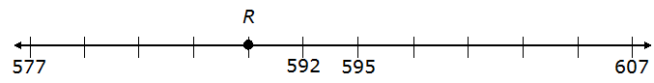  a. What number does point R best represent? ______________  b. What distance is point R from 577? _______________  c. What distance is point R from 607? ________________ | 6. Science  Objects in the sky  List and describe some objects you might observe in the sky on a clear night.  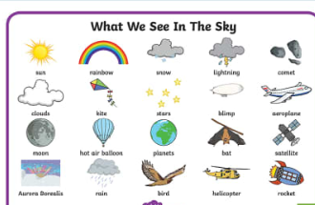
7. Reading  Log on to Imagine Reading for 60 minutes. Using the log in information sent to you.  OR  Synonyms  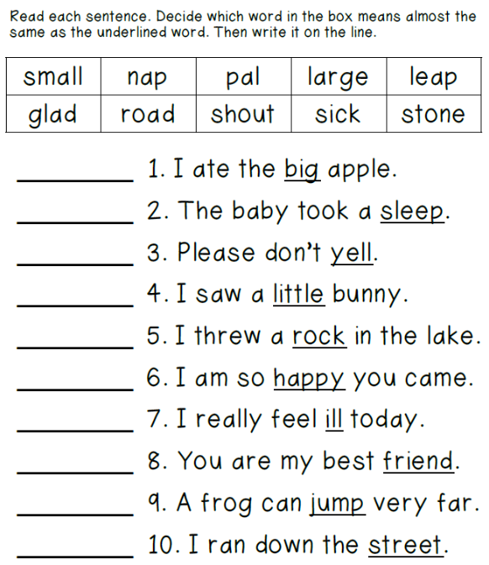 | 8. Math  Log on to Imagine Math for 60 minutes. Using the log in information sent to you.  OR  Measurement: Area  Samantha planted a garden in her backyard. The rectangle below represents her backyard. The shaded squares represent her garden.  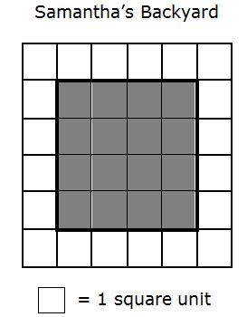  a. In square units, what is the area of Samantha’s backyard (including her garden)?  b. In square units, what is the area of Samantha’s garden? | 9. Social Studies  Producers and Consumers  1. Read the article about farm workers.  2. Draw a picture and write about each step produce takes from the farm to the store.  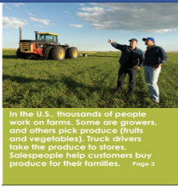  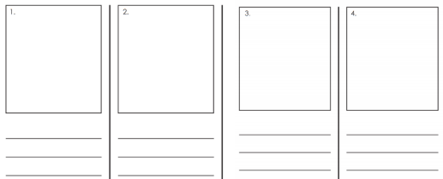  Resources: Notebook paper, pencil.

Weekly Project: ‘Compound word foldable’

Think about some compound words you know. Create a portrait foldable. Write the compound word, draw a picture and color like the one below. Compound words are formed when two or more words are joined to create a new word that has an entirely new meaning. For example, “Sun” and “flower” are two different words, but when put together, they form another word, Sunflower.
What you need:
- Paper
- Crayon or color pencil
- Scissors
- Pencil

Steps:
- Fold the Paper such that you will have point A, B and C.
- Crease the paper along the fold.
- Open the paper and cut point A and C in the middle.
- The crease line is the bisector of the segment.
- On point B write the compound word and draw.
- For Point A and C, you will break up your compound word. Write and draw the first part of the word on point A and the other on point C.
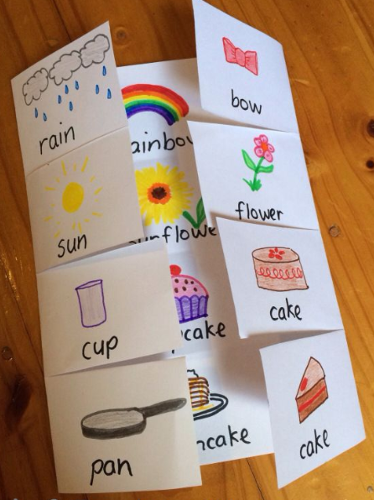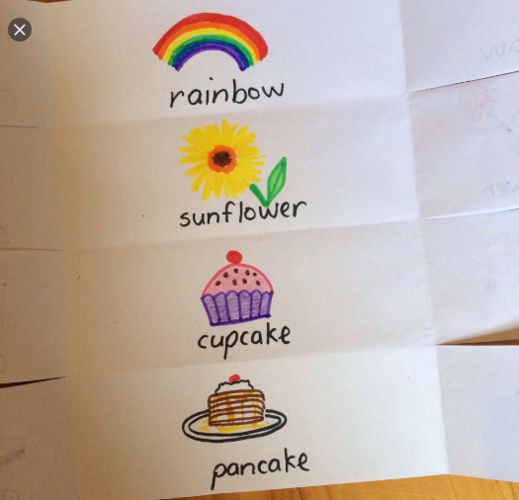
Directions: Each week students will receive a menu to be completed by the end of the week. Students will choose activities based on interest but must do: 9 squares (3Reading, 3 Math, 1 Science, 1 Social Studies, 1 extra, + Project). Of the 12 boxes, 9 must be completed. More points and reward will be given to students that will send their pictures or videos of them (parents and students) completing the work.
*The 9 boxes activity due date is May 8, 2020 while the project due date is May 15, 2020. Please submit evidence of the completion of all these activities for your child to receive the grades that are required by Texas Education Agency for this semester of learning. send completed work via our class dojo or email it to me at Esther.Onyia@houstonisd.org
If you have any questions, please feel free to call Ms. Onyia @ 281-748-6694.
Thank you for your time and patience during this time of need. Amazing Second Grade.

