1. Reading  Cause and Effect  • Today you will find the cause and effect of your text.  • Read the tip below to understand how to find the cause and effect.  • Use the following questions to help you think about the cause and effect as you read  - What happened?  - Why did this happen?  - Use the chart below to write about cause and effect relationships you found as you read.  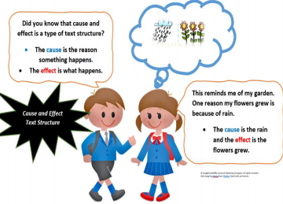  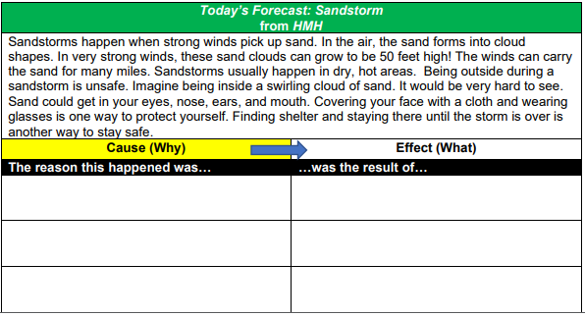 | 2. Math  Piggy banks help us save money. When we put money into the piggy bank, we are making a DEPOSIT. Deposits help add money to the bank and make the amount that you have saved grow larger over time.  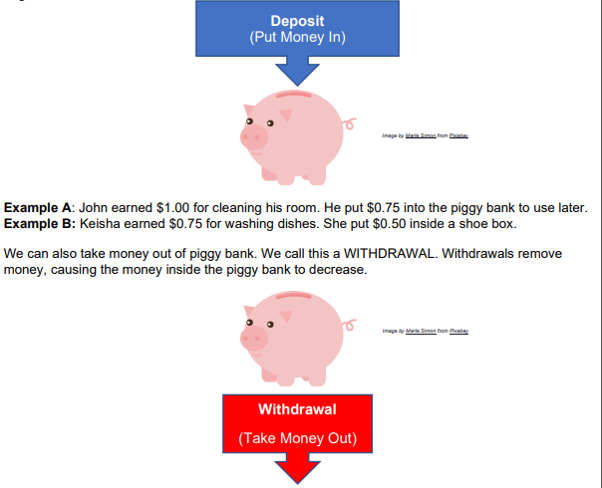  Example A: Martin takes out $0.25 of piggy bank to buy gum. Example B: Kendra removes $0.50 of her shoe box to buy a raffle ticket.  Practice: Read the following situations and determine whether each is a deposit or a withdrawal. Explain why.  Situation A: Coach Nolan put $2.75 inside a piggy bank to use to buy a basketball later.  Situation B: Ms. Stewart took out $0.52 of her shoe box to buy pencils for her son.  Situation C: Kendrick earned $0.80 for washing clothes. He saved all his money inside piggy bank. | 3. Science  Producers – Living to Nonliving Interaction.  Objective: Identify how producers use the sun to make food.  Think About It! How do producers use energy from the sun to survive? If you can, discuss this question and share your thinking with someone in your home.  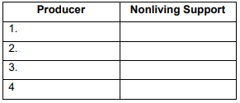  What to do:  • If you are able, go outside and search for all the producers around where you live  • Draw a chart like the one above.  • Write down all the producers you see on the Producer chart  • Identify any non-living factors helping the producer to survive.  Understand It! All grass, plants, trees, flowers, and fruits are called Producers because they make their own food using energy from the Sun.    Other Nonliving factors such as water, oxygen and soil also help Producers survive.  Resources: Notebook or sheet of paper, Pencil.
4. Reading  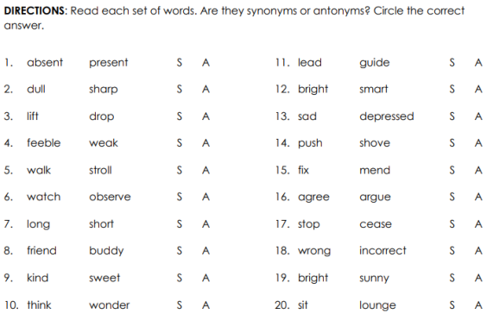 | 5. Math  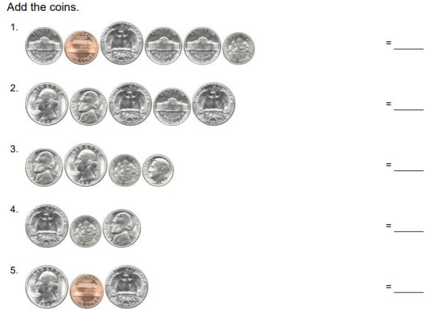 | 6. Science  Reuse and Recycle  Identify and demonstrate how to reuse and recycle natural resources and materials such as paper, plastic, and metal at home.  Think About It! How do you reuse or recycle materials at home?  What to do:  • Search your home for objects that can be reused or recycled.  • Create the T-chart shown and list the objects in the chart. • Use the materials collected to create a sculpture.  • Draw a picture of your sculpture in your notebook  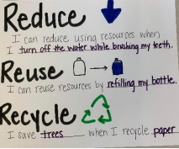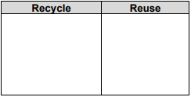  Resources: Notebook or sheet of paper, pencil, crayons.
7. Reading  READ the information in the box below.  THINK about the importance of family in your life.  WRITE about how the importance of family. Explain what makes your family important.  Be sure to ―  • clearly state your central idea  • include details to support your central idea  • organize your writing  • choose your words carefully  • use correct spelling, capitalization, punctuation, grammar and sentences.    10. Log on to Imagine Reading for 60 minutes. Using the log in information sent to you.  OR  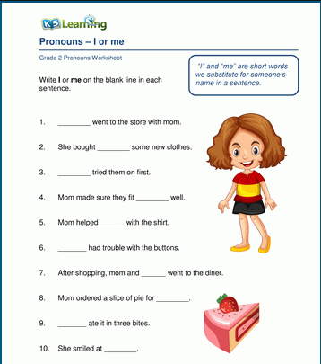 | 8. Math  Log on to Imagine Math for 60 minutes. Using the log in information sent to you.  OR  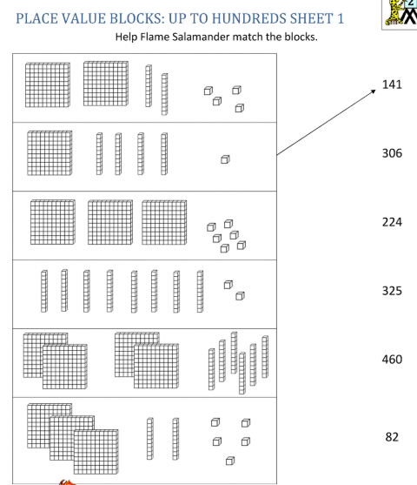  11. Math  Sally earned money for doing chores around the house last week. She spent some of the money but also saved some of it (or put it aside to use later).  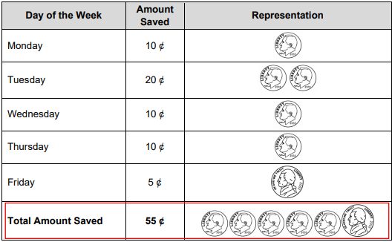  When you save money, and continue to add to that saved money, the total amount of money you save increases (or grows) over time. This is called accumulation. Sally saved the following amounts: 10¢ + 20¢ + 10¢ + 10¢ + 5¢ = 55¢.  Practice: (Use real coins if they are available to help you answer these questions.)  A. Solve the following math story: Tony gets an allowance every week. He saved 15¢ from his allowance last week and 25¢ from his allowance this week. How much money did Tony save last week and this week?  Challenge: How much more money does Tony need to save if he wants to save a total of 100¢?  B. Answer the following questions:  • How can you calculate how much money a person can save over a week?  • What can you do with money you receive instead of spending it right away?  • Explain why it would be important to save money for later | 9. Social Studies  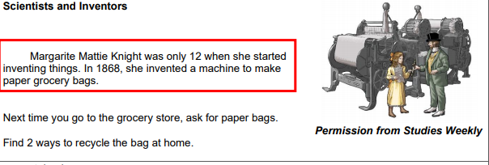  12. Social Studies  Scientist and Inventors  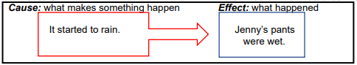  Read the sentence in the Cause column. Draw a line to the sentence to the Effect column that matches.  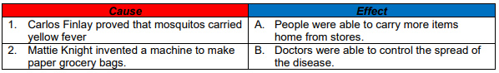  Resources: notebook paper, copy paper, crayons.

Weekly Project: ‘2 and 3-dimensional Shape construction’
- Use toothpicks and gumdrops to construct 2 and 3 dimensional shapes. write the name of each shape and their attributes. For your 2-dimensional shapes write how many sides and vertices it has. Write how many faces, edges and vertices your 3-dimensional shape has. take a picture and upload to your portfolio on dojo. Record or take pictures of yourself constructing your shapes.
What you need:
- Gumdrops, marshmallows, apple pieces, cheese, Styrofoam, play dough, or gummy bears etc.!
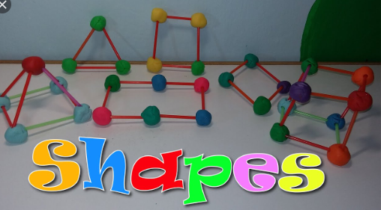
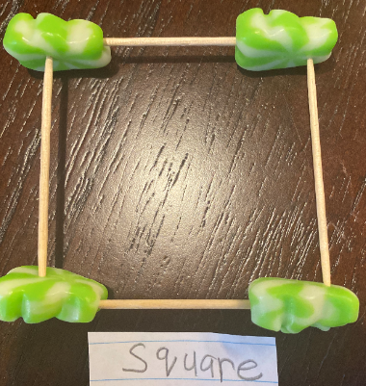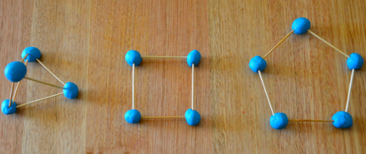
Directions: Each week students will receive a menu to be completed by the end of the week. Students will choose activities based on interest but must do: 9 squares (3Reading, 3 Math, 1 Science, 1 Social Studies, 1 extra, + Project). Of the 12 boxes, 9 must be completed. More points and reward will be given to students that will send their pictures or videos of them (parents and students) completing the work.
*The 9 boxes activity and project due date is May 29, 2020. Please submit evidence of the completion of all these activities for your child to receive the grades that are required by Texas Education Agency for this semester of learning. send completed work via our class dojo or email it to me at Esther.Onyia@houstonisd.org
If you have any questions, please feel free to call Ms. Onyia @ 281-748-6694.
Thank you for your time and patience during this time of need.
Amazing Second Grade.

