**Math/Science Choice Board(Choose 5 out of seven activities: Project a Must!!)**

|  |  |  |
| --- | --- | --- |
| **Activity 1: Representing the Decimal to the Hundredths Place (Money) Concrete and Pictorial** | **Activity 4: Volume**    Objective: Determine which object has the greatest volume. | **Activity 5: Imagine Math**    **Work on Imagine Math** |
| **Activity 2: Representing the Decimal to the Hundredths Place (Money) Expanded Notation** | **SEL: Dance Your Heart Out**  A drawing of a cartoon character  Description automatically generated  Have a group video call with friends and do a virtual dance party. Use tools like Skype or Zoom. | **Activity 6: Insulators**    Objective: Identify insulators of thermal energy. |
| **Activity 3: Fixed and Variable Expenses** | **Weekly Project:**  **Forms of Energy**   | **Activity 7: Difference Between Insulators and Conductors**   |

**Activity 1: Representing the Decimal to the Hundredths Place (Money)**

Money can be used to help you represent decimals that name tenths and hundredths. Use the information in the table to the right as a reference.

Complete the table below using the information given. Think about the place values of pennies, dimes, and dollar.

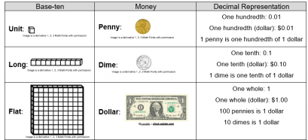

Questions to think about:

• What is the value of the digit in the tenths place? How do you know?

• What is the value of the digit in the hundredths place? How do you know?

• What is the value of the digit in the ones place? How do you know?

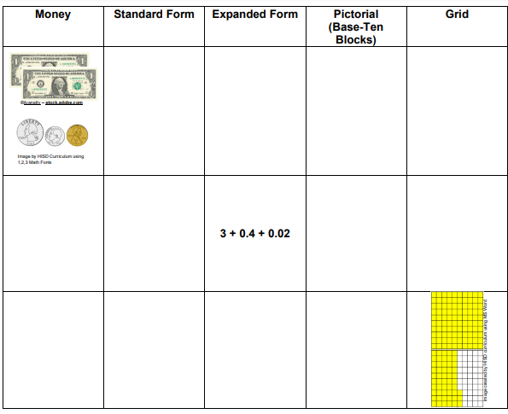

**Activity 2: Representing the Decimal to the Hundredths Place (Money) Expanded Notation**

Divide a piece of paper into six equal sections. Repeat the process on another piece of paper. Write the digits 0-9 in the sections on the paper.

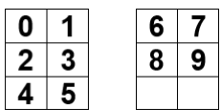

Cut out the digit cards, shuffle them, and place them face down on the table.

**Step 1:** Pull four-digit cards and place them in the place value chart like the one below.

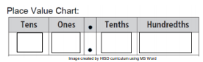

**Step 2**: Represent the number created in standard form, expanded notation (decimals), and expanded notation (fractions).

• Standard form:

• Expanded Notation (decimals):

• Expanded Notation (fractions):

**Step 3**: Repeat the steps 1 & 2 three times.

**Practice**: Read and solve the following problem. Jonathan bought a video game. The price of the video game was $25.35. How can we use expanded notation to represent the value of the digits in this number?

• Create a place value chart.

• Write this number in expanded notation using decimal and fractional representations.

• Expanded Notation (decimals):

• Expanded Notation (fractions):

Explain how the representations are similar and different. Is there another way to represent this number?

**Activity 3: Fixed and Variable Expenses**

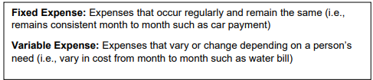

Provided are a set of expenses that are used in real-world situations. Sort these expenses to complete the two-column chart below as fixed expenses or variable expenses

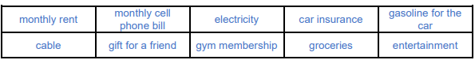

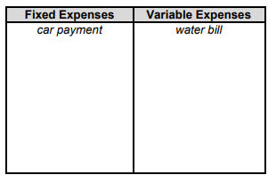

Use the chart to complete the sentence stems and answer the questions.

• I know that car insurance is a ____________ expense because________________.

• I know that groceries are a _______________expense because________________.

Questions:

1. How many more fixed and variable expenses can you think of? Add them to the chart above.

2. Rank the expenses from most important to least important.

**Activity 4: Volume**

**Objective:** Determine which object has the greatest volume.

**Think About It!** How can we find out which object has the greatest volume? If you can, discuss this question and share your thinking with someone in your home.

**Do It!**

**What you need**:

• Pencil • Science notebook/ Paper

• Tall, clear glass or pitcher similar to the one on the right

• Water

• Masking tape

• Several small objects that will fit into the glass

**What to do:**

• Put a piece of masking tape on the glass to make a measurement bar.

• Fill the glass about half-way with water.

• Record the “before” water level by making a small mark on the masking tape.

• Place your first object into the water, and make a small mark at the new water level. The object should be small enough to fit completely under the water.

• Repeat the process with a different object, and record which of the two cause the water to rise the most. That is the object with the greatest volume.

• Repeat the process with two different objects.

**Understand it!**

• Volume is the amount of space taken up by matter.

• Volume of liquids can be measured in mL using a graduated cylinder or beaker.

• The volume of a solid can be measured by dropping the object into water.

• The object will move aside, or displace, the water it is in, causing the water level to rise.

• The object that causes the water level to rise the most is the object with the greatest volume.

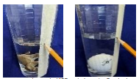

**The golf ball caused the water to rise more than the toy elephant. The golf ball has the greatest volume.**

**Apply It!**

Some students wanted to find the difference in volume between three different blocks. They filled each graduated cylinder to the same point, and then dropped one block in each cylinder. The pictures below show the level of water after the students dropped the blocks in.

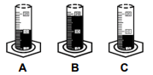

Journal: Which of the blocks had the greatest volume? Explain how you know.

**SEL Activity: Dance Your Heart Out**

Have a group video call with friends and do a virtual dance party. Use tools like Skype or Zoom.

**Activity 5: Imagine Math**

Complete at least 60 minutes a week on Imagine Math

**Activity 6: Insulators(Science)**

**Objective:** Identify insulators of thermal energy.

**Think About It!** What can you use to take a pizza out of the oven? Why would you need to use it? If you can, discuss this question and share your thinking with someone in your home.

**Do It!**

**What you need:**

• Pencil

• Science notebook/ Paper

• 1 plastic cup, 1 Styrofoam cup, 1 glass cup

• 3 ice cubes

**What to do**:

• Place one ice cube in each cup.

• Cover with a paper towel and let sit for 15 minutes.

• Observe the size and amount remaining of each ice cube

. • Draw your observations of each ice cube.

• Which cup was best at preventing the ice from melting?

**Understand it!**

Materials that do not conduct energy well are considered insulators. Insulators do not allow heat to move easily through them. Plastic, rubber, wool, and wood are examples of insulators.

**Apply It!**

Which type of cup was best for preventing ice from melting? Explain why the properties of the cup made it the best insulator of thermal energy. Give examples of at least 3 insulators found in your home. Why do you think insulators are important?

**Activity 7: Difference Between Insulators and Conductors**

Watch the following video on YouTube: <https://www.youtube.com/watch?v=a6ugPfzc70Q>,

and explain in your own words the difference between insulators and conductors of thermal energy. Also include example of each. Should be at least 4 sentences.

You can also find age appropriate videos on insulators and conductors to help you with your paragraph.

**!Weekly Project: Forms of Energy:!**

Directions:

Pick one form of energy (Mechanical, Electrical, Light, Thermal and Sound) and make a poster with the form of energy. Poster should include:

Title(form of energy you chose), Description or definition of the form of energy, and pictures of different examples of that form of energy (example: sound energy-radio)