Mrs. Price/Ms. Lara Week of May 18 – 22, 2020 Grade 1
Instructions: Choose the activities you want to complete. Out of the 12 boxes, 9 must be completed (3 Reading, 3 Math, 1 Science, 1 Social Studies, + 1 extra choice or Project). Please send evidence of completion of all these activities so that your child can receive credit. You can send pictures of your completed assignments through ClassDojo.
Reading | Math |  | Science
Choice 1  Reading Comprehension Book, Head, Heart!  1. Pick an interesting fiction text to read for the week.  2. As you read, stop and write a response in the “In the Book” column of the graphic organizer below.  3. Discuss your response with someone at home.    1. This book is about …  2. _____ is telling the story.  3. The author wants me to know …  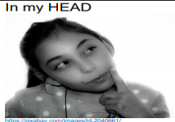  1. I noticed …  2. I was surprised when …  3. This reminds me of …    1. Something that changed in my heart was …  2. This book can help me be better by …  3. My heart lesson is …  * Spend at least 30 minutes on Imagine Language & Literacy | Choice 2  Problem Solving  Read the following math story three times:  - Read aloud the first time and picture what the math story is about.  - Read aloud the second time and focus on the question and what you need to find out.  - Read aloud the third time and determine what important information is needed.  Alex had 17 toy cars. Alex gave 8 toy cars to his brother. How many toy cars does Alex have now?  * Represent the math story using counters: beans, beads, bottle tops, etc. Then use pictures, numbers, and words to show your work:  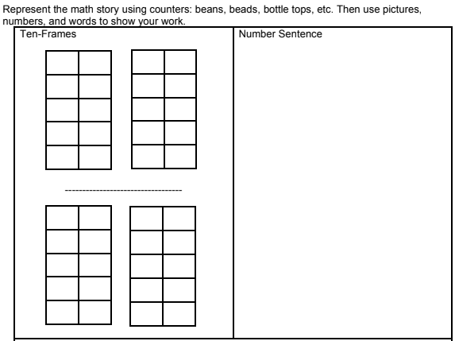 |  | Choice 3 – Science  Objective: In a pond ecosystem, I can identify plants as living things and having basic needs.  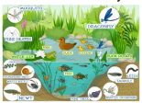  What you need:  • piece of paper • Pencil or crayons  • Picture of pond ecosystem (attached)  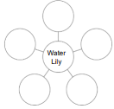  What to do:  • Copy the bubble chart into your paper.  • Observe the pond ecosystem picture (attached).  • Describe the needs of the Water Lily that will help it grow.  • Record each need on the bubble chart.  • Determine if the Water Lily is living.  *Plants are living organisms with basic needs. These needs typically include food, water, air, and space to live and grow. • Air, water, and light help plants make their own food. • Nutrients from the soil help keep the plant healthy. • Space gives the plant enough room to grow  Journal Entry: Write about the basic needs of plants.  The Water Lily is _____ (living or nonliving).  The Water Lily needs _______ for __________. The Water Lily needs _______ for __________. The Water Lily needs _______ for __________.
Choice 4  Reading Comprehension Book, Head, Heart!  1. Pick an interesting fiction text to read for the week.  2. As you read, stop and write a response in the “In the Book” column of the graphic organizer below.  3. Discuss your response with someone at home.  1. This book is about …  2. _____ is telling the story.  3. The author wants me to know …  1. I noticed …  2. I was surprised when …  3. This reminds me of …  1. Something that changed in my heart was …  2. This book can help me be better by …  3. My heart lesson is …  * Spend at least 30 minutes on Imagine Language & Literacy | Choice 5  Two more  Materials:  - Beans  - Pencil  - Paper  - Number strip 1-20  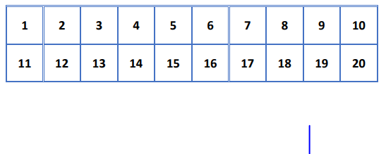  Directions:  - Put a bean on the number 1 on the table.  - On your paper, write the number 1.  - Now draw the plus symbol to show two more than 1: 1 + 2 = ____  - Move the bean 2 times, you will land on the number 3 on the number strip.  - Now complete the number sentence:  1 + 2 = 3  - Repeat activity 5 times using different numbers on the table  Example: 6 + 2 = _____ |  | Choice 6 – Science  Objective: Identify that animals are living and have basic needs.  What you need:  • sheet or paper • Pencil  • Crayons or markers • Outdoor space  What to do:  • Go outside or look out of your window. Safety tip: Keep a safe distance from others.  • Think: What animals do you see? What are the animals doing? Where do the animals live?  • List the animals that you see.  • Draw a picture of 2 of the animals that you see. • Label the names of the animals that you drew.  Animals are living things. To survive, all living things have basic needs. These basic needs include food, water, air and a place to live (shelter). Animals need food to eat and water to drink. Animals also need air to breathe and a place to live (shelter). While we can go to the store to buy food, animals must depend on their environment for food to eat and for a place to live (shelter).  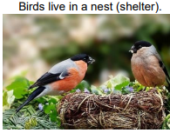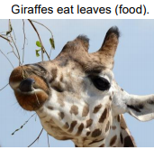  Journal Entry: Use the sentence stems to help you explain what animals need to survive.  Animals need _______ to eat.  Animals need _______ to breathe.  Animals need a place to _________.
Choice 7  High Frequency Words    1. Read each word to someone at home or to a stuffed animal.  2. Find and circle the words in the puzzle below.  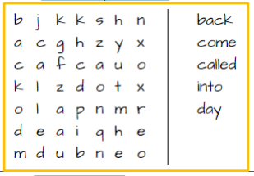  * | Choice 8  Adding Doubles  Double are math facts where we add the same number to itself.  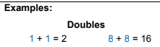  For this activity you will be adding doubles, numbers that are the same.  Practice adding doubles. You can use objects, macaroni, Legos, or any object to help you count doubles.  Complete the table below.  - To figure out what doubles you are going to add, roll a number dice.  - Draw your double.  - Create a number sentence ___+ ____= ___  - Add the sum. Record your answer in your table.  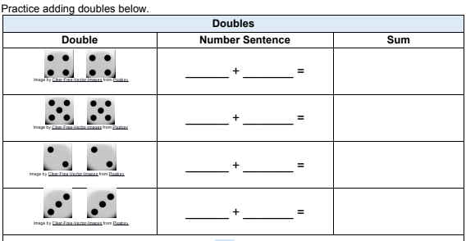 |  | Choice 9 – Social Studies  “Shhh It’s A Surprise!”  It’s fun to be surprised when you open a birthday gift.  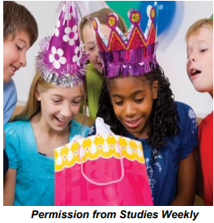  Discuss with your parents and write about a time that you were surprised when you opened a gift.  
Choice 10  Creative Writing    1. If I was a superhero, my name would be…  2. My superpower would be…  3. Draw a picture of yourself as a superhero using your superpower.  4. Use notebook paper for writing and drawing | Choice 11  Write a word problem that can be represented by the number sentence: 12 – 7 = ___ and solve the equation.    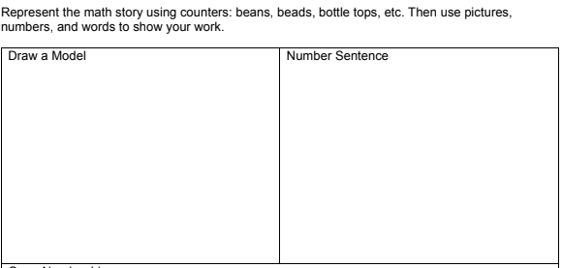  Represent the math story using counters: beans, beads, bottle tops, etc. Then use pictures, numbers and words to show your work. |  | Choice 12 – Social Studies  Families did not have much privacy  Long ago, people in America lived in homes with only one room.  How is your home different from Americans long ago?  Draw a picture of your home.  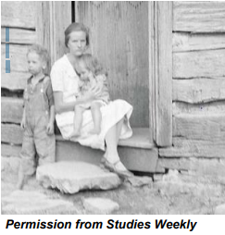  *
Choice 13  Ms. Johnson’s Class Only – Reading  Which /k/ sound? Spelling with c, k, ck  Directions:  Write either c, k, or ck to spell the correct word.  tru ____ ____ast  ____it sta____  loc____ ____lass  ____at as____  a____t s____ill  s____it ____id |  | Choice 14  Ms. Johnson’s Class Only – Math  Directions:  Rewrite each list of numbers in order, from least to greatest.  a.   ________, ________, ________, ________  b.   ________, ________, ________, ________  c.   ________, ________, ________, ________  d.   ________, ________, ________, ________  e.   ________, ________, ________, ________
Weekly Project
Craft Cleverly Camouflaged Lizards

Can you imagine what a camouflaged lizard may look like?
Let’s see, can you find the lizard in the pictures below?
Well, did you know that some animals use camouflage to protect themselves from danger.

You are to create a paper lizard. Then you are to create a patterned background for your paper lizard to blend into.




