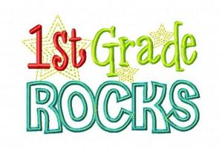

Supply List

DO NOT LABEL

|  |  |
| --- | --- |
| 4 bx | Crayola crayons 24 count |
| 2 pk | 24 pencils |
| 2 | Large Pink Erasers |
| 4 | Large Glue Sticks |
| 1 | Pair of blunt scissors |
| 1 pk | Sheet Protectors |
| 3 pk | Clorox or Lysol wipes |
| 2 | Bottles of hand sanitizer |
| 6 | Primary 1st Grade Composition Notebook |
| 1 | Legal sized pack of manila paper |
| 1 pk | 6 Dry Erase markers |
| 3 bx | Facial tissue 120 count |
| 1 bx | Storage Bags Ziploc Quart size |
| 1 bx | Storage bags Ziploc Gallon size |
| 3 pk | White vinyl, latex free Eraser |
| 1 each | Red, Blue, Yellow, Orange plastic folder with pockets and NO brads |
| 2 pk | Index cards 200 count |
| 1 pk | Color construction paper 9x12 |