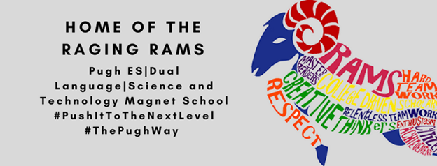
SDMC Minutes
Friday, September 17, 2021
- SIP
The Team went over all portions of the 2021-2022 SIP. We discussed our Math, Reading and Attendance goals. All portions of the SIP were agreed upon during the meeting.
- ESSER Funds
We discussed using ESSER funds for:
  - Marketing
  - Cleaning supplies
  - Tutorials
  - Reading and Math Materials
- COVID cleaning supplies
  - If the district stops providing cleaning wipes, then ESSER funds should be used to purchase Lysol wipes

