Mrs. Price & Ms. Lara Week of April 6 – April 10, 2020 Grade 1
Instructions: Choose the activities you want to complete. Out of the 12 boxes, 9 must be completed (3 Reading, 3 Math, 1 Science, 1 Social Studies, + 1 extra choice or Project). Please send evidence of completion of all these activities so that your child can receive credit. You can send pictures through ClassDojo.
Reading | Math | Science/Social Studies
Choice 1  *Read a fiction book of your choice.  *Summarize the story by telling what happened at the beginning, middle, & end.  *Write 1-3 sentences and draw a picture for each part.  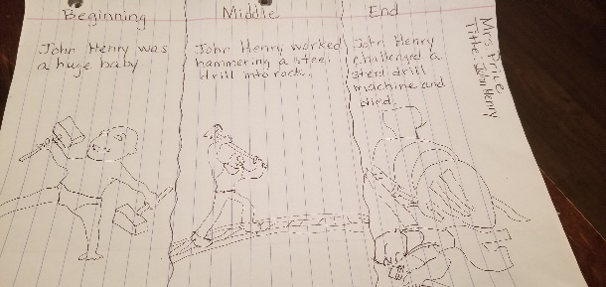 | Choice 2  1) Get a sheet of paper and fold it 2 times.  2)Fold the paper in a sandwich and then sandwich again.  3) Trace the lines of the folded paper.  4) On one square write tens and ones.  5) On another square draw the number to represent it.  6) On the 3rd square write one number more and one less.  7) On the last square write the number in expanded and standard form.  (Turn the paper around and choose another number)  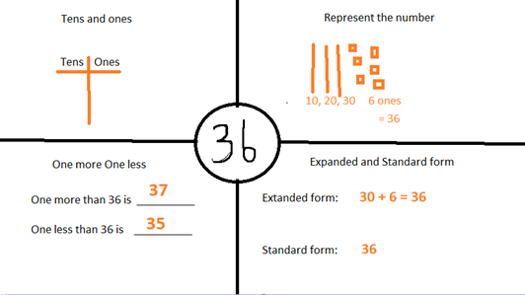 | Choice 3 – Science  *Predict, observe, and record what happens to  1) Materials when they are heated or cooled.  2) Take the cup with ice outside and set it in a sunny place or set it in a warm place in the house for 20 minutes.  3) Make a prediction about what you think will happen to the ice before h  eating.  4) Draw what ice looks like before heating and what you predict ice will look like after 20 minutes.  5) Now draw what ice really looks like after 20 minutes of heating.  Before Heating My Prediction After Heating  *Discuss what you think will happen if you put the cup in the freezer. Try it!  When heat is added to a material like __________ it __________.  When heat is taken away from a material like ________ it ________.
Choice 4  *Read a fiction book of your choice.  *Complete the following comprehension questions using the sentence stems.  Who are the characters? The characters are _______ ______________________.  What is the setting? The setting is ___________ ______________________.  What is the problem? The problem is _________ ______________________.  How was the problem solved? The problem is solved by ______________________.  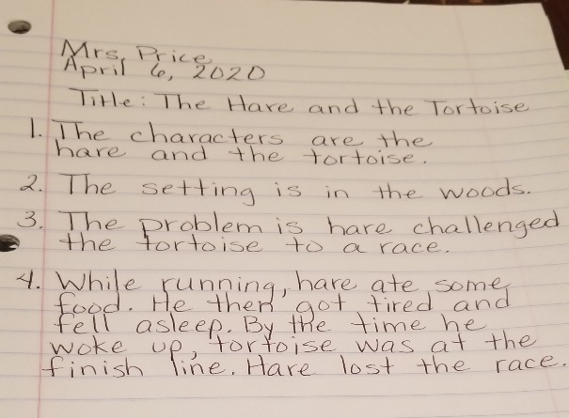 | Choice 5  *Turn over two playing cards.  Add and subtract the pictures.  Use the following Key:  A – 100  K – 50  Q – 30  J – 20  2-10 are face value  NO Jokers  Remember: For subtracting always start with the largest number first then the smallest number.  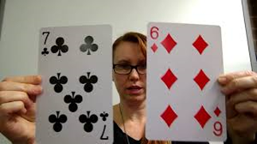  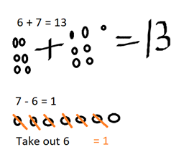 | Choice 6 – Science  *Soil is an important material that comes from the Earth. We can observe properties of soil such as color, size, and texture.  *Soil is made of different parts, such as bits of rock and other once living  materials. We can sort soil by the different things it is made up of.  What to do:  1)Draw the graphic organizer.  2) Use the spoon to scoop up a sample of soil.  3) Observe soil. Look at the grain size, shape, color, and texture.  4) Feel the texture of the soil. What does it feel like?  5) Use the spoon to sort the soil by the different things it is made up of.  6) Wash your hands afterwards.  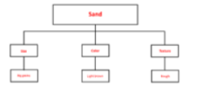  *Write and fill in the following sentences.  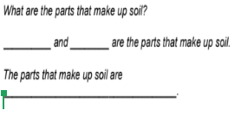
Choice 7  *Practice your High Frequency Words by sorting your words into groups patterns.  Word List  but get most day live  my name back these which  Sorting Chart  Short Vowels Long Vowels  1. 2. 3. 4. 5. 1. 2. 3. 4. 5. | Choice 8  *Read the following math story three times:  - Read aloud the first time and picture what the math story is about.  - Read aloud the second time and focus on the question and what you need to find out.  - Read aloud the third time and determine what important information is needed.  There were 50 birds sitting in a tree. Then 8 more birds flew up to sit in the tree. How many birds are in a tree now?  *Represent the math story by using objects. Then use pictures, numbers, and words to show your work.  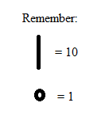  Just as we have done in class you can use you tens and one to represet the numbers. | Choice 9 – Social Studies  *Technology changes how we live. Look at the effects of technology/transportation on how people live today.  *List as many forms of transportation as you can name.  *Use a notebook paper and pencil. Share your writing with your family.  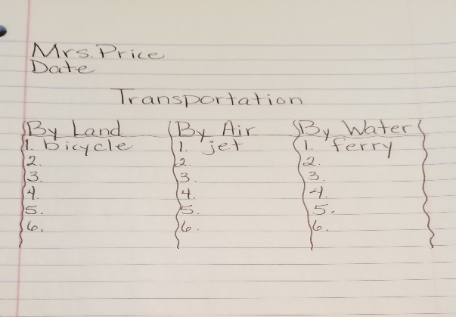
Choice 10  *You can spell the long o sound with ow, as in show and oa as in boat.  *Read each clue. Unscramble the word. Write the word correctly on the line.  Long o Word Bank  show row grow low blow  snow boat coat road toad  *  - Trucks drive on this. __________  a o d r  - I see this in winter. __________  w s o n  - The wind does this. __________  w b o l  - I put this on. __________  o a c t  - This is not high. __________  o l w  - This is an animal. __________  a o d t  *Choose 2 different spelling words. Make up a clue for each one. | Choice 11  *Create your own math problem.  *Write and illustrate a book with 2 different addition and subtraction stories.  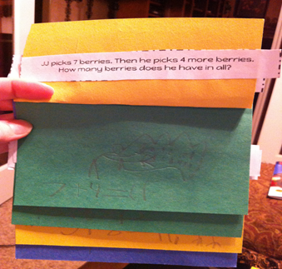  For example:  Addition problem:  Dylan had 4 stickers. His teacher gave him 8 more stickers. How many stickers doe Dylan have now?  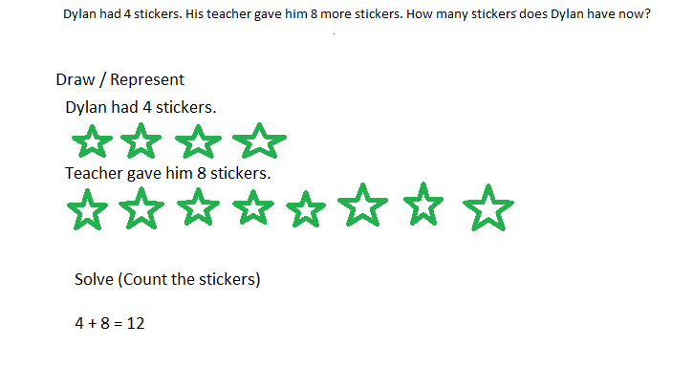 | Choice 12 – Social Studies  *Think about transportation.  *Write a story to describe why a car goes faster than a horse pulling a carriage. Then read your story to a family member.  *Use a notebook paper and pencil. Share your writing with your family.  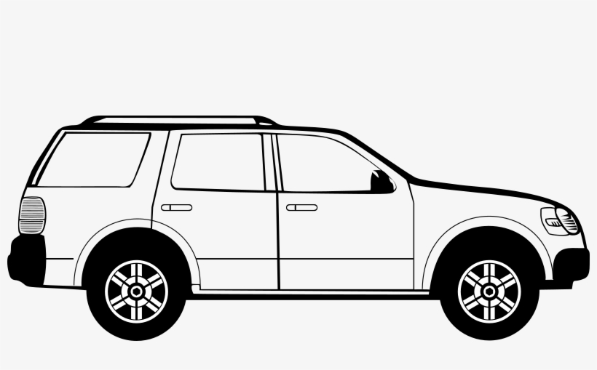  
Weekly Project
Create a journal where you can write and draw about your experiences every day. To set up your journal, you can staple together several pieces of paper or use a notebook/journal you have at home. Then decorate the outside with the title, your name, and pictures. You will create 5 entries for this week and a few more entries in the weeks to come. Every entry should have the date, a picture, and writing.

Day 1 – Set Up the journal

Day 2 – Background page: Write about how you felt when school was cancelled.

Day 3 – First entry (today’s date): Write about what life has been like at home since school was cancelled. What have you been doing? How have you been feeling?

Day 4: Next entry (date): Write about what your experience has been like doing school from home. What has been positive and what has been challenging?

Day 5: Next entry (date): Write about your day. What did you do today? What was your favorite part of the day?
