Ms. Joseph’s Class
ELA Choice Board
Directions: Students please complete the activities from ELA/Social Studies board in the order that you prefer. Submit evidence of completion by May 15, 2020 on Google Class.
#1. Sequence Text Structure  Today you will choose your own book or use the How to Build a Sandbox to identify the sequence text structure. •  Read the tip to the right and use the chart below to show your understanding.  As you read, ask yourself:  How can I tell this is a sequence structure?  Why was it important to use the sequence text structure for this text?  Use the chart below to answer the questions and follow the sequence pattern | #2. Social Studies  Celebrations “E Pluribus Unum” is the official motto of the United States of America. The words mean “out of many, one.” Our nation’s founders wanted a saying that represented how all the states work together.  Today it shows how many different cultures make up our strong nation.  Activity: Come up with a family motto and draw a picture to represent that motto. Show to family members and post in an area where the family meets.  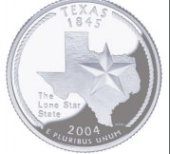 |  |  | #3. Problem/Solution Text Structure  Choose your own book at home or a story from Think Up Reading to identify the problem solution text structure.  As you read, ask yourself:  What is the main problem the author presents?  What steps does the author present to solve the problem?
#4.  Imagine Reading  The student will engage with Imagine Learning platform for 45 minutes every day. | #5 Free Space  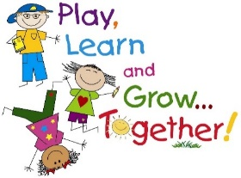 |  |  | #6. Social Studies  Celebrations Many of the foods we enjoy eating today come from many different cultures in different parts of the world. • Popcorn - harvested by Aztec tribes in Mexico. Used to please their gods  • Hamburgers – made in Germany and known as Hamburg steaks.  • Ice Cream – invented by Chinese to keep sweet syrup cold  • Ketchup – Started as a fish sauce called ketsiap.by Chinese people.  Use the chart at the bottom:
#7. Central Idea  Interesting Vs Important  Today you understand how to determine if an author is trying to wow you with an interesting fact or provide information important to the central idea.  Choose and read your own book to decide the central idea using important facts.  As you read, ask yourself:  Is this fact presented to entertain me? How can I use this important fact to help me know the central idea?  Complete the chart below to share your inference.  Be sure to ― • clearly state your central idea • include details to support your central idea • organize your writing • choose your words carefully • use correct spelling, capitalization, punctuation, grammar and sentences |  |  | #8. Make Inferences About Text  Today you will make inferences about the text you read. •  Read the tip on the right to understand how to use clues from the book and what you already know to make an inference. •  Read the text below and underline the clues that support your inference. Ask yourself:  What clues can I find to support my inference?  Do my clues match my inference?  Does my inference make sense?  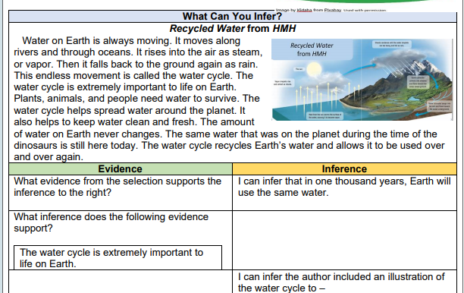
#9. Context Clues
• Today you will understand and use context clues to know the meaning of unknown words.
• Read the tip on the right to understand how to correctly find context clues for words in your text.
• Ask yourself: What does the underlined word mean? Which words help me know the meaning of the underlined word.

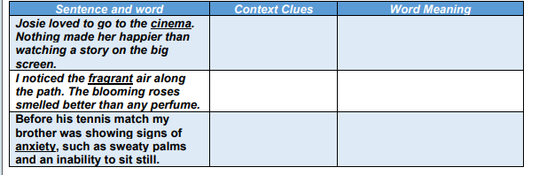
Use these Strategies to help you Solve the Problems for ELA/Writing/SocialStudies Above
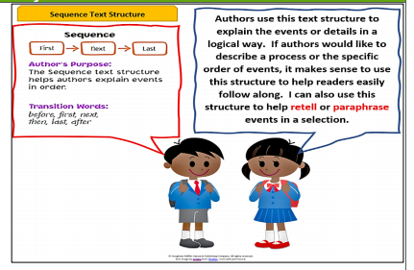  Problem #6 Social Studies  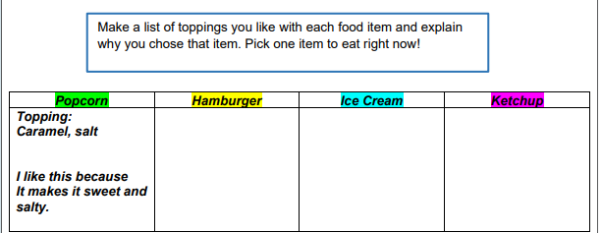 |  | 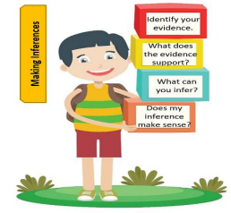  Choice Board #8
Additional Resources

www.myon.com
www.storyonline.com

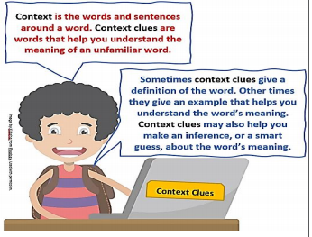  Problem #9 Context Clues |  | 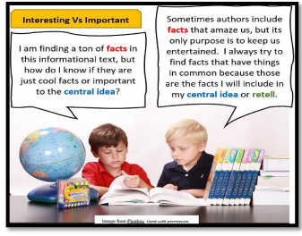  Problem #7 Central Idea Interesting vs Important

MATH Choice Board
Directions: Students please complete the activities from MATH board in the order that you prefer. Submit evidence of completion by May 15, 2020 on Google Class.
#1 Value of Coins and Bills  Carlos bought school supplies at T-Mart. The total amount he paid is shown.  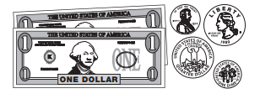  How much did Carlos pay for school supplies? | #2 Imagine Math  Do Imagine Math for at least 45 minutes.   | #3 Perimeter Watch Video Class Dojo  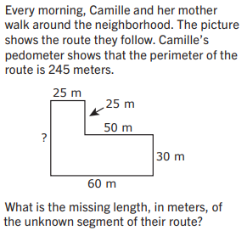
#4 Word Problem  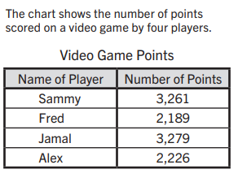  List the points in order of Greatest to Least. | #5 FREE FUN SPACE    Any Activity you want Ms. Joseph to See on Class Dojo | #6 Value of Coins and Bills  Simar has $3.00 in quarters, dimes, and nickels. He has 9 quarters and 5 nickels.  How many dimes does Simar have?  _$_________________  Show your work
#Combine Choice Board 7/8 Science
Objective: Explore natural resources and identify how they are useful

Think About It! What are natural resources? How are natural resources used?
If you can, discuss this question and share your thinking with someone in your home.
Do It! What you need: • Science notebook or sheet of paper • Pencil or crayons • Sandwich bag What to do: • Draw a 2-column chart (Natural Resource/Use) in your notebook to capture observations. • Go outside around your home with a bag to identify and gather all the natural resources that you can observe and record in your chart. • Include the natural resource name and its possible uses. For example, rocks are good to build houses because they are sturdy. Wood is also sturdy, but other times wood can also be flexible and used in other ways.

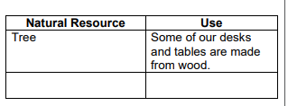
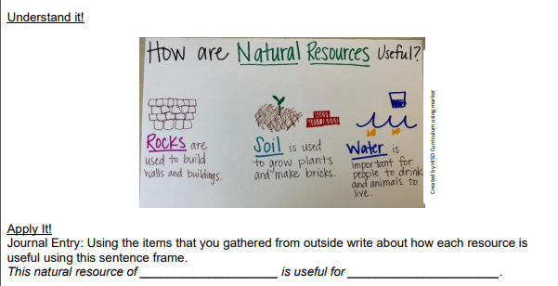
#9 I can understand labor and income

Labor – Work a person does in exchange for money. Income – Money a person receives in exchange for providing a good or service.
Think of a time you had to work hard on something. What did you do?
Did you do your best work? First, let’s talk about labor.
When we think about labor, here are some questions to ask ourselves:

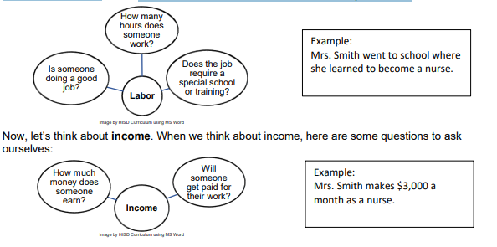

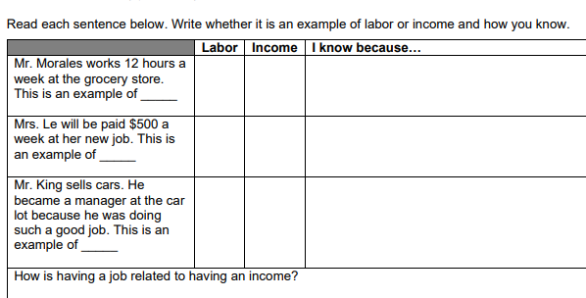

Project: Due May 15, 2020

Activity: At the close of the story, it states, “Every day food goes missing from the farm. Sometimes it’s lost. Sometimes it’s stolen. Sometimes it just runs away. With all these animals, you can be sure of one thing; trouble is sure to hatch. These are the cases for MFIs.”
Materials: Pencil/paper Phone/tablet/camera Video editing app or software (like iMovie)
Directions: Step 1: Create a newscast about a mystery of missing food on Ed’s farm. Write a script and invite friends and/or family to help.
Step 2: While you take on the role of anchor and on-site reporters, have others act as camera crew, suspects and eyewitnesses to the crime.
Step 3: Use video editing app or software to edit the footage, if needed. 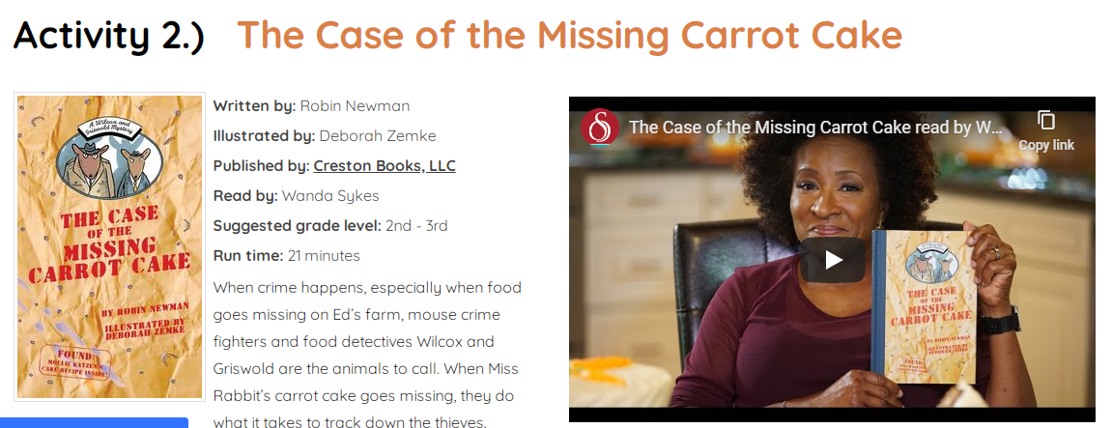
RESOURCE: www.storyonline.com

