- Reading  - Pick an interesting fiction text to read for the week.  - Think about the elements of the story.  - Who were the characters in the story? The characters were …  - Where did the story take place? The story took place in …  - What happened in the story? In the beginning … In the middle … In the end…  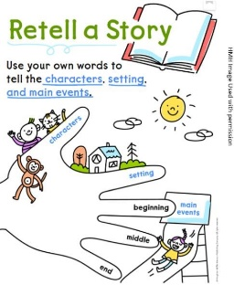  - Trace your hand on a piece of paper and create your chart. See the example above.  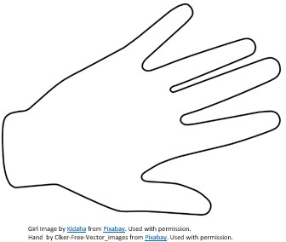 | - Math  - Read the following math story aloud and picture what the math story is about.  - There are 9 apples on the tree. Harold picks two of them. How many apples are left on the tree?  - Read the math story aloud a second time. This time focus on the question and what you need to find out.  - Read the math story a third time. This focus on the important information.  - Now model the story.  - How many apples were there at the start?  - There were _____ apples.  - When Harold removes two apples from the tree, will that make more?  - Use a piece of paper to draw pictures to represent the problem.  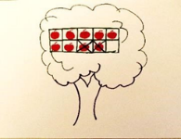  How many apples are left? There were __7__ apples left  - Now follow the steps above to solve this math story on your own. Act it out using counters and explain your thinking.  There are 8 pencils on the table. Annie takes 3 pencils to do her homework. How many pencils are left on the table? |  | - Science  Objective: I can demonstrate ways to conserve water.  Think About It! What are some things we can do to conserve water in our homes? Discuss this question and share your thinking with someone in your home!  Do It!  What you need:  • Science notebook or paper, Pencil or crayons, Adult supervision  What to do:  • Discuss with family members what are different ways to conserve water.  • Look around to the house to see ways that you can improve on saving water.  • In your notebook, illustrate four different ways to conserve water at home.  • Describe what you illustrated.  I can conserve water by _________  Apply It!  - Create a tally chart like the one on the right in your science notebook.  - List the four ways your family will conserve water.  - Write a tally mark each time a family member conserves water.  - Describe your tally chart.  Which method was practiced the most?  We will save water by: Tally Marks  1.  2.  3.  4.  Which method was practiced the least?
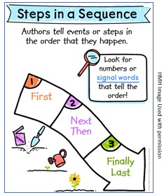  - Reading  - Reread or listen to the previous story.  - Identify the characters’ actions.  - How did the character act? The character acted like …  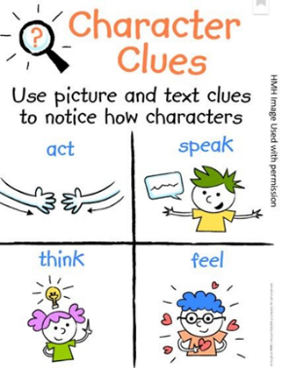  - What did the character say? The character says …  - What did the character think? The character thought …  - How did the character feel? The character felt …  - Draw pictures and label them to explain their behaviors.  Act  Say  Think  Feel | - Math  - Read the following math story aloud and picture what the math story is about.  - William has 2 red apples and 6 green apples in a basket. How many apples does William have in his basket?  - Read the math story aloud a second time. This time focus on the question and what you need to find out.  - Read the math story a third time. This focus on the important information.  - How many red apples does William have? William has ______ red apples.  - How many green apples does William have? William has ______ green apples.  - Now model the story.  - Draw a part-part-whole mat on a sheet of paper  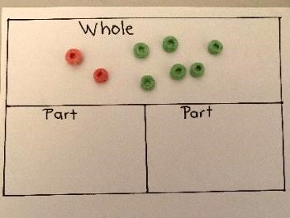  - Use counters to represent the number of red apples and the number of green apples  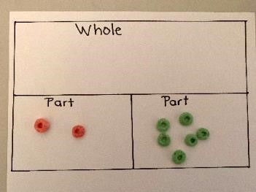  To find the whole, I can combine the two parts, and count all my counters: William has __8__ apples in all.  - Now follow the steps above to solve this problem on your own. Use the part-part-whole diagram you drew to solve the problem below.  Rachel baked 6 chocolate cupcakes and 4 vanilla cupcakes. How many cupcakes did Rachel bake in all? |  | - SEL  Choose a favorite story from your bookshelf and talk about the characters’ different feelings:  - Do you remember a time you had the same feelings? When?  - How did you manage these feelings?  - Did it help you feel better?  - What will you do the next time you feel this way?  CONNECTION: English Language Arts  - Children draw or journal their responses.  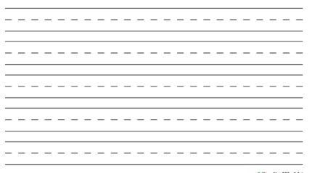  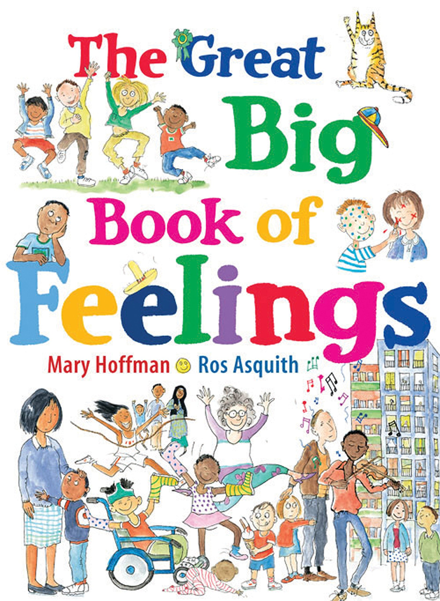
- Reading  - Reread or listen to the previous story.  - Use the following chart to retell the events.  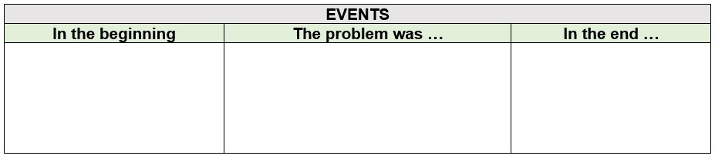  - Find the theme of the story by answering the following question:  - What did the main character learn? The main character learned …  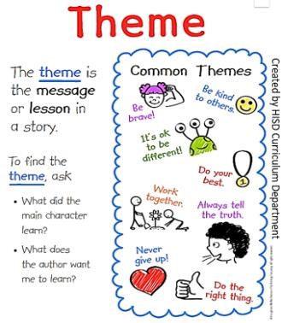  Draw Write The main character learned … | - Math  - Read the following math story aloud and picture what the math story is about.  - There are 8 cupcakes at the bakery. There are 6 vanilla cupcakes. The rest of the cupcakes are chocolate. How many chocolate cupcakes are at the bakery?  - Read the math story aloud a second time. This time focus on the question and what you need to find out.  - Read the math story a third time. This focus on the important information.  - Now model the story.  - Draw a part-part-whole mat on a sheet of paper  - How many cupcakes are there altogether?  - Is this the whole or a part?  - Use counters to represent the whole.  - How many cupcakes are vanilla?  - Is this the whole or a part?  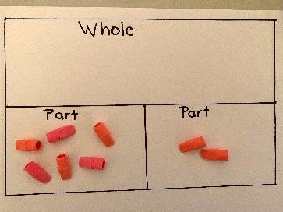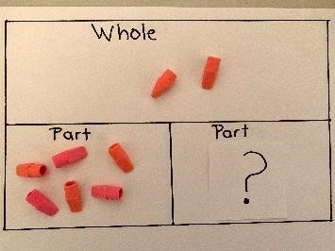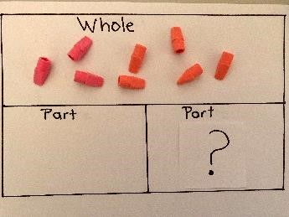  I know that 6 of cupcakes are vanilla so I can move 6 counters to one part. This means that the 2 counters left represent the chocolate cupcakes. The bakery has __2__ chocolate cupcakes.  - Now follow the steps above to solve this problem on your own. Use the part-part-whole diagram you drew to solve the problem below.  Robert has 9 stickers. Five of the stickers are stars. The rest of the stickers are happy faces. How many happy face stickers does Robert have? |  | - Social Studies  “The bank is a safe place to keep money!”  Talk to your parents about why keeping money in the bank is important.  
Weekly Project: Vocabulary

- Read the chart on right to review vocabulary.  - Reread or listen to the previous story.  - Select a character from your book to fill out your vocabulary  - Draw and label |  | Actions  Size  Feelings  