Library – Using the HISD Digital Resources

Name ___________________________________ Period 2 Potvin

* Go to [www.milby.org](http://www.milby.org)
* Download the file and save as a word document. You can edit this document.
* Once the activity is complete, save the files (with your answers). Name the file YourLastName.EnglP2 (Example: Garcia.EnglP2 ) then send this file as an attachment to [milbylibrary@gmail.com](mailto:milbylibrary@gmail.com)
* Use the same file name as the title for your email subject

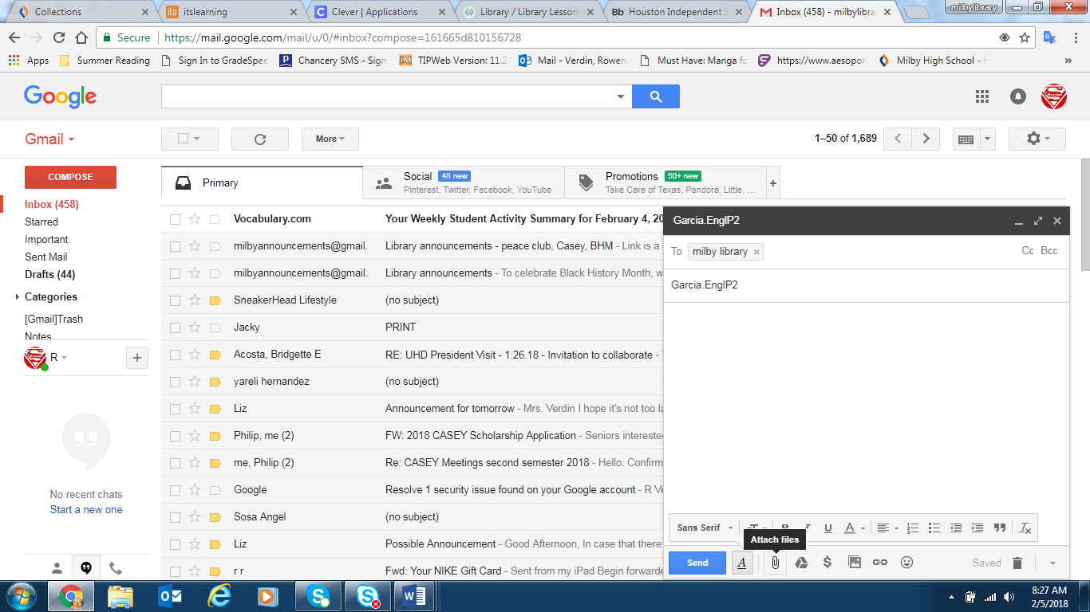

Tips: To create a screenshot, press **fn** + **prt sc** at the same time

To attach a file as an attachment, compose your email and click on the

paperclip.

1. Find an article about Malala from Ebsco (Explora). Take a screenshot of the page.
2. Get the MLA citation for the article. Copy and paste the citation below.
3. Go to Discovery Education. Find a video about Malala. The video must be appropriate for Grades 9-12 and must be published 2014 or newer. Take a screenshot and paste it below.
4. Copy and paste the citation for the video.
5. Go to Gale, Opposing Viewpoints. Search for “Malala Yousafhai.” Look for Malala’s audio interview (Malala: How A Young Girl Became A World Symbol) where her last day of school was recorded for a NYT documentary. Copy and paste the citation for the audio recording.
6. Go to Teachingbooks.net. Search for Marjane Satrapi. Click on audio name pronunciation. The author says her name is very common (in her generation) in which decade?
7. Go to Gale/Academic Onefile. Search for “Persepolis.” Limit the search by **peer reviewed journals**. Find the essay by Nima Naghibi and Andrew O'Malley.

How many words are in this essay?

What is the Lexile for the essay?