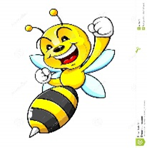 From the Pen of Nurse Buggs

Good Morning Isaccs Elementary Students and Parents,

Does anyone know what a Time Capsule is? A Time Capsule is a container storing a selection of objects chosen as being typical of the present time, buried for discovery in the future. A cache of goods or data secured for some time to be opened at a date in the future. Many times the container is buried to be discovered by others years later. While you may not be burying your time capsule this will give you an opportunity to express your feelings, doubts, happiness or disappointments during this historic time of COVID-19.

Each week you will find posted under the Health and Wellness tab your Time Capsule Activity. You will be able to earn extra points for completing the activity. For this week there are 4 pages (it’s not that bad) the first page I want you to color and put your name on it at the bottom, follow the directions and complete the next 3 pages. Have fun with this activity! For the next 3 weeks I will add additional pages to be completed. Remember this is history in the making. Be safe, wash your hands with soap and water, get exercise, eat healthy, remember to practice social distancing and I miss you all!

