Mrs. Price/Ms. Lara Week of May 11 – 15, 2020 Grade 1
Instructions: Choose the activities you want to complete. Out of the 12 boxes, 9 must be completed (3 Reading, 3 Math, 1 Science, 1 Social Studies, + 1 extra choice or Project). Please send evidence of completion of all these activities so that your child can receive credit. You can send pictures of your completed assignments through ClassDojo.
Reading | Math | Science
Choice 1  Observe a Text  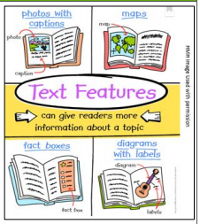  1. Select an informational text to read for this week.  2. Flip through the pages of the text and think about the text.  3. Use the following chart or blank paper to draw what you see and write what the text is about.  4. Draw and Write what you see.  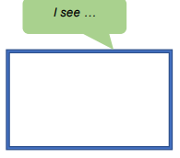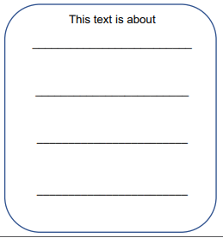  *  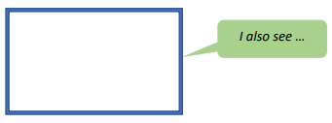  5. Spend at least 30 minutes on Imagine Language & Literacy | Choice 2  One more  Materials:  - Beans  - Pencil  - Paper  - Number strip 1-20  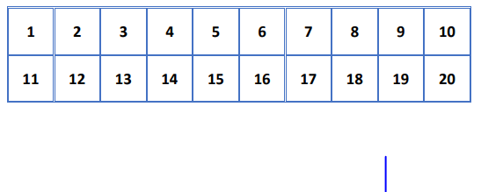  Directions:  - Put a bean on the number 1 on the table.  - On your paper, write the number 1.  - Now draw the plus symbol to show one more than 1: 1 + 1 = ____  - Move the bean for number 2 on the table to show counting on to add one more.  - Now complete the number sentence:  1 + 1 = 2  - Repeat activity 5 times using different numbers on the table  Example: 6 + 1 = _____ | Choice 3 – Science  Conservation of Water  Understand why it is important to conserve water and explain how to solve water waste problems. Conservation is to preserve (save) and protect resources. It is important to conserve our natural resources. To help conserve, we should learn to use less or reduce.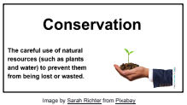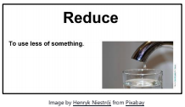  What you need:  • Timer (or other time taking device)  • sheet of paper  • Pencils or crayons  What to do:  - Observe water usage in your home for one day; including how much water is used  - Identify and record water waste problems, including an estimate of time.  - • Explain how to solve water waste problems by conserving or reducing use.  Journal Entry: List wasteful water behavior in your home. Explain how you and your family can conserve, or reduce, water usage.
Choice 4  Retell the Information  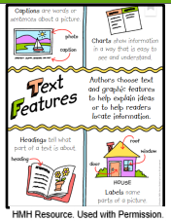  1. Select a page of the informational text from Monday and read it.  2. Close the book. What do you remember from this page?  “I remember …”  {If you do not remember the information, read the page again.}  3. Use one of the boxes below to draw and write the information.  4. Continue with another page and do the same thing.  5. Retell the information you read from the pages to someone at home or to a stuffed animal.  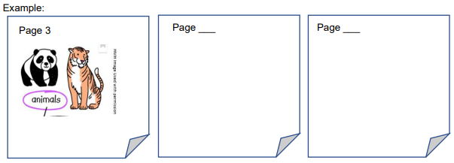  6. Spend at least 30 minutes on Imagine Language & Literacy | Choice 5  Addition  1) Create number cards. Get a paper and write the numbers 1 through 9. Have two stacks of cards with the numbers 1 through 9.  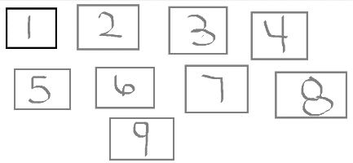  2) Without looking choose two numbers from the stack. Write your two numbers in your paper.  3) Add your two numbers, you can use beans, macaroni, Legos, or any objects to help you add. You can also draw.  4) After you find the total of your addition, write down your answer in your addition.  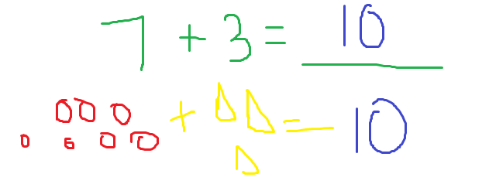 | Choice 6 – Science  Conservation of Water  Identify and learn how to reuse items and materials. It is important to reuse items and materials made from natural resources found in our home. To reuse is to repurpose a natural resource in a new way.  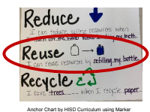  What you need:  • Items/materials typically thrown away in your house  • Science notebook or a sheet of paper  • Pencil and crayons  What to do:  - Make a list of items around the house that you usually throw away.  - Identify which of these items can be reused.  - Select 2 items and explain how you plan to reuse them.  Answer the following questions-  What are some materials typically thrown away at home that can be reused?  How can you reuse, or repurpose, these items?  Use these sentence stems:  At home, we normally throw away ….  We can reuse ________________ for ….
Choice 7  Adding Details  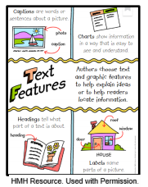  1. Reread your informational text from Tuesday.  2. Think about any new details you see.  >What new information do you remember from this page?  “I remember …”  3. Add new details to each page on the chart made on Tuesday.  Example:  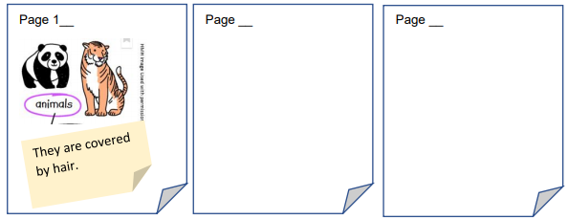  4. Spend at least 30 minutes on Imagine Language & Literacy | Choice 2  Skip count by 10’s.  For this activity you will need nickels.  - Grab a handful of dimes.  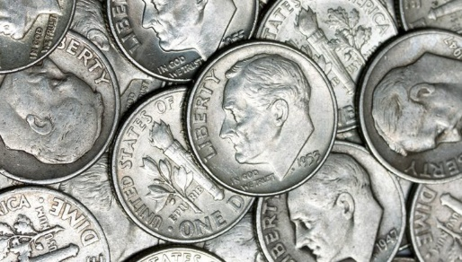  - Count the dimes. Remember that dimes are counted by 10’s, so you will skip count by 10’s  - On your notebook, write down how many dimes did you grab and skip count by 10 to find the value of your dimes. You can draw dimes by drawing a circle and 10 cents sign.  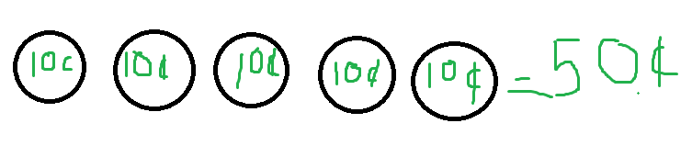  - Repeat steps 1-3 four times. | Choice 9 – Social Studies  Are We There Yet?  *The blue sign tells how far it is from the sign to each of the cities.  *Distance is the word for how far one place is from another place.  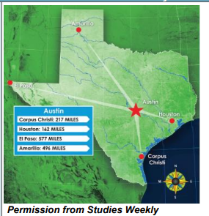  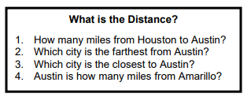  *Materials: Pencil/Color pencil and notebook paper
Choice 10  Writing Time!  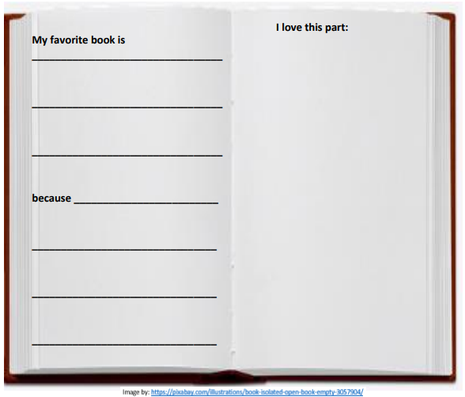  *You may use your journal or a notebook to complete this activity.  *Spend at least 30 minutes on Imagine Language & Literacy | Choice 11  Read the following math story three times:  - Read aloud the first time and picture what the math story is about.  - Read aloud the second time and focus on the question and what you need to find out.  - Read aloud the third time and determine what important information is needed.  Susan has 18 pencils. She gave 8 pencils to her friend. How many pencils does Susan have now?  *Represent the math story by using objects. Then use pictures, numbers, and words to show your work.  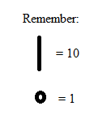  Just as we have done in class you can use you tens and one to represet the numbers. Remember this time you are subtracting, so you are taking out, you can use x to take out. | Choice 12 – Social Studies  1. Look closely at the picture on the right.  SEE: What do you see in this picture?  THINK: What does this picture make you think about? WONDER: What questions do you have about this picture?  2. Materials: Pencil and notebook paper  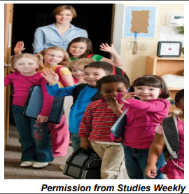
Choice 13
Ms. Johnson’s Class Only
Sound Hunt at Home
DIRECTIONS:
Find as many items at home that begin with each sound. Try and write the names
or draw a picture of each item.
/s/
/f/
/d/
/t/
/m/
/r/
/n/
/g/
/l/
/y/

Choice 14
Ms. Johnson’s Class Only
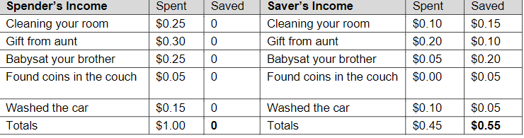

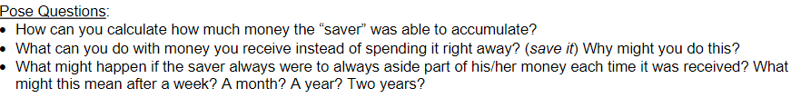

Weekly Project
*Long Creations has designed a program for students to help them document this historic period in their lives.
*Below is an example of how you should document your time during this COVID-19 pandemic.

Project is due by May 15, 2020
*



