Mrs. Price/Ms. Lara Week of April 27 – May 1, 2020 Grade 1
Instructions: Choose the activities you want to complete. Out of the 12 boxes, 9 must be completed (3 Reading, 3 Math, 1 Science, 1 Social Studies, + 1 extra choice or Project). Please send evidence of completion of all these activities so that your child can receive credit. You can send pictures of your completed assignments through ClassDojo.
Reading | Math | Science
Choice 1  1) Watch “The Mouse and the Lion”  2) Copy the hyperlink to open the video, “The Mouse and the Lion”  3) Open your web browser  4) Paste the link in the web browser  https://www.hmhco.com/blog/grades-1-2-daily-reading-activities-stories-and-tales  >>What lessons do you think these characters learn?  >>How would this story change if the Lion told it?  >>If you were Lion, how would you change the story?  >>Write your new story on notebook paper.  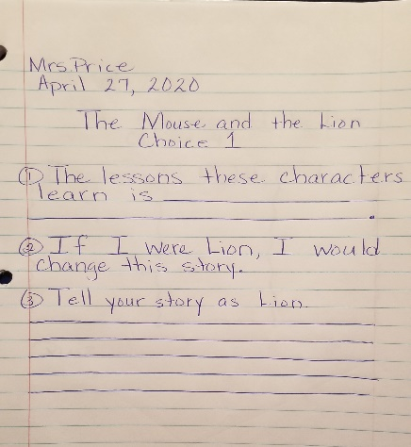  * | Choice 2  Collect objects that have different lengths: a notebook, an eraser, a marker, and a pencil.  *If you don’t have one of the items you can supplement them.  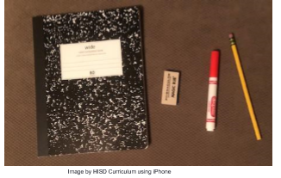  Place the objects on the table and order them from shortest to longest.  - Answer the following questions on a sheet of notebook paper using complete sentences:  - Is the notebook longer or shorter than the eraser?  - Which item is the longest?  - Is the pencil longer or shorter than the marker?  - Which item is the shortest?  - Is the marker longer or shorter than the eraser?  Use the following sentence stems:  - The notebook is _____ than the eraser.  - The longest item is ____.  - The pencil is _____ than the marker.  - The shortest item is _____.  - The marker is ______ than the eraser. | Choice 3 – Science  Compare ways that young animals look like their parents.  What you need:  - Pictures of young animals and their parents (provided below)  - sheet of paper  - Pencil  - Crayons or markers  - 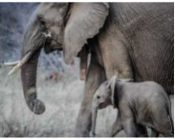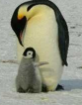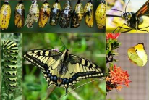  What to do:  - Look at the pictures of the young animals and their parents.  - Think: In what ways do the young animals look like their parents? In what ways do the young animals look different from their parents?  - Draw a chart like the one below on a sheet or paper.  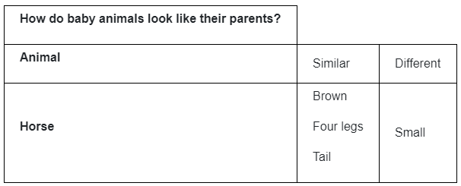  - Complete the sentence stems below.  My baby animal is like its parent because _______________.  My baby animal is different than its parent because________________________.
Choice 4  1) Read “The Princess and the Pea” retold by Debbie Croft  2) Copy the hyperlink to open the book, “The Princess and the Pea”  3) Open your web browser  4) Paste the link in the web browser  https://s3.amazonaws.com/prod-hmhco-vmg-craftcms-private/documents/1re_lr_j_princessandthepea.pdf  5) Retell the story in your own words on notebook paper  Beginning *Introduces the characters and the setting Middle *Introduces and describes the problem End *Solves the problem and ends the story  6) Complete the quiz on the same notebook paper  7) Copy the hyperlink to open the quiz (below)  8) Open a new web browser  9) Paste the link in the new web browser.  https://s3.amazonaws.com/prod-hmhco-vmg-craftcms-private/documents/1re_lrq_princessandthepea.pdf  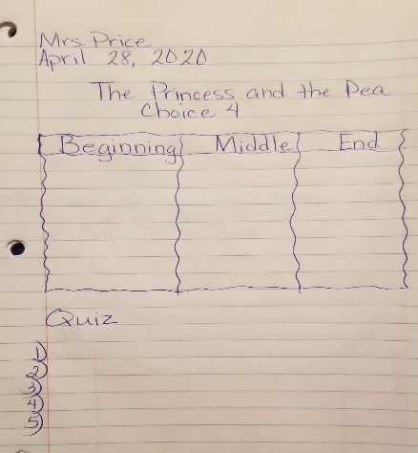  * | Choice 5  Collect 4 objects of different lengths a pencil, stick, crayon, pen, or a small toy and a set of same-sized objects such as beans or macaroni.  Place the objects on a table. Draw each objects of different length on a sheet of paper (leave space under each drawing).  Predict how many same-sized objects you are going to use to measure the length of each object (write you prediction next to your drawing).  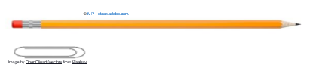  Measure the length of each object, using the paperclips, beans, or macaroni.  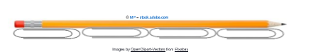  Write about how many paperclips each item measured in length and draw the paperclips below each item. Use a complete sentence to say the length.  Compare your estimate measurement and your actual measurement.  Write a complete sentence using comparative language  Sentence stem:  My estimate of ____ paperclips was greater than my actual measurement of ____ paperclips.”  Repeat the activity with the objects collected: pencil, book, glue stick and crayon. | Choice 6 – Science  * Observe and record the life cycle of a fish.  What you need:  - sheet of paper  - Pencil  - Crayons or markers  - Picture of the life cycle of a fish  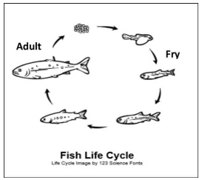  What to do:  - Look at the picture of the life cycle of the fish.  - Draw a picture of each stage of the life cycle of the fish.  - Label these three stages (egg, fry, adult).  - On a sheet of paper, complete the following sentence stems to help you explain the life cycle of a fish.  - Fish begin their life cycle as an __________.  - The next stage in the life cycle is the _____ stage.  - The last stage in the life cycle of a fish is the ____ stage.
Choice 7  1) Let’s reread our story, “The Princess and the Pea” by Debbie Croft  2) Copy the hyperlink to open the book  3) Open your web browser  4) Paste the link in the web browser  https://s3.amazonaws.com/prod-hmhco-vmg-craftcms-private/documents/1re_lr_j_princessandthepea.pdf  5)Write a short fairy tale using the phrases:  Once upon a time  They lived happily ever after  6) Retell as troy you know well or create one of your own.  7) Draw a picture of your setting.  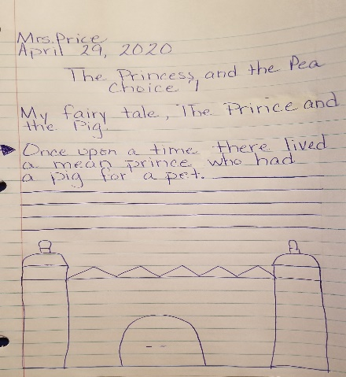  * | Choice 8  Place Value  Look at this model:    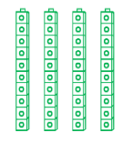  Write the number in standard and expanded form.  Standard form:  Expanded form:  _______+_______= ______ | Choice 9 – Social Studies  *If you are in a lot of trouble, like when you are fighting with your brother or sister, remember that THERE IS ALWAYS A SOLUTION.  *This story encourages creative problem solving as it takes readers through a series of adventures  1) Watch the video “Always A Solution”  www.youtube.com/watch?v=55k4RJHVInQ  2) Think of the problems and the solutions discussed in this video  3) Make a list of the problems and identify their solutions.
Choice 10  1) Watch “The Tortoise and the Hare”  2) Copy the hyperlink to open the video, “The Tortoise and the Hare”  3) Open your web browser  4) Paste the link in the web browser  5) Scroll down until you get to the video title  https://www.hmhco.com/blog/grades-1-2-daily-reading-activities-stories-and-tales  >>How does Hare change from the beginning of the story to the end?  >>If you could give advice to Tortoise about running the race, what would you say?  >>Write your responses on notebook paper.  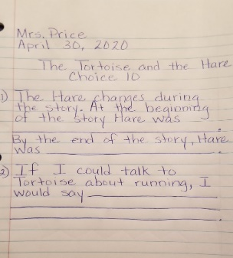 | Choice 11  Read the following math story three times:  - Read aloud the first time and picture what the math story is about.  - Read aloud the second time and focus on the question and what you need to find out.  - Read aloud the third time and determine what important information is needed.  Jane has 40 balloons. Then, her mom gave her 4 more balloons. How many balloons does Jane have in total?  *Represent the math story by using objects. Then use pictures, numbers, and words to show your work.  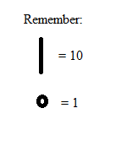  Just as we have done in class you can use you tens and one to represet the numbers. | Choice 12 – Social Studies  *Problems are always around us. We have problems in our homes, our neighborhoods, our schools, and in our communities.  *Every problem needs to be solved.  1) Think of a problem  2) Create a solution  3) Problem ideas  -Trash in the park  -an argument with a friend  -holes in the road  -school supplies for all students  -organizing your bedroom
Weekly Project
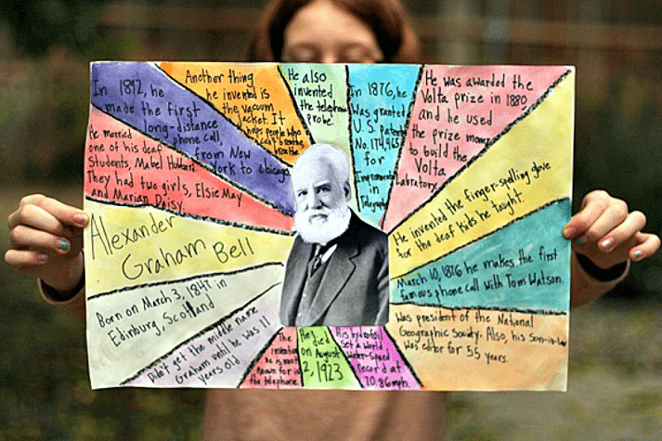
We are going to be making a biography poster collage, like the one pictured, about music composers. We want you to focus on the most essential biographical facts.

Johann Sebastian Bach John Williams
Tomas Luis de Victoria Ella Fitzgerald
Chevalier de Saint-Georges Sarah Vaughn
Wolfgang Amadeus Mozart Margaret Bonds
Ludwig Von Beethoven Gabriela Ortiz
Miles Davis Carlos Chavez
John Coltrane Joel Thompson

Please select one of the composers to complete your research on and make sure to include the following:
1. composer’s name 2. date of birth
3. place of birth 4. a picture of the composer
5. type(s) of music he/she composed 6. famous songs that were composed

