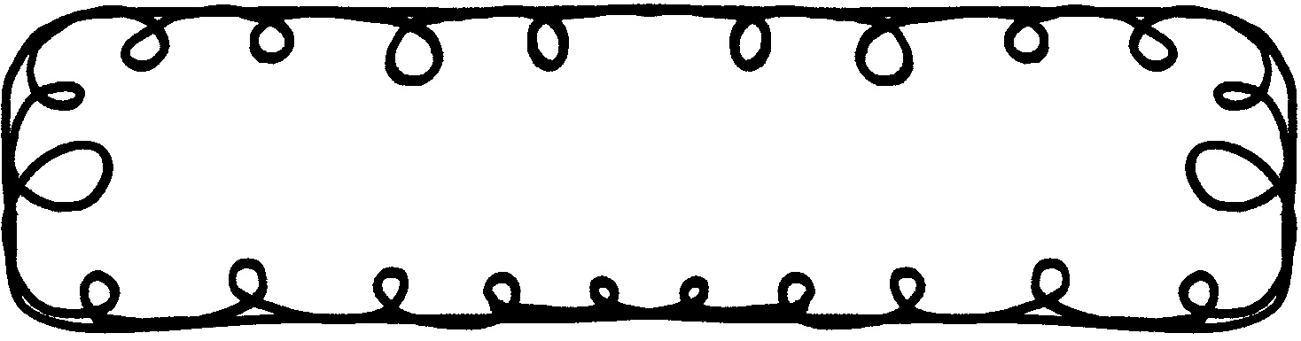

First Grade Gazette October 21, 2019

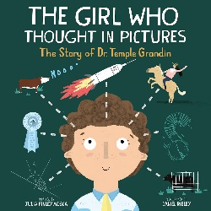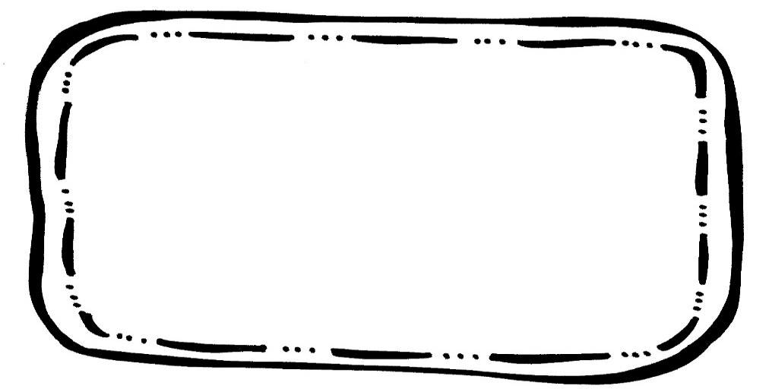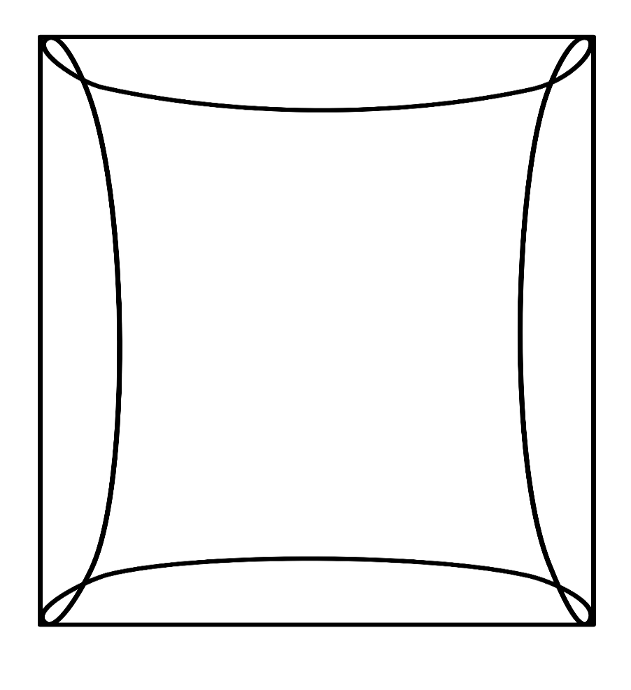

Math

We will work on solving Subtraction word problems. We will also solve missing addends to 5.

Writing

We will continue working on writing complete sentences and ABC order.

Science & Social Studies

We will be learning about map features and how to use maps.

Spelling

dip in pin rip zip

the of oh them want

**create your own**

**Reading Comprehension**

***The Girl Who Thought in Pictures***

* Nonfiction Text Features

**Vocabulary Words**

Unique – very special; unlike anyone or anything else

Shy – feeling nervous; not comfortable around other people

Invention – something that has been created from a new idea

Ranch – a large farm where animals are raised

taunt – to make fun of or tease

**Upcoming Events**

**October**

18 – Early Dismissal

22 – Oil Ranch Field Trip

21 – 25 – Red Ribbon Week