Reading  Introducing Zoo Animals  - Read Welcome to Zippity Zoo book from Frog Street  - Review zoo animals from the book: giraffe, elephant, zebra, kangaroo, koala, lion, etc.  - Draw two of your favorite zoo animals.  .  Questions for children:  1.Why are these two your favorite zoo animals?  2.Can you describe them to me? What do they look like?  Picture of two favorite animals with permission from Ms. Coronado taken with  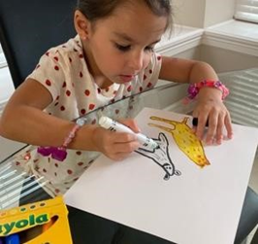  Resources  •Book Welcome to Zippity Zoo from Frog Street go to http://portal.frogstreet.com Username is: parent Password: is parent  •paper  •crayons  •pencil  Send your picture to your teacher. | Math  Counting Animal Legs  • Count how many legs each of your favorite zoo animals have  • Write down the number of legs and compare the numbers.  (Picture of counting animal legs with permission from Ms. Coronado taken with iPhone )  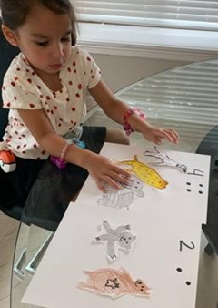  Questions for children:  1.How do you know this is the total number of legs?  2.Which animal has more legs?  3.What happens if we add them all together?  Send your picture to your teacher  *Challenge: Sing/move as you “Count to 100 Everyday”; Let’s Get Fit with Jack Hartman on You Tube.  Parents: If you don’t have “you tube”, your child already knows this song. |  | Science  (Plants are Living Organisms (cont’d)  Gather some dry beans and/or a collection of different seeds from  Foods that you eat. (Examples: apple seeds, orange seeds, etc.)  - Observe and compare the different types of seeds you collect  in a sandwich bag.  - Select one type of seed that you want to plant in soil to observe  - growing.  - Plant 1 type of seed in a cup of soil and add water to make the soil  moist.  - Place this cup in an area that will get some sunlight.  - Observe and draw how the seed grows from a 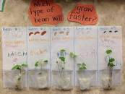seed to a plant
Literacy  Animal Riddles  - Draw, describe, and make the sounds of these zoo animals: chimpanzee, elephant, lion, peacock, seal, zebra, etc.  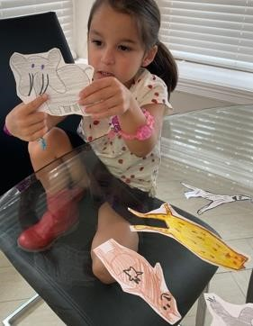  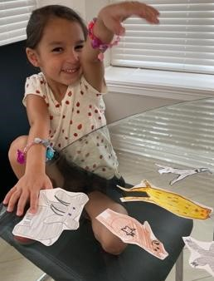  - Play a game of animal riddles where your child will name and point to the animal you are  describing (example: I’m thinking of an animal that looks magnificent and has colorful feathers…it’s a peacock!)  Ask:  1.Can you tell me which animal has 4 hoofs and stripes?  2. Can you tell me which animal has a rough skin and is ginormous? | Math  Sorting Animals  - Use the animal drawings from the previous lesson: chimpanzee, elephant, lion, peacock, seal, zebra, etc.  - Cut these individually.  - Sort these animals by the number of legs.  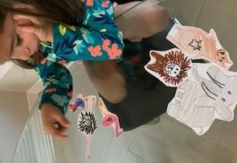  - Sort these animals by their fur and feathers.  Picture of soring animals with permission from Ms. Coronado taken with iPhone  Ask:  1.How did you sort the animals?  2.Can you think of other ways to sort them?  Resources  - Paper  - pencil  - crayons  - scissors |  | SEL  Self - Awareness  Parent/guardian ask your child to name 5 things he/she is grateful  For.  Have your child use this sentence starter each for each thing they are grateful for…  I am grateful for______________.  Then have your child draw a picture of the one thing they are most grateful for.  .
Literacy Clapping Syllables  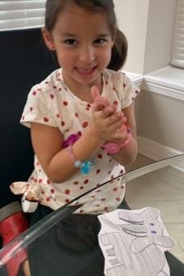  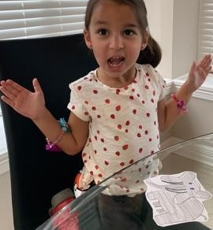  • Clap the syllables for each zoo animal: snake, penguin, flamingo, tiger, bear, alligator, chimpanzee, eagle, zebra, lemur, etc. (example: ti-ger 2 syllables)  Picture of clapping syllables with permission from Ms. Coronado taken with iPhone  Ask:  Can you name other zoo animals we can use to clap the syllables in their names? | Math  Animal Patterns  - Paint a zebra pattern with black and white watercolorsmarkers  - Paint a tiger pattern with orange, black, and white watercolors or markers.  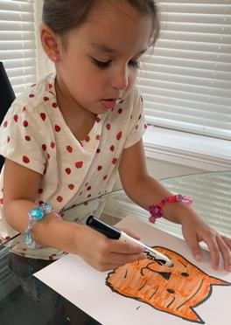  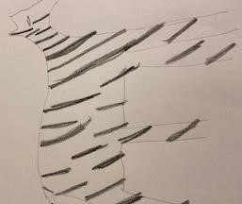  - Name the pattern for eachanimal  Picture of animal patterns with permission from Ms. Coronado taken with iPhone  Ask:  What other animals have pattens on their fur or feathers?  Resources  • paper  • watercolors or markers |  | Science/Social Studies  Animals and Inseects  Parent /Guardian talk with your child about butterflies.  Show them a picture of a butterfly or a live butterfly outside.  Discuss the parts of their body that help them fly. (wings)  Have your child to draw and color the butterfly.  Ask:  What colors do you see on the butterfly?  How does the butterfly use its wings?  What do you think would happen to the butterfly if the wings  got hurt?  
PreK Parent/guardian,  *NOTE: Please remember, when asked to write, PreK students’ writing may look a bit like scribble. Allow child to draw/ write (scribble) their ideas in the journal. Then say, read your sentence to me. Next, you can rewrite their response under the sentence they wrote (scribbled).  This week you will create 5 entries and a few more entries in the weeks to come. Every entry should have the date, a picture, and at least one sentence of what you did that day. (Idea: Write about your time working a lesson.)  Remember: Make an entry in your journal every day. * (Save your journal)  Days 1-5: Make an entry for the day by drawing a picture and writing a sentence about it.  Options:  - Your favorite activity you did that day (inside game, outside play, school work, TV you watched)  - How you felt that day  - What you ate that day  - Anything else that was important for you that day.  ** Try to make each day’s entry different** |  | 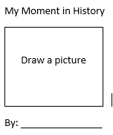  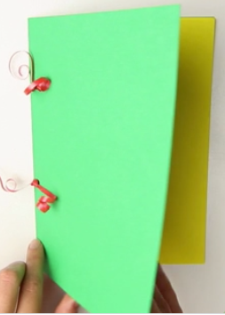

LITERACY: Animal Rhymes  •Read Welcome to Zippity Zoo book from Frog Street  •As you read the book, stop and point out rhyming words in each page.  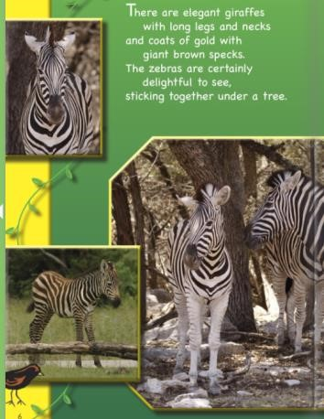  Picture of digital book Welcome to Zippity Zoo with permission from Frog Street Press  Ask:  1.What word rhymed with bear?  2. What word rhymed with zoo?  Resources  • Book Welcome to Zippity Zoo from Frog Street go to http://portal.frogstreet.com Username is: parent Password: is parent Math Resources  • paper  • pencil | Math  Comparing Carnivores and Herbivores  - Review: What is a carnivore? Animal that eats meat  - What is an herbivore? Animal that eats plants  - Make a T-chart  - List animals that are carnivores on one side and list herbivores on the other side  - Decide which list has more.  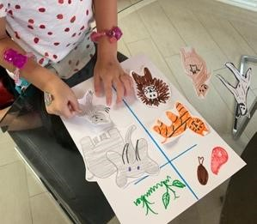  Picture of T-chart with animals with permission from Ms. Coronado taken with iPhone  Ask:  1.What is the total number of carnivores on this list?  2.What is the total number of herbivores on this list?  3.How many more are in the longest list?
LITERACY  : Let’s Make up a Story  - Make an animal puppet with a sock or paper bag  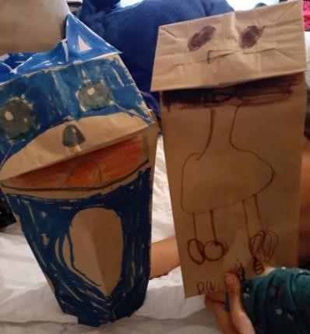  - Draw eyes, nose, mouth, ears, and part of the upper body  - Use the puppet to tell a story about the zoo animals.  Picture of paper puppets with permission from Ms. Castruita taken with iPhone  Ask:  Where is the story taking place?  Are there other characters in your story?  How does the story end? | Math  Counting in the Jungle  Draw a jungle on a piece of paper  Draw 5 zoo animals that leave in the jungle (elephant, monkey, tiger, snake, and toucan) and cut them individually  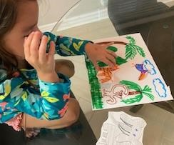  Create word problems using those animals (example: there is 1 elephant and 1 monkey in the jungle and 1 tiger comes by…how many do we have now? Total of 3) Ask: 1. How do you know the total number of animals in the jungle? What happens if we have all 5 animals in the jungle and 2 leave? | Math  Counting in the Jungle  Resources  - brown paper bag or sock  - crayons or markers Math Resources  - paper  - crayons  scissors

