**PK – 1 Rest**

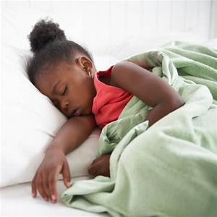

Just as your child had a daily routine during school hours it’s important to try to keep to that routine as much as possible during this challenging COVID-19 time. Getting the correct amount of rest is still important and a general rule is that toddlers need around 12 hours of sleep a night, children 3-6 y/o need 10-12 hours, 7-12 y/o need 10-11 hours and teenagers around 8-9 hours. Your child is accustomed to getting a nap midday especially PK-K. If you are finding that they are a little cranky midday maybe a nap is in order.

**Grades 2-5 Good Sleep and Your Body**

Investigate the effect good sleep and rest has on the human body. In this health instructional activity discover the different stages of sleep and list ways you can alleviate tension and anxiety through exercise, discussion or journaling/poetry. I’ll start you off, there are 5 stages of the sleep cycle. What happens to your body in each stage?

Healthy Eating Games and Activities

Using games and activities is a great way to help children learn about healthy eating while having fun at the same time! The activities below can be used to engage children in healthy eating practices, teach them to recognize different foods and inspire them to experiment with new foods, tastes, flavors and textures.

**PK – 1 Scavenger Hunt**

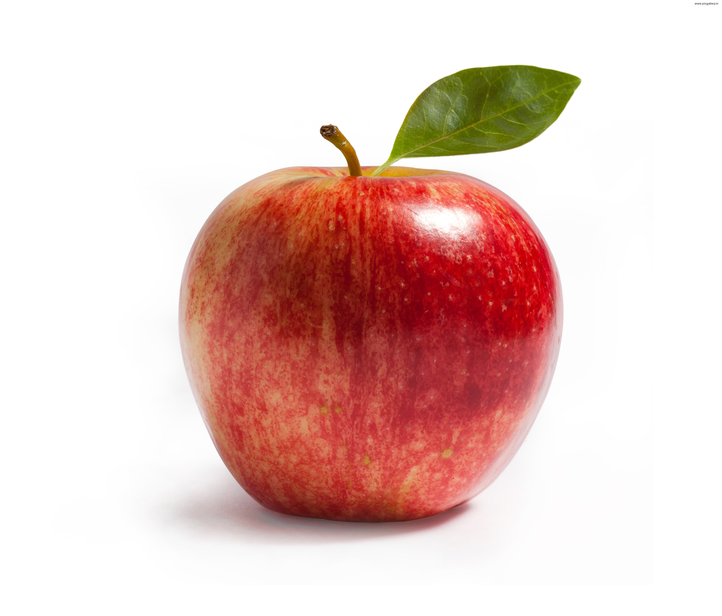 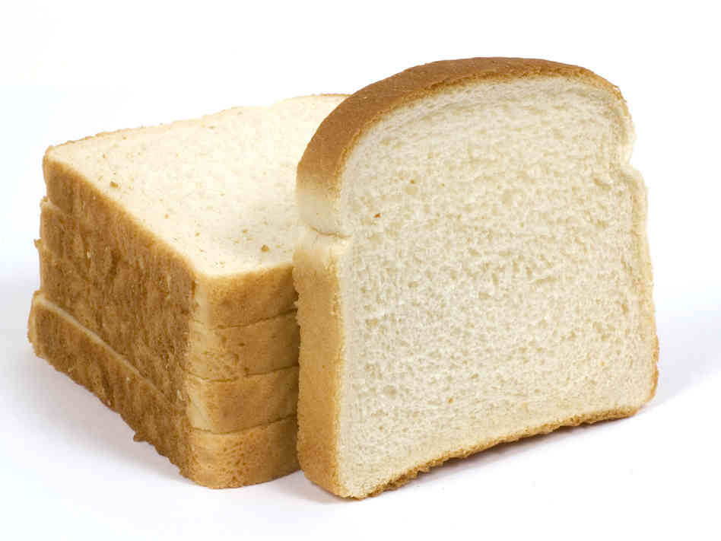 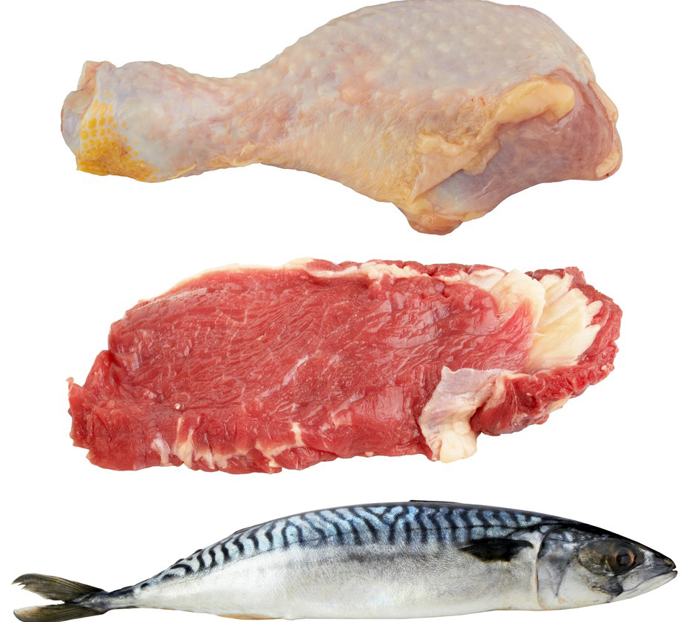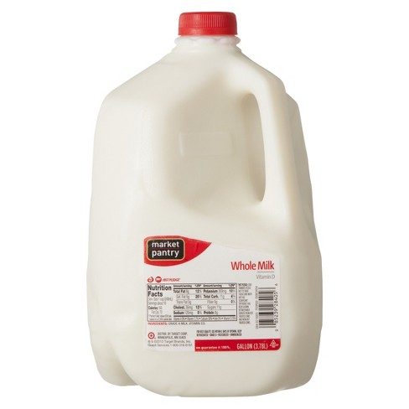 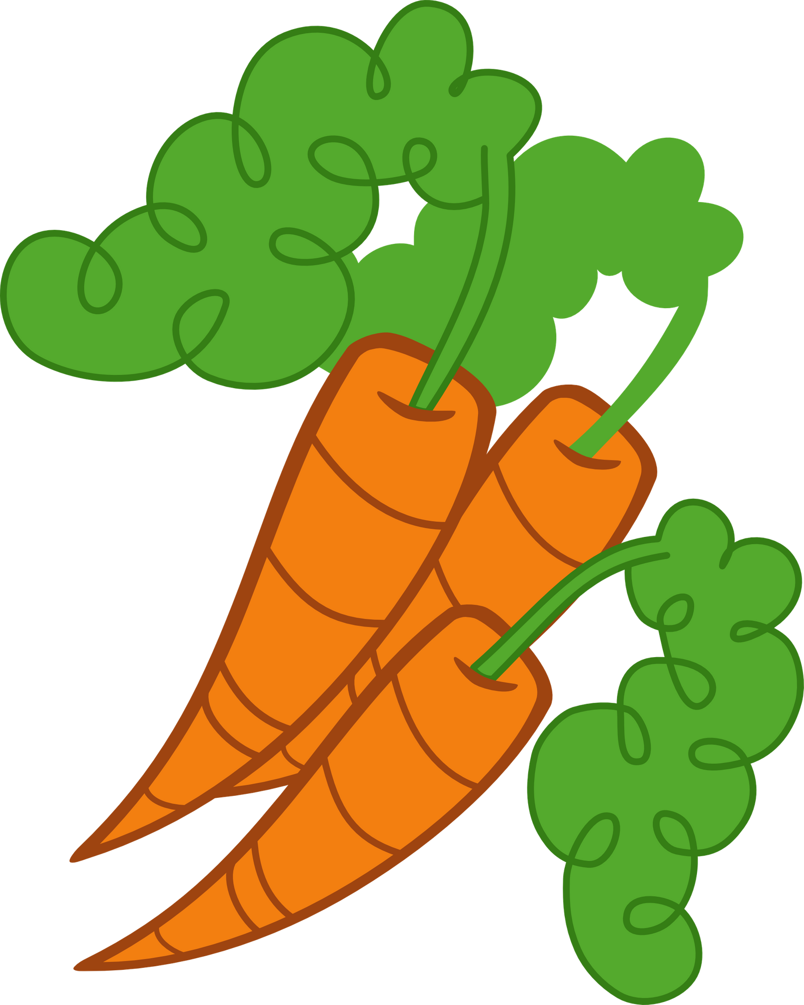

Let’s go on a Scavenger Hunt at home. Let’s see if you can find these items of the different food groups in your home and correctly name the group that they belong in.

**Grades 2- 5 Choose a letter of the week**

Continue each weeks taste and discussion of healthy foods which start with the chosen letter of the week, keep a log of the foods that you have tried. Try to choose difficult letters and try foods that you’ve never tried before. For example, for the letter ‘E” try eggplant, éclair or elderberry or “Z” for zucchini, ziti or zest.