Mrs. Price/Ms. Lara Week of May 4 – 8, 2020 Grade 1
Instructions: Choose the activities you want to complete. Out of the 12 boxes, 9 must be completed (3 Reading, 3 Math, 1 Science, 1 Social Studies, + 1 extra choice or Project). Please send evidence of completion of all these activities so that your child can receive credit. You can send pictures of your completed assignments through ClassDojo.
Reading | Math | Science
Choice 1  Story Elements  1. Pick an interesting to story to read for the week.  2. Think about the elements of the story.  >Who are the characters in the story?  “The characters are …”  >Where did the story take place?  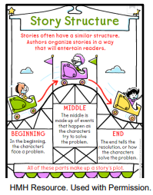  “The setting of the  story …”  >What happened in  the story?  “In the beginning…”  “In the middle…”  “In the end…”  3. Use the following chart to answer your questions. Draw & label  Characters Setting  Story Elements  Beginning Middle End  4. Spend at least 30 minutes on Imagine Language & Literacy | Choice 2  Skip count by 5’s.  For this activity you will need nickels.  - Grab a handful of nickels.  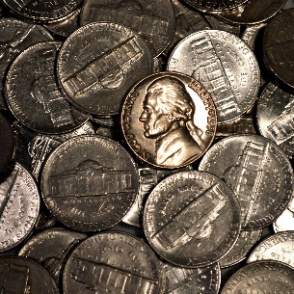  - Count the nickels. Remember that nickels are counted by 5’s, so you will skip count by 5’s  - On your notebook, write down how many nickels did you grab. You can draw nickels by drawing a circle and 5 cents sign.  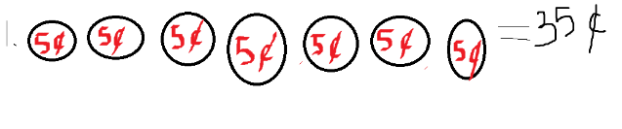  - Repeat steps 1-3 three times. | Choice 3 – Science  Observe, classify, and sort objects by the physical property of texture.  Objects can be classified by their physical properties, such as texture. The texture of an object can be observed by using eyes to see and fingers to feel. Objects can be sorted by the way it feels: smooth, rough, hard, soft, or bumpy. Some objects have more than one texture. For example, a rock can be hard and rough. 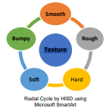  What you need:  - sheet of paper • Pencil or coloring pencils  • 3-4 objects around your home, such as cotton ball, uncooked noodle, grains of salt, rock, piece of foil  What to do:  - Observe one object. Discuss the way the object looks and feels.  - Draw and label the object.  - Describe how it feels using the words smooth, rough, hard, soft, or bumpy.  - Observe, draw, and describe an additional two objects.  - Complete the sentence stems below.  The _____ is _________. It is also ________. The _____ is ______ and ______.
Choice 4  Playing with the Characters  1. Reread your story from Monday.  2. Use paper and colors to make character puppets like the ones in the chart below.  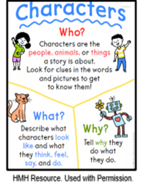  3. Use the character puppets to act out what happens in the story.  4. Be sure to think about the ideas in the anchor chart.  5. Spend at least 30 minutes on Imagine Language & Literacy | Choice 5  Create your own clock.  Materials:  - 1 construction paper or paper  - 1 pair of Scissors  - Marker or pencil  - To create a clock, you would have to draw a circle. You can create a circle by tracing a cup or something circular.  - Write down your numbers from the clock, 1-12. Just like shown. Make sure you draw five lines before writing a number.  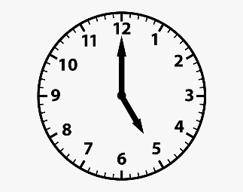  - Now, you are going to draw the clock hands. To do this you have to draw to arrows, one big one and one small one.  - Put the clock hands in the middle of your clock.  Your small arrow represents the hour and the big arrow represents the minutes. To read the minutes you will have to skip count by 5’s. So every number is skip count by 5 and you will only do this to read the big arrow.  When you tell time, you read the small arrow first and then the big arrow. | Choice 6 – Science  Use non-standard units to measure and compare length.  When using non-standard units, we use objects to measure instead of the usual tools. Pennies are examples of non-standard units that can be used to measure the length an object.  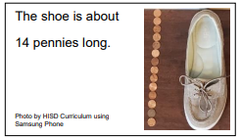  What you need:  - 20 pennies or other non-standard units, such as your thumb or toothpicks  • Objects to measure such as shoe, book, DVD cover, shoe box, remote control  • sheet of paper • Pencil 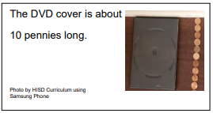  What to do:  - Estimate the length of a shoe and a DVD cover. Place the heel of the shoe on the floor next the wall.  - Use the pennies (or other non-standard units) to measure the shoe from heel to toe. Draw the shoe and pennies (or other non-standard units).  - Place a DVD cover next to the shoe. Measure and record the length using pennies (or other non-standard units). •  - Draw the DVD cover and pennies (or other non-standard units).  - Write sentences to compare the two objects. Which is longer? Which is shorter? Which used more? Which used less?  Complete the following sentence stems to help you compare the length of the objects your measured.  - There were _____ _____ used to measure the _____.  - The _____ is _____ than the ____.
Choice 7  Theme  1. Select another interesting story to read.  2. Identify the theme or the lesson the character learned in the story.  3. Fill in the chart below about theme. Use words and pictures.  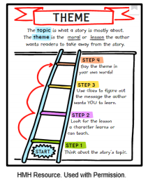  Theme  “The theme of the story is …”  “The lesson the character learned is …”  Textual Evidence  “I know this is the lesson the character learned because the story said …”  4. Spend at least 30 minutes on Imagine Language & Literacy | Choice 8  Scavenger Hunt – Finding Clock’s  - Grab a paper and pencil.  - Go around your house and see where you can find a clock. You can find either a digital or analog clock.  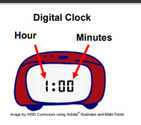  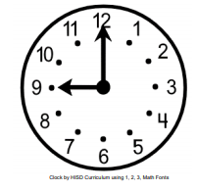  - When you find a clock, like the ones above draw the clock in your paper and where it is located. Make sure that you also draw where the clock hands are located in your analog clock and what time is it in your digital clock.  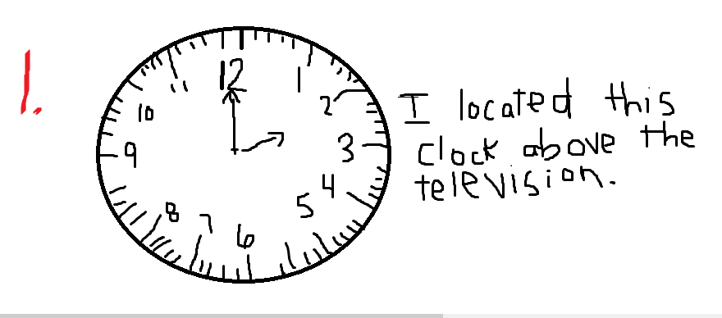 | Choice 9 – Social Studies  *Have you ever had a problem you needed to solve? Maybe you and your friend can’t decide what game to play together.  *Good citizens use this process to help find solutions, or answer, to problems.  - Identify the problem – What needs to be done?  - Gather information – Get all the facts  - Think about all the options – What are all the possible ways to solve the problem?  - Consider the option – What are the good things and the bad things that can come from your solution.  - Decide on your solution  - Think about the results – Did the play work? Will you use the same plan next time? What could you do differently next time?  1. Following these steps, solve a problem.  Problem Ideas:  -You lent a friend a game, but he hasn’t given it back yet. How do you solve this problem?  -You are trying to watch a movie, but your brother or sister is being too loud. How do you solve this problem?  -You want a turn on the computer, but your brother or sister isn’t sharing. What do you do?  
Choice 10  Personal Narrative Writing  1. LOOK at the picture below  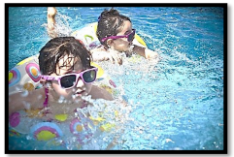  2. THINK about a time when you felt very happy. It could be a birthday party, a time you went somewhere special, or an important event in your life.  3. WRITE about a time when you felt very happy.  Be sure to ―  • write about a personal experience  • organize your writing  • develop your ideas in detail  • choose your words carefully  • use correct spelling, capitalization,  punctuation, grammar and sentences  4. Spend at least 30 minutes on Imagine Language & Literacy | Choice 11  Read the following math story three times:  - Read aloud the first time and picture what the math story is about.  - Read aloud the second time and focus on the question and what you need to find out.  - Read aloud the third time and determine what important information is needed.  James has 20 car toys. He gave 4 car toys to his brother. How many car toys does James have now?  *Represent the math story by using objects. Then use pictures, numbers, and words to show your work.  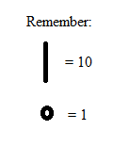  Just as we have done in class you can use you tens and one to represet the numbers. Remember this time you are subtracting, so you are taking out, you can use x to take out. | Choice 12 – Social Studies  *Problems are always around us. We have problems in our homes, our neighborhoods, our schools, and in our communities.  1. Decide on a project that would make your community a better place.  2. Write a letter to Mayor Sylvester Turner  3. Do your best to convince him that the project you created would be good for our city.  4. Write your ideas in complete sentences.  5. Be sure to use capital letters and punctuation correctly.
Weekly Project
*Long Creations has designed a program for students to help them document this historic period in their lives.
*Below is an example of how you should document your time during this COVID-19 pandemic.

Project is due by May 15, 2020
*