Daniel Ortiz Middle School Magnet for the Performing and Visual Arts an International Baccalaureate World School
Dance Department
Syllabus & Handbook
2023-2024

Ms. Martinez 713-845-5650, ext. 338227
Dance 1,2,3, and ensemble Sierra.Martinez@houstonisd.org

Overview

Being a student in the Dance program at Ortiz will provide you with a wealth of experiences and education in the art of Dance. Basic elements and technical skills will be introduced, learned, and mastered in Beginner Ballet, Modern, Jazz Dance, Hip-Hop-Hop, Contemporary, as well as Dance Composition, Performance, Production, Technology, and Conditioning. The goal of each student should be to practice and perfect each element and skill. Historical and cultural aspects of Dance will be addressed as well as involvement in the Houston Dance community through outreach, dance technology, field trips, master classes, and performances. The focus of the curriculum is in developing the well-rounded, technically skilled, and intelligent young performers who seeks to pursue a career path in dance. Being in this program will foster and nurture a strong education in dance technique, as well as knowledge and appreciation of dance today. Our performance group, The Eagle Elites Ensemble, is made up of advanced students who excel academically and behaviorally, and have great technical skills and performance qualities, and represent the school, department, and school district in performances and events. This elite group is made up of students who plan to pursue dance in high school and beyond, at a pre-professional level.

Dress Code/Supplies

FEMALE
Leotard: black princess cut with camisole (spaghetti straps-only).
Tights: flesh tone (skin); all tights must be convertible/transitional-no shimmery, footed tights or pantyhose. Recommended brand (Capezio).
Jazz Shoes: Black or Tan (Dance team uses tan), Jazz shoes are optional for Dance 1 and 2. In Dance 3 and Ensemble they are highly recommended. Foot undies and half-sole shoes are also an option.

Hair: If long, it must be pulled back into a ponytail and pinned securely away from the dancer's face and neck. If short, it too must be tied or pinned back. Bangs, hanging or loose curly hair styles are not allowed. As dancers are learning movement, hair should not be a hinderance to their being able to move freely without distraction, this would include addition of beading or decorations to hair.

Nails: Should be kept neat and clipped at an appropriate length for safety.

MALE
Top: black fitted t-shirt
Bottom: fitted black sweats (w/elastic at ankle so can be rolled up) or men/boys’
black pants, athletic shorts (no logos)

The following items ARE NOT permitted in class or changing rooms: Headscarves/bandanas, and jewelry are not allowed. No food, drinks, candy, or chewing gum in the dance room. Water bottles are always allowed.

As a reminder, dancewear should be washed daily, after classes, and proper hygiene is expected in the dance learning environment. Undergarments must be neatly concealed under dance clothes (brassiere straps must be pinned to leotards)-no visible undergarments.

You may get your dancewear from your choice of store. Below are some places that may have these items. If for any reason you cannot find the items, please feel free to reach out for further assistance.

DPOIS Kids Girls Camisole Ballet Dance Leotard Gymnastics Bodysuit Black 12-14 - Walmart.com

https://www.discountdance.com/dancewear/style_L5607_html?pid=21314&shop=Style&rfilter=Category%23Leotards%3A%3ASubCategory%23Leotards%21Camisoles&SID=1812263769

https://www.discountdance.com/dancewear/style_1916_html?pid=21225&shop=Style&&skey=Capezio+Tight&search=true&SortOrder=R&SID=1812264894

https://www.discountdance.com/dancewear/style_T7702_html?pid=22715&shop=Style&&skey=jazz+shoes&search=true&SortOrder=R&SID=1812264439

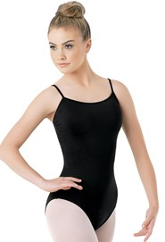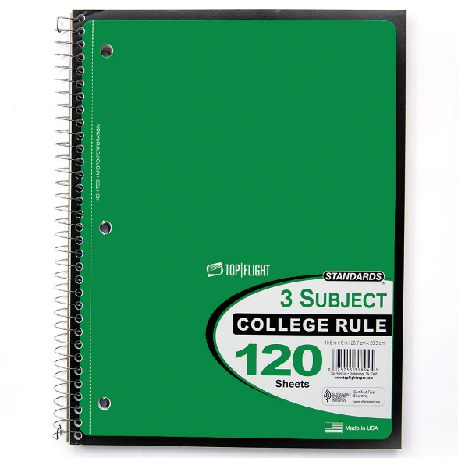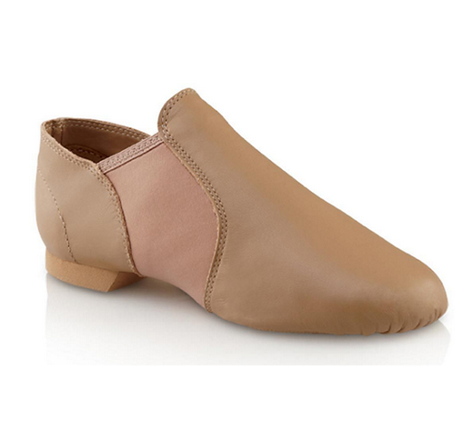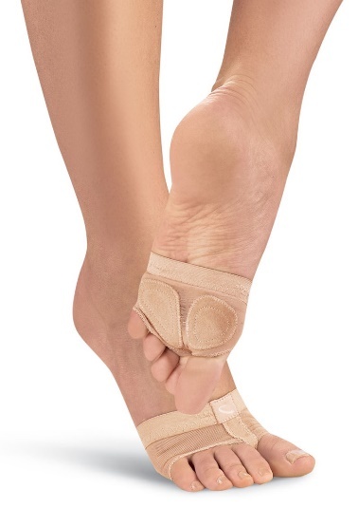

Additional items students may want to bring for class.
Baby wipes, deodorant, and hygiene supplies.

All students are required to have a college rule notebook that will be used in class as a journal.

All supplies for new Ortiz Dance students must be purchased by Week 3 of instruction, as full grading policies will be in effect, including deductions for not being dressed properly, bringing supplies, and class participation. Returning students are required to have all materials by the first week of school, as continuation of grading policies and class procedures will resume.

Grading Policy

Dress and Participation Grade consists of:

- Dress- Neat, clean, and untorn required attire must be worn for every class. Hair must be neatly pinned and/or pulled back in a secure ponytail or bun, and NO jewelry allowed (if ears are recently pierced, student may wear small posts only until able to remove—2 weeks maximum). This requirement lends itself to not only a neat and uniformed appearance, but also promotes safety, discipline and professional qualities. Please discreetly mark all dance clothes and dance shoes with student’s name on the interior of supplies.

If a student does not dress out for class they will earn a zero for their daily grade, they will be required to take detailed notes, and parents will be notified immediately. If problem persists, Assistant Principal will be notified, and student will receive a discipline referral. 25 points will be automatically deducted if student is dressed out but not in the appropriate dance attire or missing any part of their required attire. (i.e. clothing, tights, etc…)

- Participation- This is an active performing arts class. Students are expected to learn and master techniques, dance, and participate in every class. A daily participation grade will be given based on a Dance Rubric. Students may only be excused from participation if they have a doctor’s note. If the student is under Doctor’s restrictions for a long period of time an appropriate assignment will be given. If excused, when a student does not participate, they will have a written assignment to complete, take detailed well-written class notes, and they will be responsible to make up the skills worked on that day. Points may be deducted from participation grade if the quality of work on the classroom assignment is not appropriate, or a student is asked to sit out for lack of participation or dance class etiquette.

GRADING POLICY
- Classwork/Participation 40%
- Performances/Projects 40%
- Exams/Quiz 20%

Dance projects are graded according to 5 Key Points:
1. Creativity……................................25pts
2. Neatness……………..................25pts
3. Fulfillment of objective……......30pts
4. Effort……………………….….10pts
5. Time…………………………...10pts
TOTAL…………………………………. 100pts

Attendance- Daily attendance is very important. If a student even misses one day, he/she will fall behind in the class. It will be the responsibility of the student to make up any missed work, assignments, or tests as it regards to school guidelines.

Promptness- Students are to be in the dance studio, and on the dance floor before the tardy bell rings. After the bell rings they have five minutes to dress, secure their personal belongings, and sit in assigned row in the dance studio. Students will have approximately five minutes at the end of class to change back into their school clothes and wait in the dance studio for the bell to ring. Students are not allowed to go back and forth to the changing room once class has started, or to the dance studio once their class is over for the day.

- Restroom policy -Students are to use the restroom before and after class, so as not to interrupt the learning and creative process.
Leaving class to use restroom will be permitted sparingly and/or on an emergency basis only.

Performances
Spring, and/or Showcase Performances are MANDATORY. Students are assessed both on and offstage, and for backstage etiquette. Missed rehearsals and/or performances will be reflected strongly, overall, for the six-week grading period.

Examination/Projects
Each student will be given a post-unit test to gauge their knowledge of dance vocabulary, forms of dance and dance history. Tests and projects will be given covering skills and terminology taught in class throughout the year. Written and skills test will be used to monitor student’s progress.

Interactive Notebook/Dance Journal
Students will utilize a notebook to record daily corrections, vocabulary, skills taught and choreography notes. Records in Journals will count for one test grade each grading period.

Student Conduct
All students will be expected to follow the rules of the school as well as those for Dance Class Etiquette.

Dance Class Expectatios
Students are not to leave worn dancewear at school. They should be clean and stored in their bag, brought in daily for class, and should leave after class. This is for health and hygiene reasons, keep students responsible for their belongings, and create self-discipline.

*Be on time
*Be prepared
*Be courteous and respectful
*Participate *Practice at home
*Maintain a Positive Attitude
*Do AMAZING Work
*No food, drinks, gum or candy
*No CELLPHONES!

ACKNOWLEDGEMENT FORM

Parents/guardians and students need to read the Ortiz Dance syllabus, thoroughly, and sign and return this form to Ms. Martinez. This will count as a grade, and is due by Friday, September 1st, 2023.

***I have read the Ortiz Dance syllabus I understand and agree to the expectations and requirements for my child to be enrolled in Dance at Ortiz.

Parent Name ______________________________________

Parent Signature ___________________________________

Parent E-mail ______________________________________

Parent Phone Number _______________________________

***I have read the Ortiz Dance syllabus and I understand and agree to follow the requirements to be successful as a student enrolled in Dance.

Student Name ______________________________________

Student Signature ____________________________________

Date__________________________________________________

