|  |  |  |
| --- | --- | --- |
| **Activity 1: Book, Head, Heart**  You will use the strategy Book, Head, Heart with a fiction text. Choose your own fiction text and fill out the graphic organizer. | **Activity 2: Verbs is what you DO!**  Verbs are actions, things you do. Write about all the things you did today! Underline all the verbs you use in your writing. There needs to be a minimum of 10 verbs. | **Activity 3: Compare and contrast**  Read or listen to “Patillo Higgins: A Man with a Dream” in Week 27 of Texas Studies Weekly. Create a Venn diagram, and write down 5 things you learned about Patillo Higgins on the left side. Write 5 things about you on the right side. Do you share anything in common with Patillo Higgins? Write these ideas in the middle. |
| **Activity 4: Journal**  Create an award for a friend or family member. Along with the award, create a speech that you would give when presenting the award to your chosen person. | **Activity 5: About ME!**  Write your name in a way that tells people at least 10 different facts about you.  **Example:**  **P**lace of birth **Merced, California** in **1993.**  **E**asily persuaded by **food** and **other’s emotions,** and **travel.**  **N**osey with **family business,** and **gossip**.  **A**ffordablethings are my favorite.Such as **sales for furniture, clothes** and **makeup.** | **Activity 6:**  **Making Connections Across Texts**  Today you will make connections by comparing two different texts. Read the selection titled A Pair of Tricksters: The Fox and the Crow & Raven and Crayfish. When your done, answer the questions on the chart attached. |
| **Activity 7: Characters & Changes**  Today, you will use details from the text to identify character interactions & explain how they change. Use the story Raven and Crayfish. | **Activity 8: Read and Record**    Pick a good book. Find a phone/computer or tablet to record yourself either audio only or video as well. Read and record yourself while you read. | **Activity 9: Context Clues**  When we do not understand words, we need to look for context clues. Complete the graphic organizer below with context clues in mind. |
| **Project: Presidential Timeline**  Create a timeline of events that have happened in the life of a president. You can pick any president you would like past or present.  **Requirements:**   * Minimum of 10 events. * Each event needs to have a brief description (two or three sentences) and an Image to go with it. * You will need present your timeline with a brief video explaining each event. * First event must be birth. * Last event must be death. (unless they are still alive, then list their most recent event.) (**Example**: April 2020, Obama endorses Joe Biden for Democratic presidential candidate.) * Timeline must be in chronological order (in the order the events happened).   *** **This will be due for a grade**. Make sure you **upload a video to google classroom.** Under the **PROJECT** assignment. | | |

**ELA/Social Studies Choice Board Week of April 27- May 1st**

|  |  |  |
| --- | --- | --- |
| **Activity 1:**  **Materials:** sheet of paper, fiction book, pencil  **Instructions:**  Student will read a fiction text when they are done, they will fill out the graphic organizer provided with the answers to the questions on the graphic organizer.  The graphic organizer is attached to the choice board (scroll down). | **Activity 2:**  Instructions  **Materials**: Sheet of paper, pencil.  I**nstructions**: Write about all the things you did today! Give me a lot of details. Underline all the verbs you use in your writing. There needs to be a minimum of 10 verbs.  **Requirements:**  -Underline all verbs.  -Minimum of ten (10) verbs.  -Write a least a half page.  **Example:** Today I woke up at 7 am and sat on my bed thinking to myself, “Why I am awake so early?” | **Activity 3:**  **Materials:** Sheet of paper, pencil, article: “Patillo Higgins: A Man with a Dream” (found in google classroom under Activity 3 assignment)  **Instructions:** Students will read or listen to the article “Patillo Higgins: A Man with a Dream”. Once you’re done reading create a Venn diagram. On the left side of the Venn diagram write Patillo Higgins name and write down 5 facts you learned about him. On the other side write 5 things about you. Then in the middle write the things you have in common.    **\*\*\* This will be taken as grade. Upload a picture to Google Classroom.** |
| **Activity 4:**  **Materials:** Paper, Pencil, colors  **Instructions:** Students will create an award for a friend or family member. The award can be for anything you would like, be creative. Once you’re done you will create a speech that you would give when presenting the award to your chosen person.  **Requirements:**  -Student must write at least half a page.  -Use complete sentences  -Create the award and speech | **Activity 5:**  **Materials:** Paper, pencil  **Instructions:** Students will use their first name to say 10 facts about themselves. If your name is short you will have to put multiple facts about yourself per letter. (look at example) If your name is long then you might not have to do that depending on how many letters are in your name. Be creative! | **Activity 6:**  **Materials:** paper, pencil, Stories: Pair of Tricksters: The Fox and the Crow & Raven and Crayfish  **Instructions:**  Students will read the selection titled A Pair of Tricksters: The Fox and the Crow & Raven and Crayfish (Link in google classroom under activity 6) Once you’re done reading answer the questions on the chart attached.(google Classroom under activity 6)      **\*\*\* This will be taken as grade. Upload a picture to Google Classroom.** |
| **Activity 7:**  **Materials:**  Pencil, paper  **Instructions:** Students will use a fiction text to identify the main character and answer the following questions in complete sentences.   * What does the character say? * How does the character think and act? * How does the character interact with others? * How does the character change? | **Activity 8:**  **Materials:** phone/table/computer and a book.  **Instructions:** while you read record yourself. Submit the video/ recording to class dojo/text message. | **Activity 9:**  **Materials:** Paper, pencil, colors  **Instructions:** Look at the graphic organizer and fill in the part that are missing. Remember that when we don’t know what a word means we look for context clues. context clues can be synonyms, antonyms, examples or definitions of the word. |

**Activity 1 Graphic Organizer**

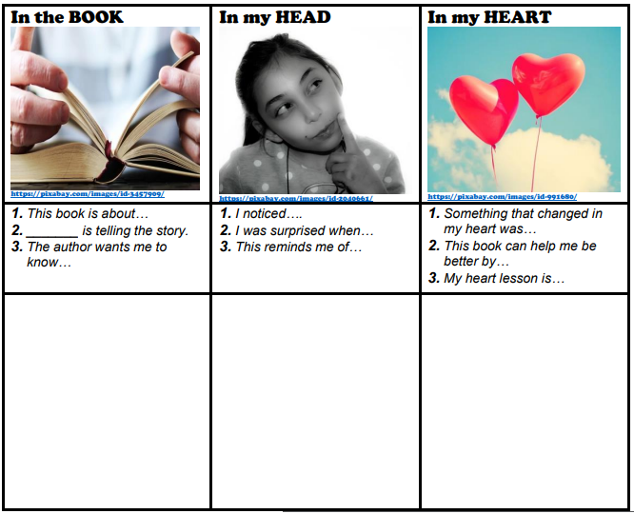

**Activity 9 Graphic Organizer**

