Lovett Elementary
SDMC
April 28, 202
General Updates: Discuss what funds the campus receives based on 651 student projection.
Budget: This is a copy of the allocation from One Source
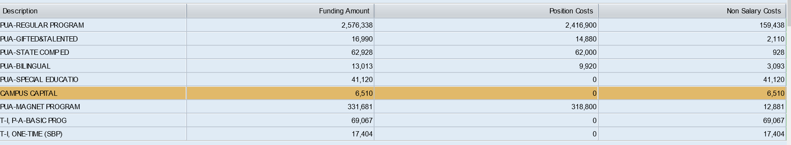
- Currently we can maintain all positions for the 22-23 school year
- All funds are allocated with 105,000 in reserve to plan for the possibility of not making enrollment-this is put into general supply funds
- Approximately $40,000 of our budget goes to pay for subs
- ESSER funds will be allocated next year for:
  - HB4545 tutoring: 22K: these funds are to provide small group tutoring for students that were not successful on STAARR Reading or Math: Parent can opt in or opt out of tutoring.
  - Wrap Around funds 28K: These funds will be used to support implementation of programs or services to support whole student development. We want to remove barriers or provide on campus support to students through various programming.
  - Innovation funds 7K: These funds can be used for extra pay for teachers, support personnel, hourly pay, contracted services, etc. Lovett would likely use these funds for extra pay for teachers or support personnel.
*We are scheduling interviews for any new positions or vacancies for next year:
- Kinder: 1 vacancy
- First grade: 1 vacancy
- 2nd grade: 1 vacancy
- 4th grade 1 vacancy
- Guidance Counselor
- Possible LPAC Clerk
22-23 Planning Tuesday Talks through May to hear from community: Requesting SDMC attend at least one of these meetings if possible. Next meeting May 12th

