- Reading  - Make your journal and color the cover page. (This journal will be your reading journal/writing journal.  - Date your journal entries.  - Todays Prompt: What is your favorite thing to do in the house? My favorite thing to do is…  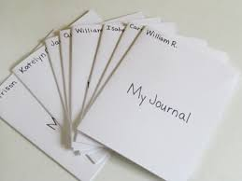 | - Math  Cut out number cards 1-10 and mix them up. Choose a number card.  - Say the number on the card.  - Use objects (for example, cheerios, beads, buttons, etc.) to show the number on the card.  - Say the number of objects you have.  - Write the number of objects you have.  - Repeat with other number cards.  7 | - Science  How can I tell if an object is bigger or smaller than another object?  Do It! What you need:  • A set of toys (or any cluster of objects in different sizes) • Science notebook or paper • Pencil or crayons  What to do:  • Draw a sorting mat data table  • Observe (look at) the toys (or objects) and think about their size.  • Describe (tell) if each toy is big or small The __________ is big because __________. The __________ is small because __________.  • Sort (group) the toys by size on the mat.  Small  Big
- Reading  Read or listen to a story. (Use the same book during this week). Think about the characters and the setting in the story.  Who were the characters in the story? The characters were…  What was the setting in the story? The story took place …  Draw the characters and add details to describe the setting. Label your picture  Write your sentence and picture in your journal and date it.  Title:____________________ | - Math  Cut out number cards 11-20 and mix them up. Choose a number card.  - Say the number on the card.  - Use objects (for example, cheerios, beads, buttons, etc.) to show the number on the card.  - Say the number of objects you have.  - Write the number of objects you have.  - Repeat with other number cards.  15 | - SEL My Gratitude Entry  - Utilize your reading/writing journal to respond to the prompt  - Date your entry  - What are you grateful for? I am grateful for…
- Reading  Problem and Resolution  1. Reread or listen to the previous story.  2. Think about the problem and the resolution in the story.  What was the problem? The problem was …  How was the problem solved? The problem was solved when..  Write your sentence and picture in your journal and date it.  Retell the problem and the resolution using your pictures | - Math  Read the following math story three times aloud to students:  1. Read aloud the first time and picture what the math story is about.  2. Read aloud the second time and focus on the question and what you need to find out.  3. Read aloud the third time and determine what important information is needed.  Nine bees stopped at a flower. Two more bees flew over to join them. How many bees are on the flower now?  Use objects to show your work then use pictures, numbers, and words to show your work | - Social Studies  Create a chart on notebook paper that list at least 5 different kinds of technology and how it has benefited the world, draw a picture.  Technology Benefits  Ex. Cell Phone Talking to others  1.  2.  3.  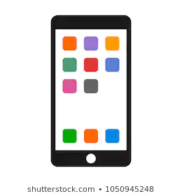
Weekly Project: My ABC Sidewalk
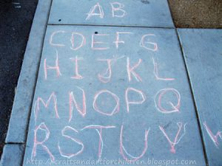
- Write letters A-Z in chalk on the sidewalk
- Next to each letter write a word that starts with that letter and draw a picture
- Take a picture of you next to your list and upload to your DOJO portfolio or send me a text.

