|  |  |  |
| --- | --- | --- |
| **Activity 1: Book, Head, Heart**  You will use the strategy Book, Head, Heart with a fiction text. Choose your own fiction text and fill out the graphic organizer. | **Activity 2: Noun Hunting**  Look around your house, it’s filled with nouns (person, place, things and animals). Pick 5 nouns and create a sentence for each.    [This Photo](http://fizleglitz.com/2010/09/15/vintage-tables/) by Unknown Author is licensed under [CC BY-SA](https://creativecommons.org/licenses/by-sa/3.0/)  [This Photo](http://elmundosefarad.wikidot.com/) by Unknown Author is licensed under [CC BY-SA](https://creativecommons.org/licenses/by-sa/3.0/)  [This Photo](https://en.wikipedia.org/wiki/Common_goldfish) by Unknown Author is licensed under [CC BY-SA](https://creativecommons.org/licenses/by-sa/3.0/) | **Activity 3: Talk Show Host**  Imagine you are a talk show host like Jimmy Fallon, Ellen De Generes, or even Oprah who would you interview? Write five (5) questions you would ask this person. |
| **Activity 4: Journal**  Write a letter to your future self!  Write a letter from your fourth-grade self to your Middle school self. What life advice would you give yourself? What things would you want to remember about being in fourth grade? | **Activity 5: Quiz about ME!**  Create a quiz about yourself!  Give it to your mom, dad, teacher, sibling or best friend to see how well they know you.  Quiz must have at least 10 multiple choice questions. | **Activity 6: Informational Text Structure**  Choose a non-fiction book (informational text) and identify the text structure. Create a graphic organizer to represent your text structure. Fill in at least 1 example from the text.  Remember text structure is the way the author organizes the text.   * Cause and Effect * Chronological/sequence * Compare and contrast * Description * Problem and solution |
| **Activity 7: Characters & Changes**  Today, you will use details from the text to identify character interactions & explain how they change. Choose your own fiction text to answer the following questions. | **Activity 8: Read and Record**    Pick a good book. Find a phone/computer or tablet to record yourself either audio only or video as well. Read and record yourself while you read. | **Activity 9: Context Clues**  When we do not understand words, we need to look for context clues. Complete the graphic organizer below with context clues in mind. |
| **Project: Timeline**  Create a timeline of events that have happened each year of your life.  **Requirements:**   * Minimum of 10 events (one per year alive) * Each event needs to have a brief description (two or three sentences) and an Image to go with it. * You will need present your timeline with a brief video explaining each event. * First event must be your birth. * Timeline must be in chronological order (in the order the events happened).   *** **This will be due for a grade**. Make sure you **upload a video to google classroom.** Under the **PROJECT** assignment. | | |

**ELA/Social Studies Choice Board**

|  |  |  |
| --- | --- | --- |
| **Activity 1:**  **Materials:** sheet of paper, fiction book, pencil  **Instructions:**  Student will read a fiction text when they are done, they will fill out the graphic organizer provided with the answers to the questions on the graphic organizer.  The graphic organizer is attached to the choice board (scroll down). | **Activity 2:**  Instructions  **Materials**: Sheet of paper, pencil.  I**nstructions**: Students will find five nouns around their home. Nouns can really be anything person, place, thing, and animal. They will use those five nouns to write individual sentences. The end result should yield five different sentences with each noun underlined.  **Example:**  The table at my house has many purposes, it is used for eating, studying and playing board games. | **Activity 3:**  **Materials:** Sheet of paper, pencil  **Instructions:** Students are to pretend to be talk show host such as those mentioned on the front side you can pretend to interview whoever you would like. You need to make sure the questions you ask are meaningful and give you MORE THAN a YES or NO response. Make sure to write in full sentences a minimum of five questions.  **\*\*\* This will be taken as grade. Upload a picture to google classroom.**  **Example:**  **Interviewee:** Michelle Obama  **Question 1:** If you could go back and change one thing in your life, would you? If so, what would you change? |
| **Activity 4:**  **Materials:** Paper, Pencil  **Instructions:** Students will write a letter to their future middle school self. You can be as creative as you want. Give yourself advice or tell yourself memories that are fresh in your head now.  **Requirements:**  -Student must write at least half a page.  -Use complete sentences | **Activity 5:**  **Materials:** Paper, pencil  **Instructions:** you are going to create a quiz about yourself and the things you like or dislike. You can make your questions as hard or as easy as you would like. Then go quiz someone on their knowledge of you!  **Example:**   1. What is my favorite color? 2. Green 3. Blue 4. Purple 5. Orange | **Activity 6:**  **Materials:** paper, pencil, informational text  **Instructions:** Students will read an informational text and find the text structure (the way the author organized the text) they will then create a graphic organizer to represent the text structure and fill in at least one example of the author text structure.  **Example:**  Problem Solution  limpiarlo con el trapeador  Spilled milk |
| **Activity 7:**  **Materials:**  Pencil, paper  **Instructions:** Students will use a fiction text to identify the main character and answer the following questions in complete sentences.  **\*\*\* This will be taken as grade. Upload a picture to Google Classroom.**  **Questions:**   * What does the character say? * How does the character think and act? * How does the character interact with others? * How does the character change? | **Activity 8:**  **Materials:** phone/table/computer and a book.  **Instructions:** while you read record yourself. Submit the video/ recording to class dojo/text message. | **Activity 9:**  **Materials:** Paper, pencil, colors  **Instructions:** Look at the graphic organizer and fill in the part that are missing. Remember that when we don’t know what a word means we look for context clues. context clues can be synonyms, antonyms, examples or definitions of the word. |

**Activity 1 Graphic Organizer**

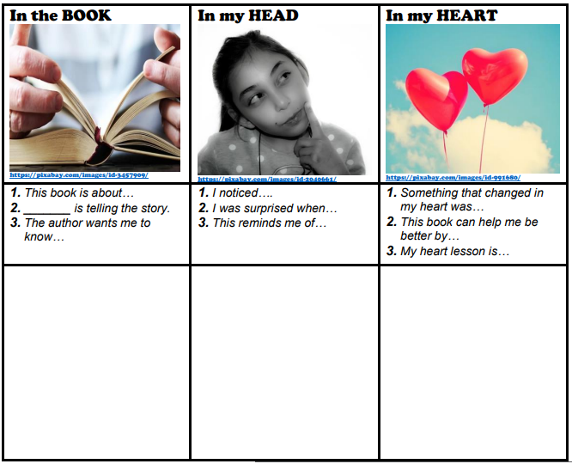

**Activity 9 Graphic Organizer**

