## ROTC Fields Of Study

Army ROTC Cadets can major in any field of study, from technical to non-technical degrees, from all participating schools in the greater Houston area.

## Army CaREER Options

* Cyber Warfare
* Engineer (Construction & Demo)
* Aviation (Pilot & Drone)
* Military Intelligence (Analyst)
* Medical Service (Hospital Admin)
* Logistics
* Nursing
* JAG (Lawyer)
* Armor (Tank Commander)
* Military Police
* Artillery
* Infantry (Airborne, Ranger)
* Finance
* And Many More……

## Participating Schools

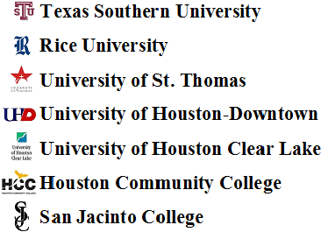

 **Houston Baptist University**

**University Texas Health Science Center**



#### ARMY ROTC

3875 Holman St. Rm 28

Houston, Texas 77204-6014

Phone (713) 743-3883/8460

Main Office (713) 743-3875

TSU (713) 313-4857

Fax (713) 743-3885

http://www.uh.edu/rotc

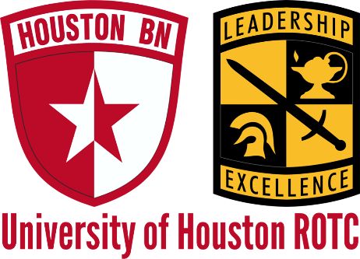

**Partnership with**

**Texas Southern University**

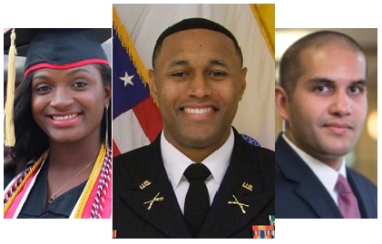

***Your Future is Now***

***Beginning Classes taught at TSU***

**Honor ♦ Courage ♦ Commitment**

## Benefits

**ROTC Cadet Benefits:**

* **2 - 4 year scholarships that pay full tuition and provide a book allowance**
* **A Tax Free Stipend of $420 a month for cadets**
* **Be part of an exciting team**



**U.S. ARMY Officer Benefits:**

* Competitive Salary and tax free benefit packages
* 30 Days paid vacation every year. Medical and Dental Insurance Included
* 100% Tuition Assistance for Advanced Degrees



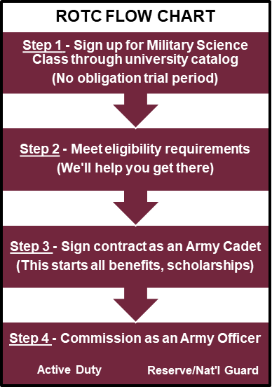

## Eligibility to Contract

* Be a full-time student in good academic standing
* Meet height/weight standards
* U.S. Citizenship
* Complete the Army physical

## **Why rotc?**

* **Path to a professional career in/out of the Army**
* **Financial aid, benefits**
* **Unique experiences**
* **Be part of a team**
* **Get Physically Fit**
* **Challenge Yourself**
* **Best Leadership Training**
* **Outdoor Training**
* **Full College Experience**
* **Foreign Exchange (summers)**

