4th Grade Math/Science Choice Board
Activity 1: Create your Own Number  Create your own number using a place value chart  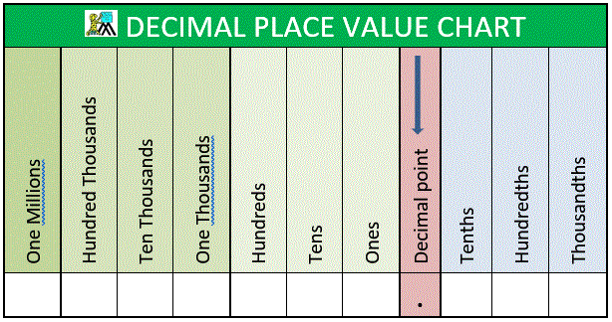 | Activity 4: Friction Investigation (Science)  Design a descriptive investigation to test the effects of friction on an object.  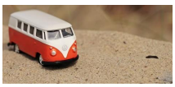 | Activity 5: Imagine Math  Work on Imagine Math
Activity 2: Number Riddle  Create your own number and a riddle for that number | SEL:  Draw a picture of yourself.  Write at least 10 strengths all around the image   | Activity 6: Solids, Liquids Gas Scavenger Hunt (Science)  Look for objects around your home that are solids, liquids and gas  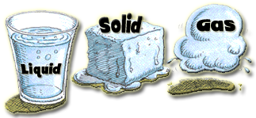
Activity 3: Adding and Subtracting Digits  Create your own numbers and add and subtract those numbers | Weekly Project: Shadows Book (Science)  Create a book about shadows   | Activity 7: Musical Notes Worksheet  Complete worksheet included in your packet  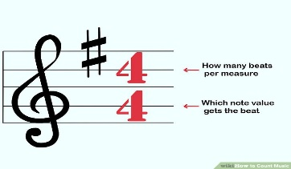

Activity 1: Create your own number  Using the digit cards or playing cards, create a number to the millions place and through the hundredths place. Record the number created using a place-value chart.  Choose a place value position. Using your number, identify the value of the digit in the chosen place value position. Explain your thinking using this sentence frame:  In the number ____________________, the value of the digit in the _____________ place is ____________ because _____________________ equals _____________________ . Example: In the number 7,123,456.89 the value of the digit in the hundreds place is 400 because (4 x 100) equals 400.  Mix up the cards and repeat. | Activity 4: Friction Investigation  Think About It! What makes an object slow down or stop? If you can, discuss this question and share your thinking with someone in your home.  Do It!  What you need: An object that will roll on a surface when pushed (ex. Toy car): Chalk or other marking objects ): A ruler or tape measure: A variety of surfaces (concrete, grass, carpet and tile)  What to do: You will design an investigation using the materials listed investigating the effects of friction on an object. :Remember to include a data table to show the distance that the object traveled on different surfaces.  Understand It! Friction is a force that resists (slows down or stops) the motion of two surfaces sliding across one another. How did your investigation test friction? | Activity 5: Imagine Math  Work on Imagine Math for at least 30 minutes
Activity 2: Create Number Riddle  Create another number. Instead of writing the number in standard form (like a regular number), write the number in the form of a riddle using the following sentence frame for at least 5 of the place value positions:  The value of the digit in the  _____________ place is ____________.  Sample riddle:  The value of the digit in the ones place is 5. The value of the digit in the hundreds place is 600. The value of the digit in the hundred thousands place is 300,000. The value of the digit in the tenths place is 0.4. The value of the digit in the hundredths place is 0.07 What could be my number? 300,605.47 (multiple numbers are possible, since not every digit is identified) Write a riddle for two more numbers and record these numbers in standard form. | SEL:  Draw a picture of yourself.  Write at least 10 strengths all around the image | Activity 6: Solids Liquid Gas Scavenger Hunt  Objective: Describe objects as solid, liquid, or gas and compare them based on their properties  Think About It! How can we determine if an object is a solid, liquid, or gas? If you can, discuss this question and share your thinking with someone in your home.  Do It!  What you need: • A pencil • A journal / notebook or a sheet of paper  What to do: • You will go on a scavenger hunt looking for objects around your home that are examples of solids, liquids and gases. • You will record the objects you find in a table like the one below.  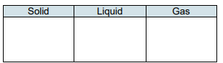
Activity 3: Adding and Subtracting Numbers  Shuffle the digit cards (or playing cards) and place them face down in a pile. Pick eight digit cards. Create two four-digit numbers that go to the hundredths place value.  First, find the sum of the two numbers created. Then subtract the sum from the number 200.  Example: Step 1: 36.52 + 89.74 = 126.26 Step 2: 200 – 126.26 = 73.74 Repeat using different numbers. | Project: Shadow Book  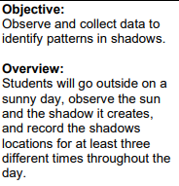  After you have did your observations, you will create a book with your drawings and 3-5 sentences about each drawing | Activity 7:  Complete “Adding Notes and Rests” Worksheets that is included in your packet

