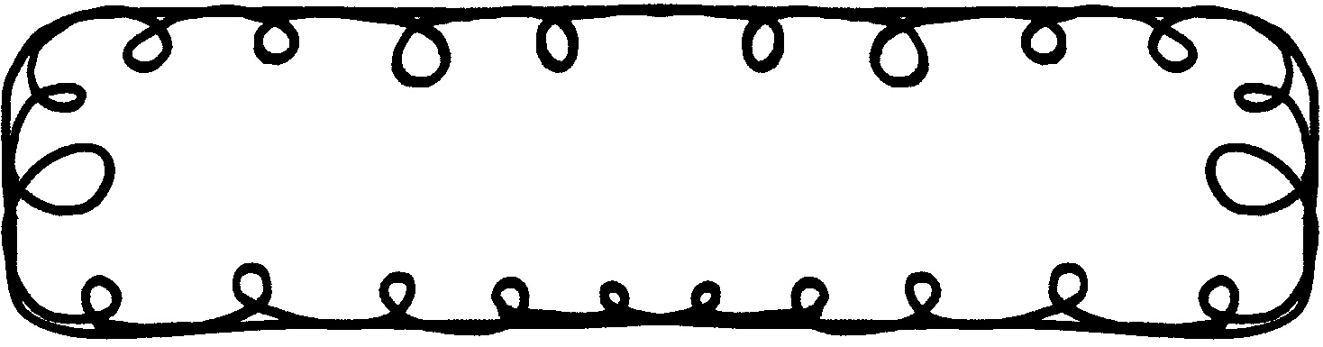

First Grade Gazette September 23, 2019

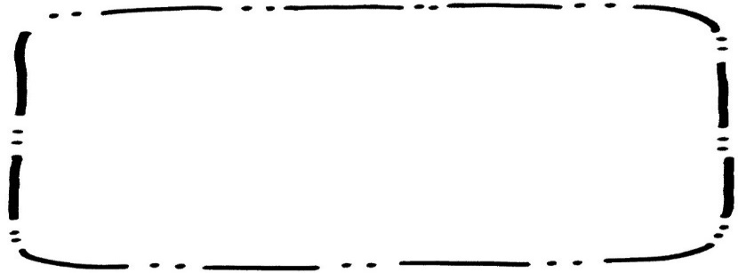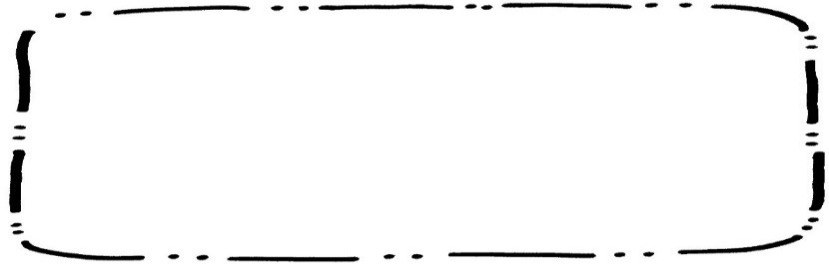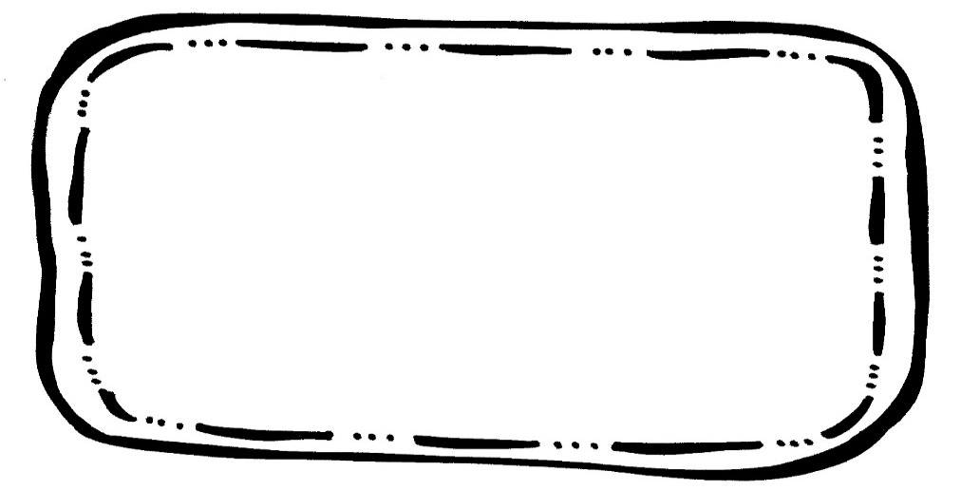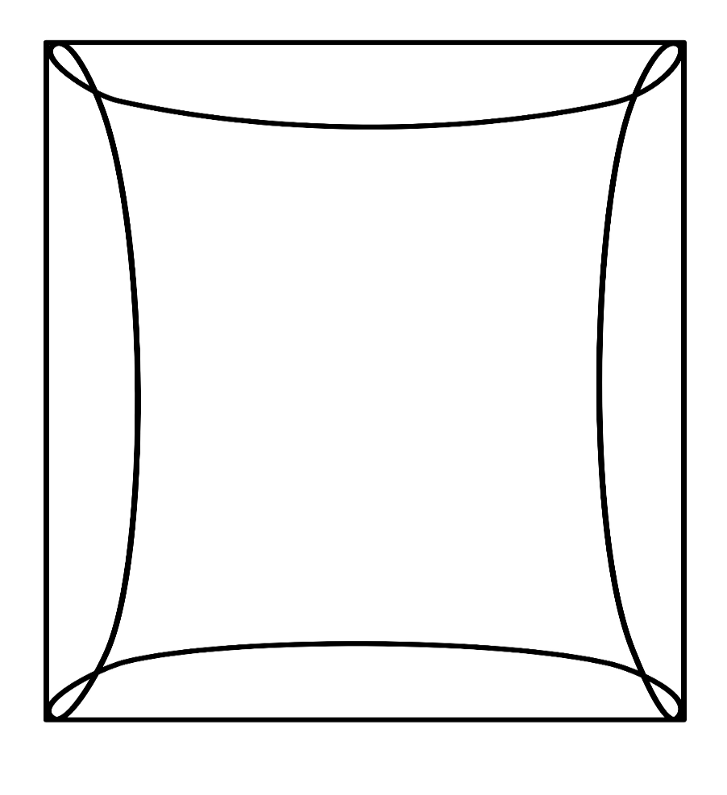

Math

We will finish up Chapter 3, Addition. We will also continue to work on Missing Addends to 3.

Writing

We will learn about asking questions. We will also be writing stories.

Social Studies

We will learn what is a need and what is a want.

Spelling**Tested 9/13

cat fat rat fan pan

one will some into out

**You can tap the cat.**

**Reading Comprehension**

* Asking questions in a story

**Vocabulary Words**

Cowhand – a person who works with cattle

Chaps – leather clothing worn over pants to protect the legs

Herd – any group of cattle or wild animals that feed and travel together

Stampede – a sudden and hurried movement of a large group of scared animals

Chuck wagon – a wagon used to carry food and utensils for feeding outdoor workers like cowboys

**Upcoming Events**

**September**

23 – Grandparent’s Lunch

27 – Early Dismissal (No Extended Day)

30 – 10/4 – Book Fair