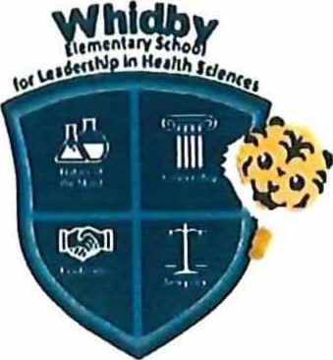Whidby Elementary School

# for Leadership in Health Sciences

7625 Springhill Houston, TX 77021

Phone: 713-746-8170 Fax: 713-746-8173

Second Grade

2024-2025 School Supply List

## 48 #2 Standard pencils

1 box of crayons (24 count)

1 color pencils

1. pencil sharpener (covered)
2. large erasers

1 pair of scissors

1 zipper pencil bag 41arge glue sticks 1 box of quart size zipper bags

1 box of gallon size zipper bags

## 2 plastic folders with brads

## 1 assorted construction paper

1 packs of manila paper

6 wide ruled composition books (marble-covered 100 sheets)

## 2 bottle of hand sanitizer

2 bottles of hand soap

2 containers of disinfectant wipes

1. Lysol disinfectant spray
2. large boxes of facial tissue 

2 packs of index cards (3in x 12.7cm)

## 1 set of personal headphones