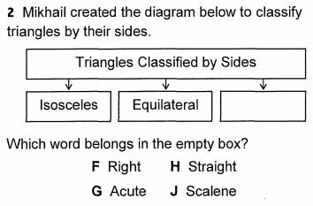  *REMEMBER TO THINK ABOUT OUR ANCHOR CHART THAT WAS HANGING UP IN THE CLASSROOM. THERE WAS ONLY THREE TRIANGLES THAT WE IDENTIFIED* | 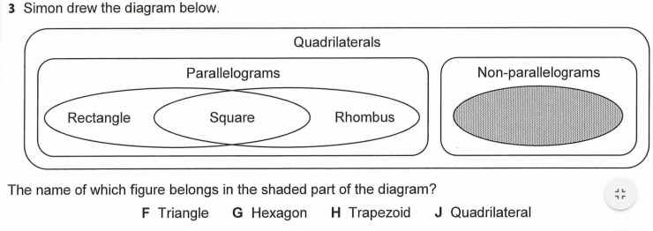  *Think about the story that I told you all in class about the grandparents, the mother, the father and their children* | Natural Disasters  - Watch the video below and answer the following questions  - https://www.generationgenius.com/videolessons/natural-disasters-video-for-kids/  - Can you list two natural disasters?  - What is a Hazard?  - What is the job of an engineer as it relates to natural disasters?  - How can you describe a Tsunami?
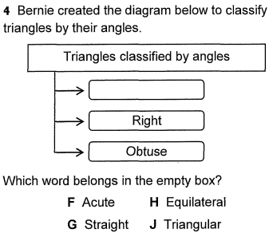  *Pay attention to the question, it is only asking for angles, not sides, or triangles* | SEL  Now that we are getting closer and closer to our summer break, what are your plans for the summer?  How has COVID-19 changed your summer plans?   | What does it mean?  WRITE THE DEFINITION FOR EACH OF THE WORDS BELOW!  - EARTHQUAKE  - NATURAL DISASTER  - TSUNAMI  - VOLCANO  - MAGMA  - EARTH’S PLATES  - EARTH’S CRUST  - SEISMOGRAPH
IMAGINE MATH  - You are to spend at least 40 minutes on Imagine Math Today  • WWW.CLEVER.COM  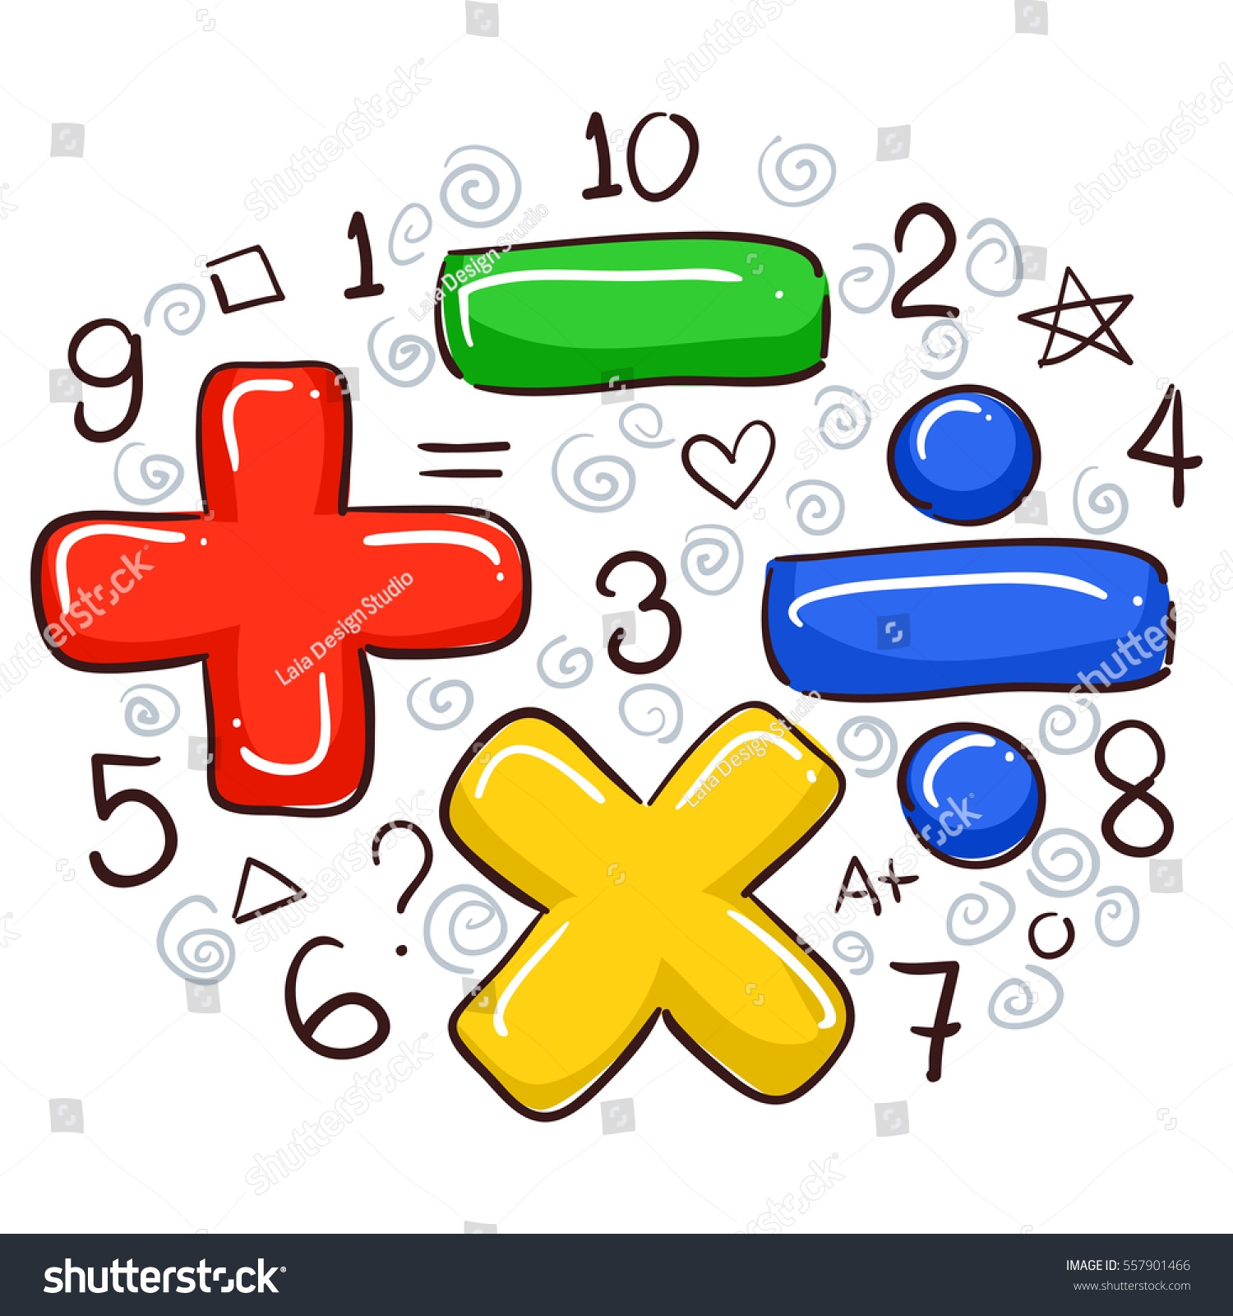 | IMAGINE MATH  - You are to spend at least 40 minutes on Imagine Math Today  • WWW.CLEVER.COM  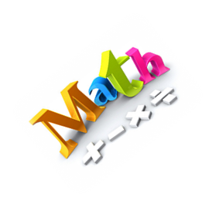 | IMAGINE MATH  - You are to spend at least 40 minutes on Imagine Math Today  • WWW.CLEVER.COM  