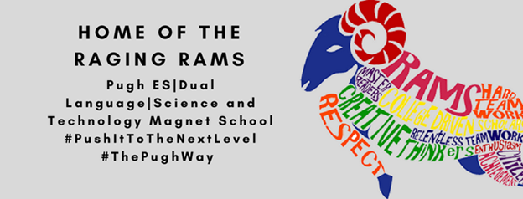
SDMC Minutes
Friday, September 17, 2021
- SIP
- ESSER Funds
- COVID cleaning supplies

